Literature Search Plan

1. **Briefly describe your ideas for a possible research topic.**

If you are having trouble thinking of a possible research topic consider the following questions: What are your big questions about teaching right now? What do you consider to be most integral to student learning? What current events in education interest you? What experiences most stand out to you from your own schooling?

1. **Identify key concepts and related terms.**

Based on your response to #1, generate a list of possible keywords that you could use to support your literature search on this topic.

|  |  |  |  |
| --- | --- | --- | --- |
| **Key Concept**  **(eg. “experiential learning”)** | **Related Term 1**  **(eg. “real-world learning”)** | **Related Term 2**  **(eg. “hands-on learning”)** | **Related term 3**  **(eg. “authentic learning”)** |
| **1.** |  |  |  |
| **2.** |  |  |  |
| **3.** |  |  |  |
| **4.** |  |  |  |

1. **Improve results using * and “ ”**
2. **Use * to search for different endings.**

Canad* (= Canada; Canada’s; Canadian; Canadian; Canadiana)

Note that most databases will automatically search for hyphenated words, i.e. Search for “inner city school” = inner city school and inner-city school

1. **Use “ ” for phrase searching.**“higher education”

“inner city school*”

**Note: you can use both an asterisk and quotation marks**

1. **Identify types of resources you would like to find, and best places to search.**

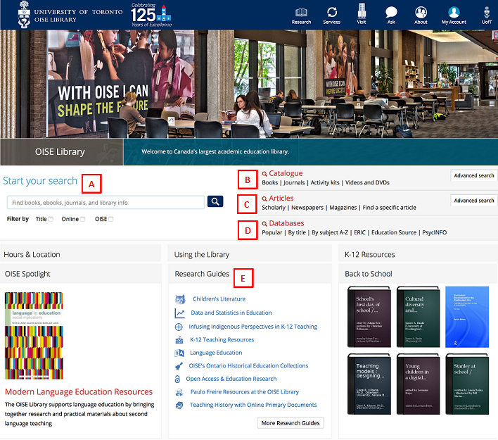

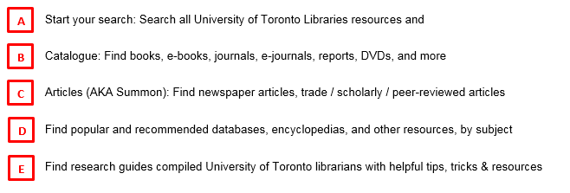

**5. Is it Peer-reviewed? Check Ulrichsweb:** <http://go.utlib.ca/cat/7912016>

**6. Cite in APA Style**

* Publication Manual of the American Psychological Association (6th Edition) is   
  available in the UofT libraries <http://go.utlib.ca/cat/6784923>
* Online Writing Lab (OWL) Purdue: <https://owl.english.purdue.edu/owl/resource/560/01/>

**5. Is it Peer-reviewed? Check Ulrichsweb:** <http://go.utlib.ca/cat/7912016>

**6. Cite in APA Style**

* Publication Manual of the American Psychological Association (6th Edition) is   
  available in the UofT libraries <http://go.utlib.ca/cat/6784923>
* Online Writing Lab (OWL) Purdue: <https://owl.english.purdue.edu/owl/resource/560/01/>
* RefWorks guide <https://onesearch.library.utoronto.ca/refworks>   
    
    
    
  RefWorks guide  
  <http://guides.library.utoronto.ca/refworks>

**E**

Find research guides compiled University of Toronto librarians with helpful tips, tricks & resources

**Questions? Don’t hesitate to contact us!**

Monique [monique.flaccavento@utoronto.ca](mailto:monique.flaccavento@utoronto.ca) & Navroop [nk.gill@utoronto.ca](mailto:nk.gill@utoronto.ca)