2021 GSRC Program

# Day 1 March 5, 2021

|  |  |
| --- | --- |
| **Time** | **Session Information** |
| 10:00AM to 11:15AM | Opening Ceremony and Keynote by Kahontakwas Diane Longboat From the Kitchen Table: Grandma’s Vision for Learning and Discovery in 2040  Land Acknowledgement by Jeffrey Ross  Welcome Comments by Associate Dean of Programs – Dr. Norman Labrie |
| 11:15AM to 11:30AM | Coffee BreakHosted by OISE Student Associations (CTL; LHAE; CIDE) |
| 11:30AM to 13:00PM | Conference Plenary Session by OISE Faculty and OISE Students Dr. Ruth Hayhoe  Dr. Kiran Mirchandani  Paula Davis  Nicole Miller |
| 13:00PM to 14:00PM | Lunch Break |
| 14:00PM to 15:10PM | Sessions A1, A2, A3, A4, A5 |
| 15:15PM to 15:30PM | Mindful SessionFacilitated by Danielle Denichaud |
| 15:40PM to 16:50PM | Sessions B1, B2, B3, B4, B5 |

# Day 2 March 6, 2021

|  |  |
| --- | --- |
| **Time** | **Session Information** |
| 10:00AM to 11:10AM | Sessions C1, C2, C3, C4, C5 |
| 11:15AM to 11:30AM | Coffee BreakHosted by OISE Student Associations (CTL; LHAE; CIDE) |
| 11:40AM to 13:10PM | Panel Session: What Matters for International Students Dr. Elizabeth Buckner  Marlene Hood  Gauravi Lobo  You Zhang  Facilitated by Phoebe Kang and Latifa Soliman |
| 13:15PM to 14:15PM | Lunch Break |
| 14:15PM to 15:25PM | Sessions D1, D2, D3, D4, D5 |
| 15:30PM to 15:45PM | Mindful SessionFacilitated by Danielle Denichaud |
| 15:55PM to 17:10PM | Networking EventFacilitated by Sandra Kahale |

# Day 3 March 7, 2021

|  |  |
| --- | --- |
| **Time** | **Session Information** |
| 11:00AM to 12:10PM | Sessions E1, E2, E3, E4 |
| 12:10PM to 13:00PM | Lunch Break |
| 13:00PM to 14:00PM | Closing Ceremony: Indigenous FuturesConversation with Sean MonteithFacilitated by Jefferey Ross |

Keynote Speakers

# Keynote Speaker: Kahontakwas Diane Longboat

## From the Kitchen Table: Grandma's Vision for Learning and Discovery in 2040

March 6, 2021 Time: 10:00AM to 11:15AM

Headshot of Diane Longboat. She is an Indigenous woman who has grey hair with bangs and brown eyes. She is wearing a black turtleneck sweater.  


Kahontakwas Diane Longboat is a member of the Turtle Clan, Mohawk Nation at Six Nations Grand River Territory, Canada, and a citizen of the Haudenosaunee Confederacy. She is a ceremonial leader, traditional teacher, and healer. Diane is founder of Soul of the Mother and First Nations House (Office of Aboriginal Student Services and Programs) at the University of Toronto.

Since 2013, Diane has served as Elder for the Centre for Addiction and Mental Health (CAMH). She led the development of the Ceremony Grounds for CAMH to establish the Sweat Lodge, Sacred Fire, and medicine gardens, including the policy development required to support traditional Indigenous healing as a standard of practice.

Diane has taught at universities and conferences, lectured nationally and internationally, on the topic of traditional Indigenous knowledge systems and spirituality as the fuel for innovation. In 2017 and 2018, Diane was the Indigenous Education Advisor to the Premier of Ontario and the Ontario Minister of Education. Diane currently serves on the Dean’s Strategic Advisory Group at the Ontario Institute for Studies in Education.

# Closing Ceremony: Indigenous Futures

## A Conversation with Sean Monteith Facilitated by Jeffrey Kiyoshk Ross

March 7, 2021 Time: 1:00PM to 2:00PM

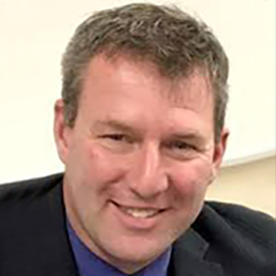

Sean Monteith is the Director of Education for the Hastings and Prince Edward District School Board. He spends time in the summer at his camp on Lac Seul First Nation, where his family is from. Sean has focused his attention on increasing graduation outcomes and rates for marginalized and racialized students and saw the largest increase for Indigenous student graduations in the KPDSB for Ontario 2013-2018. It is imperative that we not lose sight of helping our most vulnerable students and families with schools and families facing such an uncertain future.

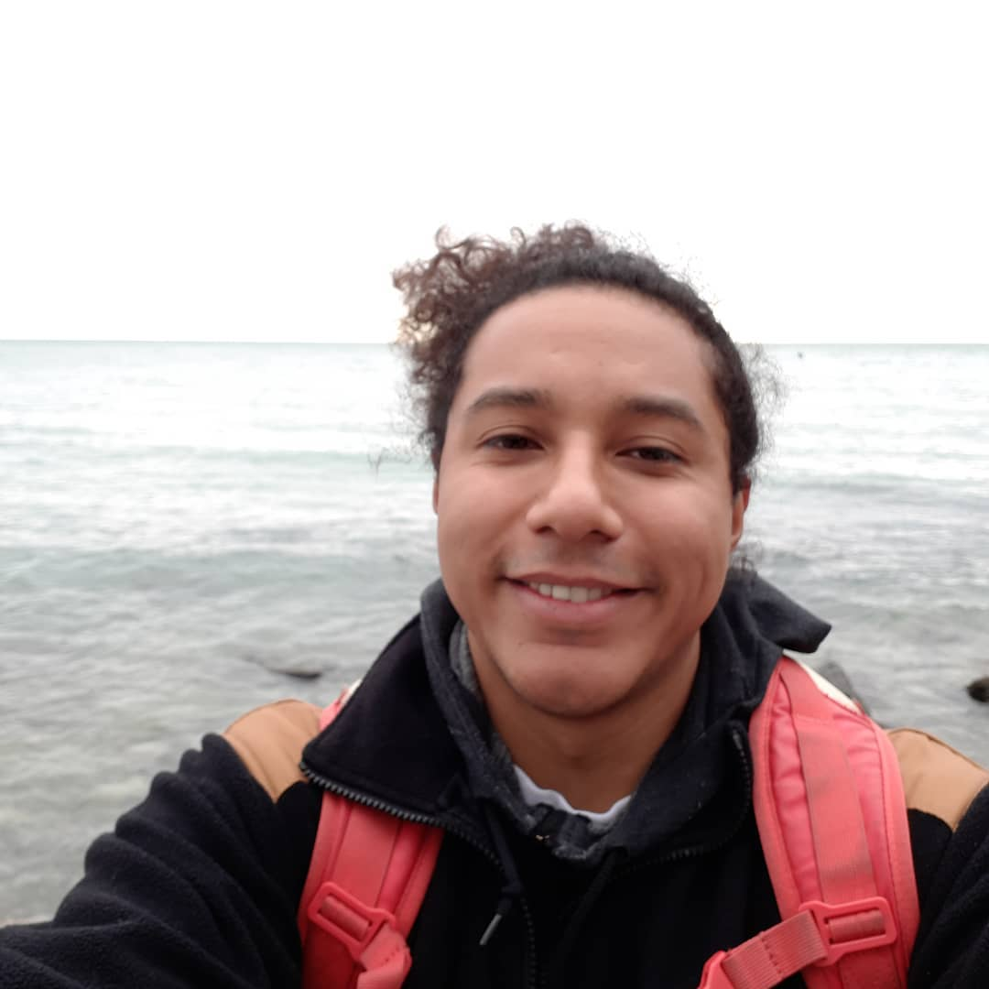

Jeffrey Kiyoshk Ross is an Ontario Certified teacher with over 10 years of communications, journalism, and marketing experience working with First Nation communities and organizations in Ontario. He has taught in Pikangikum, Pickle Lake, and Thunder Bay and develops and delivers curriculum that is informed by Canada’s FNIM histories and cultures. As a new member of the University of Toronto’s First Nation House as the Resource Centre Coordinator, Jeffrey has been able to help to develop and deliver resources that are centred on Indigenous knowledge, new materials to inform learning around the colonization of Canada, and housing the stories of the resiliency of Indigenous culture. Miigwetch.

Featured Events

# Charging the Soul: Mindfulness Session

## March 5 Time: 3:15PM to 3:30PM and March 6 Time: 3:30PM to 3:45PM

Join us for the guided mindfulness sessions during the conference to charge your internal energy. Enjoy your sessions facilitated by our virtual host, Danielle Denichaud.

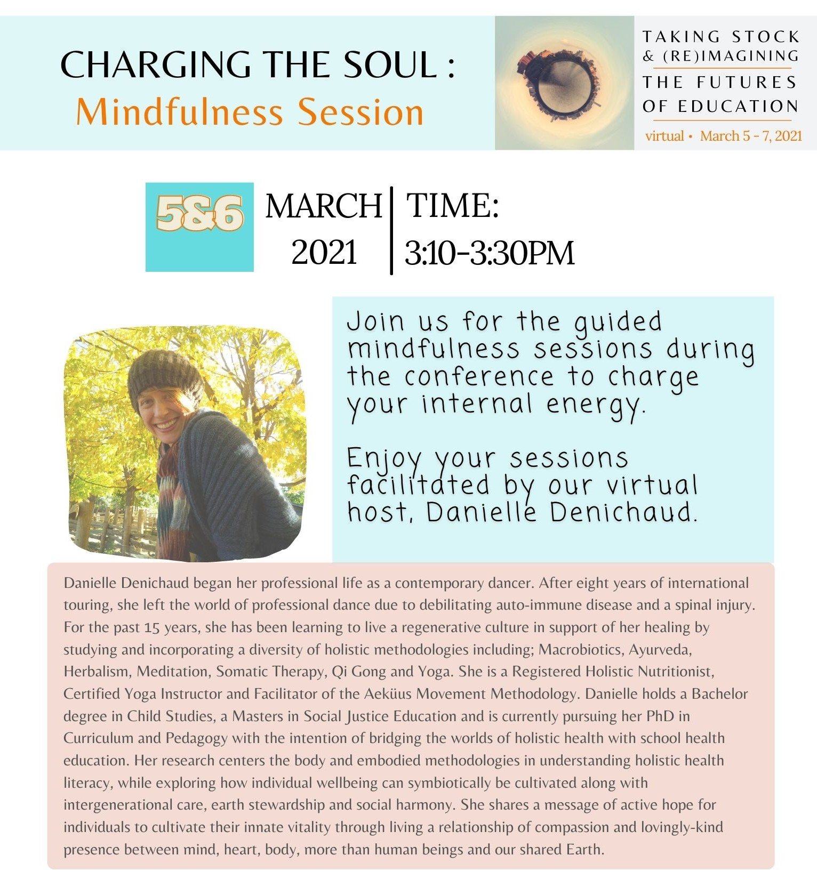

Danielle Denichaud began her professional life as a contemporary dancer. After eight years of international touring, she left the world of professional dance due to debilitating auto-immune disease and a spinal injury. For the past 15 years, she has been learning to live a regenerative culture in support of her healing by studying and incorporating a diversity of holistic methodologies including; Macrobiotics, Ayurveda, Herbalism, Meditation, Somatic Therapy, Qi Gong and Yoga. She is a Registered Holistic Nutritionist, Certified Yoga Instructor and Facilitator of the Aeküus Movement Methodology. Danielle holds a bachelor’s degree in child studies, a master’s in social justice education and is currently pursuing her PhD in Curriculum and Pedagogy with the intention of bridging the worlds of holistic health with school health education. Her research centers the body and embodied methodologies in understanding holistic health literacy, while exploring how individual wellbeing can symbiotically be cultivated along with intergenerational care, earth stewardship and social harmony. She shares a message of active hope for individuals to cultivate their innate vitality through living a relationship of compassion and lovingly-kind presence between mind, heart, body, more than human beings and our shared Earth.

# Creating Connections: Virtual Networking Event

## Love meeting people but hate networking? We get it!

March 6, 2021 Time: 3:55PM to 5:10PM

Join us for Creating Connections — a fun, energizing event where you’ll meet fellow students and OISE alumni for interesting conversations and exciting exchanges.

No small talk — just big ideas! Meet new people, make deep connections, and have fun in a supportive environment facilitated by virtual host, Sandra Kahale.



Strategist, facilitator, trainer, and host, Sandra Kahale, creates engaging online and in-person environments that help people connect, collaborate, and create. She’s famous for hosting networking events even introverts love.

Plenary Session and Panel

# Conference Plenary: The Futures of Education

## Moderated by Norin Taj

March 5, 2021 Time: 11:30AM to 1:00PM

#### Panelist names and biographies:

Nicole Miller is a principal with the Toronto DSB and a doctoral student at OISE in the Education, Leadership and Policy Program.

Paula Davis is currently completing her PhD at LHAE, OISE with a collaborative specialization in Ethnic and Pluralism Studies, at the Munk School of Global Affairs and Public Policy. Her research examines students'— who identify as African, and or Black—experiences in special education programs in Ontario public schools, from their point-of-view. Paula’s student-centered pedagogy as a classroom teacher reveals that when all pupils both see and feel themselves in their learning, the sky’s the limit to their learning engagement. She is the 2019 recipient of the Elementary Teachers of Toronto, Excellence in Teaching Equity Award.

Dr. Kiran Mirchandani's research and teaching focuses on gendered and racialized processes in the workplace; critical perspectives on organizational development and learning; criminalization and welfare policy; and globalization and economic restructuring. Using qualitative, interpretive approaches, her work is based on qualitative interviews with transnational service workers in India and workers in precarious jobs in Canada.

Ruth Hayhoe’s research has mainly related to Chinese higher education and educational relations between East Asia and the West. She has been interested in the ways in which cultural values and epistemologies from Eastern civilizations may provide a resource for new thinking in global higher education development. She is also interested in the intersection between Asian ways of knowing and women's ways of knowing, and questions of gender in cross-cultural leadership, topics stimulated by her personal experience of institutional leadership in an Asian context.

# Where is the campus? Where is the Community? What matters for International Students?

# Panel Session moderated by Phoebe Kang and Latifa Soliman

## March 6, 2021 Time: 11:40AM to 1:00PM

#### Panelist names and biographies:

Elizabeth Buckner, Ph.D., is an Assistant Professor of Higher Education at the Ontario Institute for Studies in Education, University of Toronto. Her research examines how globalization affects higher education, and recent projects focus on privatization and internationalization. Her recent publications have appeared in Comparative Education Review, Higher Education, and the Sociology of Education.

Meng Xiao is a doctoral graduate specializing in social justice education from OISE. Meng spent years as a community activist and researcher at OISE prior to founding Dream X Education Inc., an educational organization supporting international student engagement in North American. A big believer, and educational practitioner, in enriching international students’ whole person journey as global citizens based on their wellbeing, identities, and strengths. Her vision is to empower every international student to achieve their success, improve their engagement motivate their full potentials in inclusive education.

Marlene Hood is an international student from Chile, currently completing her fourth year of the EdD program in Educational Leadership and Policy Program at OISE. Her research focus is specifically on special education, including, but not limited to, special education policy analysis, professional development linked to collaboration, inclusive practices, inclusive curriculum design, organizational theories, qualitative and quantitative research methods, and program evaluation. She brings in her professional background as a special education teacher, coordinator, and administrator in private and public institutions to her collaborations as a graduate student and to her work.

Gauravi Lobo currently is completing her MEd in Social Justice Education with a collaborative specialization in comparative, development, and international education. She identifies as a cishet woman of color from India. Before coming to OISE, she worked in a mix of roles in the education sector in India, usually involving running workshops on a variety of socio-emotional subjects, like adolescent mental health and sex education. She also did a lot of collaborative and partnership building with schools, parents, community organizations, and NGOs.

You(Yoyo) Zhang is in her third year of the Ph.D. program in higher education and also her third year studying in Canada as an international student. She also served as the President of the International Students Association at OISE between 2019-2020. Born and raised in China, You studied English and Linguistics for her BA and MA, and worked in international education. She also studied in the U.S. for her MA before coming to Canada.

Featured Performances and Presentations

# Featured Performance: Into the Forest

# Building Community and Criticality: Arts-Based Learning Through Online Collaboration

March 5, 2021 Time: 2:00PM to 3:10PM

#### Presenters’ names and biographies:

Hoang Anh Thu Nguyen is a yoga teacher and sound practitioner.

Wales Wong is a PhD candidate in the Department of Curriculum, Teaching & Learning at OISE.

Yecid Ortega is a PhD in the program of Language and Literacies Education (LLE) specializing in CIDE at OISE.

Norin Taj is a PhD candidate in the department of Educational Leadership and Policy, specializing in CIDE at OISE.

# Back to Work After Breast Cancer

March 5, 2021 Time: 2:00PM to 3:10PM

For cancer survivors, returning to work means returning to normalcy and a sense of well-being. The COVID-19 pandemic disrupted this transition, through job loss, delayed returns to work and fears of working with an increased risk due to cancer status.

In my vGSRC presentation, I explore the themes of these varying and unique working challenges, to understand how a pandemic can have an even greater impact on lives already touched by critical illness. The aim of my project is to inform the supportive efforts for cancer survivors returning to work in the coming year.

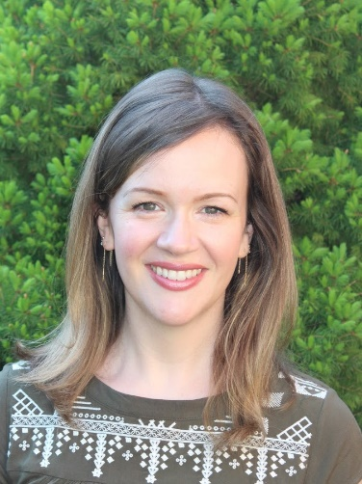

Elise Wouterloot is a PhD Candidate Clinical and Counselling Psychology

# Addressing Anti-Black Racism in ESL

March 5, 2021 Time: 3:40PM to 4:50PM

This presentation describes an ongoing duo ethnographic self-study research project that engages conversations around anti-Black racism in the teaching of English as a second language (ESL). We utilize an antiracist theory framework to explore the possibilities and challenges for ESL teachers to plan, execute and evaluate lessons relevant to the students’ academic needs.

This research is significantly important for ESL teachers in the manner how they engage with materials to address issues of anti-Black racism and for researchers who are seeking alternative modes of doing research that are more in line with both the researchers’ identities and the communities they serve in Canada and elsewhere.

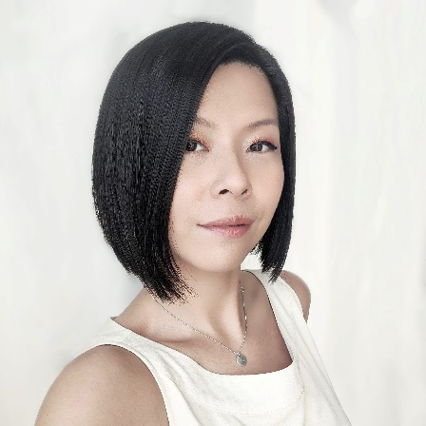

Wales Wong is a PhD candidate in the Department of Curriculum, Teaching & Learning at OISE.



Yecid Ortega is a PhD in the program of Language and Literacies Education (LLE) specializing in CIDE at OISE.

# Learnings from African Indigenous Women

March 6, 2021 Time: 10:00AM to 11:10AM

Instead of submitting to the Eurasian colonized culture currently presiding over Africa and the globe today, which by Nature oppresses the woman, and for which the woman is constantly in a battle to be free from, could a return to our Ancestral African Indigenous culture be the answer for her to experience herself dignified and empowered?

In this presentation, I draw upon our African Indigenous cultural knowledge and practices to show how our African Indigenous culture presents the African Indigenous woman. The conclusion presents the African Indigenous culture as one that aligns with Nature, and, following Nature, the African Indigenous woman is honoured, well respected, empowered, and regarded as the elder of the night that presides over the birth of a Nation and the destiny of their children.

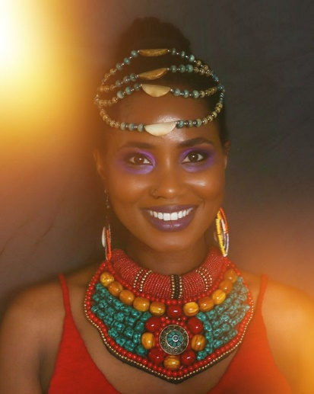

OSHOLENE OSHOBUGIE is a PhD Student in Social Justice Education at the Ontario Institute for Studies in Education.

Twitter: oise_gsrc

Facebook: OISE GSRC

For more info contact: [oise.gsrc@utoronto.ca](mailto:oise.gsrc@utoronto.ca)

virtual-OISE Graduate Student Research Conference 2021

en linge-Colloque de recherches des étudiants de l’IEPO 2021

**End of page**