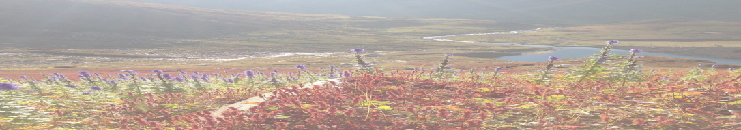
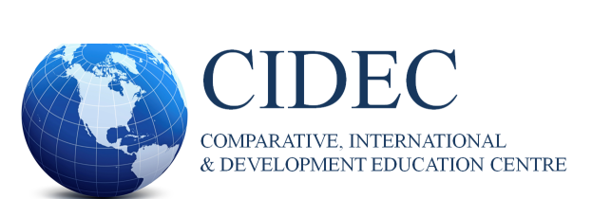
NEWSLETTER | SPRING 2021

Editorial Team Inside this Issue

Editor: Dr. Carly Manion
- Director’s Message
- J.P. Farrell Student Research Symposium
- Community News –
- CIDE Student Association
- CIDEC Interest Groups
- Dr. Kathy Bickmore Interview
- CIDE June 2021 Graduates
- CIDE Faculty, Alumni, and
- Students’ Research Reports,
Initiatives, Awards, Presentations, Publications
Co-editor: Neelofar Ahmed (Doctoral Student)

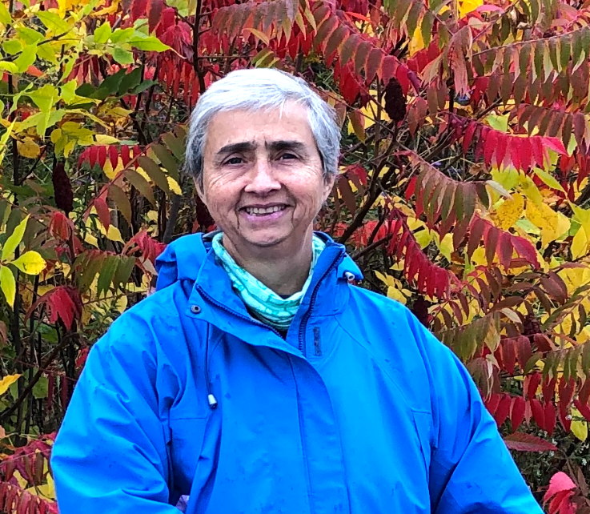

Dr. Kathy Bickmore
Inside this Issue

Director’s Message

Thanks for participating in the Comparative, International, and Development Education Centre (CIDEC) and graduate specialization (CIDE)! The long COVID19 pandemic has created and reinforced many hardships—along with some inventive solution-finding that, I hope, will help many people and ecosystems, including yourselves, to learn and eventually to thrive.

Congratulations to CIDE’s June 2021 graduates since last Fall—reflecting M.Ed., M.A., Ed.D., and Ph.D. degrees in our six collaborating programs: Social Justice Education (in SJE), Higher Education (in LHAE), Educational Leadership and Policy (in LHAE), Adult Education and Community Development (in LHAE), Language and Literacies Education (in CTL), and Curriculum and Pedagogy (in CTL).

Please join me in appreciating CIDE/CIDEC’s excellent administrator, Sazna Aliyar (cidec.oise@utoronto.ca). Among Sazna’s many accomplishments this year, she constructed a new-improved CIDEC website (https://www.oise.utoronto.ca/cidec/). Thanks, also, to this year’s CIDEC GA (Graduate Assistant), Neelofar Ahmed, for tremendous accomplishments, including co-editing two newsletters, co-organizing CIDE’s annual Joseph P. Farrell Student Research Symposium in February, and more. Not least, thank you to CIDE Student Association co-conveners Nooreen Rahemtullah and Tatiana Feitosa de Britto, for their crucial work bringing people together in a difficult year. CIDESA leadership changes each year, as students move along. Please contact the CIDESA (oisecidesa@gmail.com) to assist with starting up activities for Fall 2021, and/or to initiate an event or a new interest group.

Spring 2021 Newsletter

Inside this Issue

Director’s Message, Continued

Welcome to the faculty newly affiliated with CIDE since our last newsletter: Abbie Bakan of SJE, Alexandre
Cavalcante of C&P in CTL, Diane Farmer of SJE, and Jennifer Wemigwans of AECD in LHAE. CIDE
faculty offer CIDE courses in our graduate specialization, cross-listed with their home programs, and engage
with the CIDE Centre in various ways.

Especially welcome are the terrific set of new students accepted to begin in CIDE in September 2021! Please
save Thursday, September 9, 5:00-6:30p, as the tentative date for CIDE’s Welcome Orientation, online via
Zoom. Along with providing CIDE-related information and answering questions for new students, returning
students, faculty, and visiting scholars are also welcome to (re-)introduce themselves. ‘Normally,’ we would
celebrate with dinner together. It has been nice to include people from across the time zones in CIDEC
activities, but eventually it will be nice to get some people together in person as well.

This Newsletter issue includes lots of goodies including Interest Group activity, individual publications and
awards (including CIDE graduate Dr. Danielle Freitas’ CATE thesis award!), recent graduates to
congratulate, CIDE alumni news, artwork, comparative and international education-related periodicals,
notes from the field… We would love to hear from more of you, near and far, soon and often: please send
your news and views for a future newsletter: cidenewsletter@gmail.com.

It has been an honour and a pleasure to serve this beautiful community of people doing such important
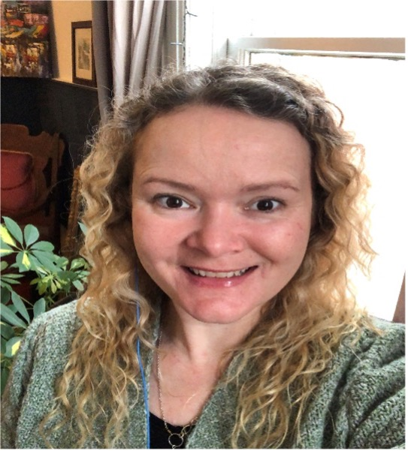
constellations of work. My term as CIDEC Director is coming to an end this June 30. I am truly pleased to (re-)introduce to you the wonderful leader selected to be CIDEC’s new Director, for a three-year term beginning July 1, 2021: Dr. Carly (Caroline) Manion. Dr. Manion, a faculty member in Educational Leadership and Policy (LHAE), has been a faculty member, student advisor, and Acting Director, for several years. Since completing her PhD in CIDE in 2010, Carly has engaged in extensive professional work in East and West Africa, North America and elsewhere, conducting research related to equity and social justice, gender and education, role of international organizations, civil society, public policy, and teacher development. Welcome and thank you, Carly!

Dr. Carly Manion

All are warmly welcome to engage with the CIDEC community.

Peace!

Kathy Bickmore (CIDEC Director and Curriculum & Pedagogy program, CTL)

Spring 2021 | Page No. 2

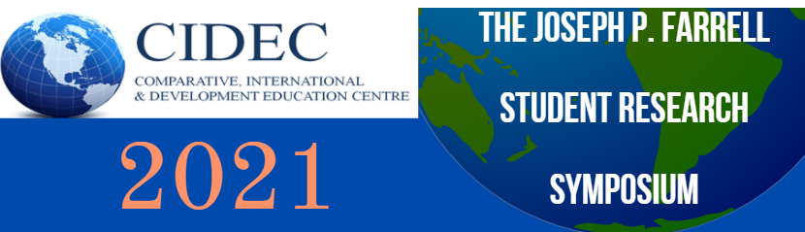

This year, the CIDEC Joseph P. Farrell Student Research Symposium was held on Friday, February 19, 2021. The CIDE community came together to share and learn about the research that students are currently engaged in. It was exciting to see that the symposium was attended by a large audience who participated in the discussions, enjoyed Dr. Vandra Masemann’s short remarks on Joseph Farrell and attended the social event. Special thanks to the presenters, volunteer chairs, CIDE GA, Neelofar Ahmed, CIDESA, Carly Manion, Kathy Bickmore and Sazna Aliyar for their valuable contributions to making this year's event a resounding success!

9:00am: Symposium Opening and Welcome [CIDE Director, Dr. Kathy Bickmore]

Session 1 – Teachers, Leadership and Growth of Private Schools in the Middle East and Korea [Chair: Dr. Carly Manion]
The Professional Identity and Career Longevity of Native English-Speaking Teachers [Jasmine Pham, MEd student, Educational Leadership and Policy, LHAE]
An Exploration of School Leadership in International Schools In Kuwait, Middle East[Mary Ellen Kelly, EdD candidate, Educational Leadership and Policy, LHAE]
The Growth and Impact of Private Schools in the Gulf Cooperation Council Countries [Susan Kippels, EdD student, International Educational Leadership and Policy, LHAE]
COVID-19 and its Impact on International Development – An Autobiographical Reflection (pedagogy training in virtual Egypt) [Farrah Kamani, MA student, Curriculum & Pedagogy, CTL]

Session 2 – Policy Discourses and Practices: Equity and Climate Change in Schools, Universities, and Communities
Short remarks: Joseph Farrell and CIDE – Emeritus Professor Dr. Vandra Masemann
Not a Third Mission: Extension Policy-Making and Institutional Practices in Brazil [Magdalena Martinez, PhD candidate, Higher Education, LHAE]
Shifting Conceptions of Equity in Education: A Critical Policy Analysis of Official Policy Discourses in Peru [Gisele Cuglievan Mindreau, PhD candidate, Higher Education, LHAE]
The Dilution of Equity in International Climate Change Politics - Implications for Comparative International Research and Education [Shashank Kumar, PhD candidate, Curriculum and Pedagogy, CTL]

Session 3 – Curriculum and Pedagogies: Critical Global Citizenship, Difficult Histories, Violence and Peace [Chair: Neelofar Ahmed]
Acting to action: Soft to Critical Global Citizenship Education in the Theatre/drama Classroom [Nooreen Rahemtullah, MEd student, Educational Leadership and Policy, LHAE]
Education: The Double-Edged Sword of Violence and Peace [Sigrid Roman, PhD candidate, Educational Leadership and Policy, LHAE]
Learning to Teach the “Difficult Histories” of Brazil: Historical Thinking for Peacebuilding at the Pontifical Catholic University of Rio de Janeiro (PUC Rio) [Ana Luiza Lacerda, PhD student, Curriculum and Pedagogy, CTL]
Changing the meaning of the Images in the History Textbook: An indication of Internal Colonialism [Sudhashree Girmohanta, PhD student, Language and Literacies Education, CTL]

Spring 2021 | Page No. 3

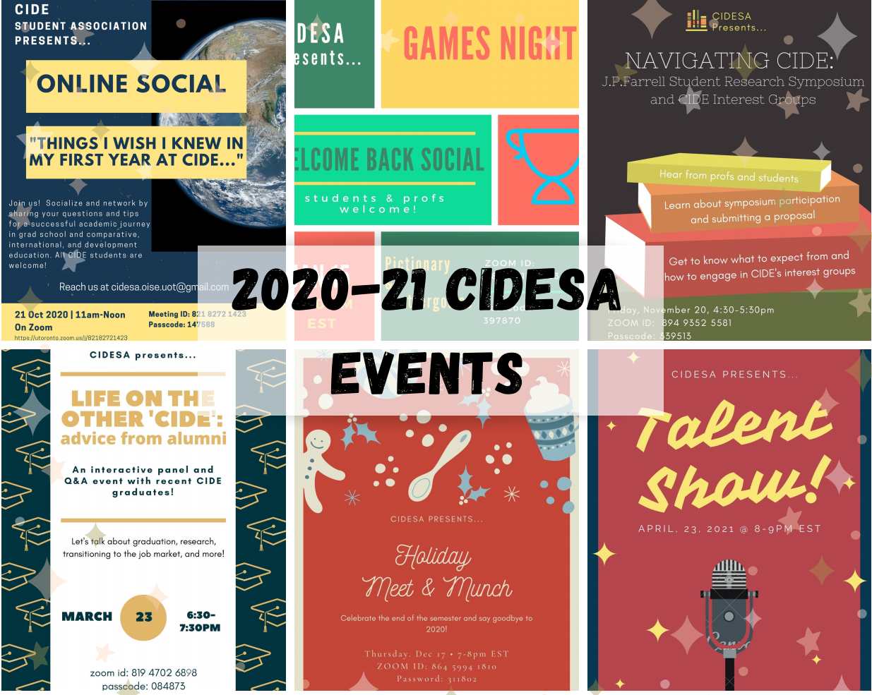
Community News
Inside this Issue

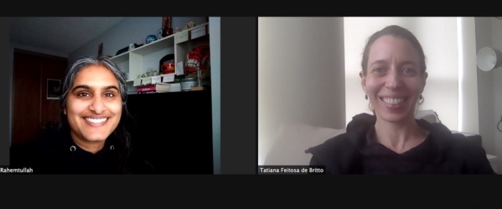
CIDE Student Association End of Year Thank You from 2021 Leadership

Thank you!

It sure was a different school year for everyone! Managing to get together and create community through our events has made it unforgettable. We could not have done it without the support from each and every student, faculty, and staff that participated in our academic and social events. Thank you for making our work (and play!) possible. We wish everyone a safe and fun summer! Stay strong and see you next year! ­ CIDESA Core Team

*Note that the CIDE SA leadership will be transitioning in the next school year, and we hope that you all will consider participating in this fun and valuable group. Please watch for more information about these opportunities coming up in September!

Spring 2021 | Page No. 4
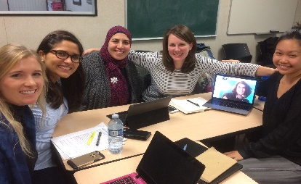
CIDEC Interest Group News
Inside this Issue

Under the care of the CIDE Students Association, CIDEC is home to a dynamic, fluctuating set of special interest groups, comprised of diverse students and some faculty. Some, such as those profiled below, emphasize a particular world region. Other Interest Groups have gathered around shared interest in Central Asia (including post­Soviet regions and Afghanistan), and thematic interests such as Teachers InCIDE and Resisting Islamophobia/Xenophobia. Recently, a CIDE member has initiated the possible formation of a new interest group around education in emergency and/or armed conflict settings. If you would like initiate a gathering around an interest area that might become an on­going Interest Group, please contact the CIDESA (cidesa.oise.uot@gmail.com), cc to the Director c/o the CIDE office: cidec.oise@utoronto.ca, to let us know of your interest. Next, communicate with some interested people, then circulate a notice through the CIDEC listserve (handled by administrator Sazna ­ cidec.oise@utoronto.ca) with a short paragraph explaining your proposed Interest Group focus and inviting interested participants (students, faculty, alumni) to reach out to you. If possible, announce your first gathering – or include a doodle poll of people’s date/time preferences. Create and include a gmail account for the group, so that your private email does not need to be circulated (for safety reasons). Later, your group may wish to add an event to the CIDE calendar, in consultation with those named just above, and to write a paragraph for the CIDEC website.

Inside this Issue

Afghanistan/Central Eurasia Education Research Group

Prof. Sarfaroz Niyozov and Dr. Stephen Bahry have recently collaborated with Profs. Duishon
Shamatov and Mir Afzal Tajik of Nazarbayev University Graduate School of Education, Kazakhstan.
Together, the research team has been awarded “Aga Khan Foundation Global Research Grant for
2021­2022”. The research project entitled Exploring school-based education stakeholders’ perspectives on
quality of education in Kyrgyzstan and Tajikistan in the context of School 2030 initiative will include
field visits to 15 schools in Kyrgyzstan and 15 schools in Tajikistan.
Inside this Issue

Grupo de Estudios Latinoamericano-OISE (GELO) – Latin American Study Group

The Latinamerican Studies group (GELO) gladly invites those who are interested in knowing more
about research and education in the region to reach out. Email yecid.ortega@mail.utoronto.ca for
more information. On April 28, we hosted a presentation about el Buen Vivir, political ontology and
decolonization of mestizaje. Also those interested in learning Quechua (Indigenous language of Peru) visit
their website for more information (https://www.facebook.com/indigenasdelperu)


Inside this Issue

South Asia Interest Group

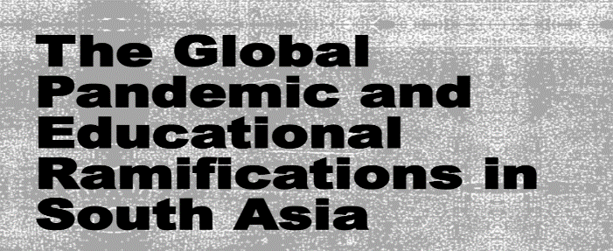
The South Asia Interest Group members, Neelofar Ahmed, Prerana Bhatnagar, Shahidul Islam, and Sarah Alam came together at the Center for South Asian Studies, the University of Toronto, to present findings from their recent research publication at the CSAS Graduate Symposium 2021. Chaired by Sarah Alam, the authors highlighted the effects of the pandemic on education in South Asia. They emphasized the need to prioritize education, strengthen school leadership and technological infrastructure to improve the poor human development outcomes and longstanding structural inequalities within the three countries.

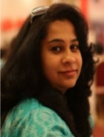
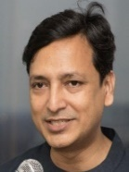
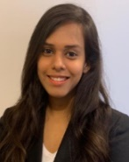


Spring 2021 | Page No. 5

CIDEC Interest Group News, Continued

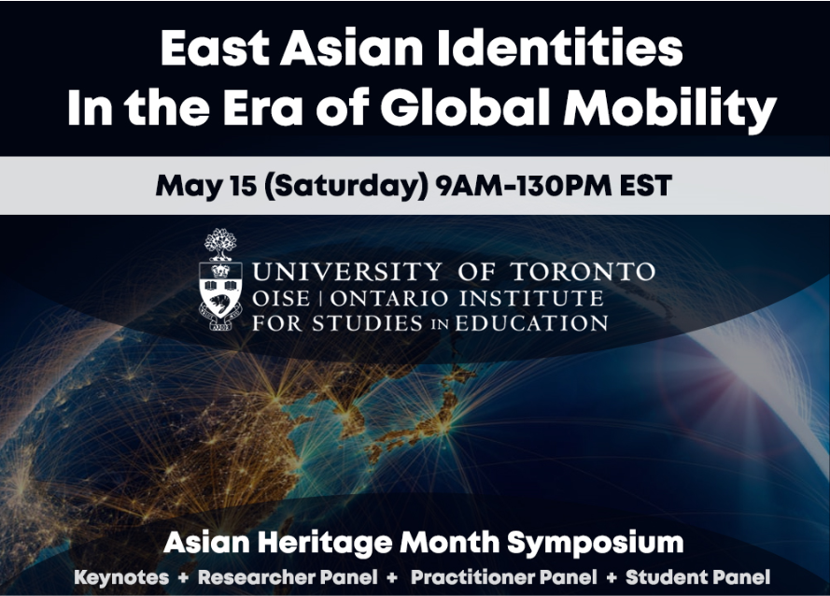

East Asia Interest Group |

Symposium Imvitation

The theme for this Symposium explores the ways in which East Asians come to terms with their identities outside of East Asia. As awareness of Anti­Asian racism grows, the struggle of finding where East­Asian identifying individuals belong and
where their identities lie, has emerged as a key concern impacting their sense of self­worth and well­ being. Many feel that they are seen as the 'Other', a perpetual foreigner not only in their country of residence but also in their country of origin, regardless of their citizenship or

permanent residence status.

This Symposium examines the space that many East Asians are in as they navigate their identities between the country they reside in and the one they belong to through ancestry, through personal stories, and research. Please Register here:

Keynote Speakers:
Dr. Ruth Hayhoe, University of Toronto
Dr. Henry Yu, University of British Columbia

https://utoronto.zoom.us/meeting/register/tZ0qd­6urDwjHd1RTBDecIQbPswVznOAj8EM
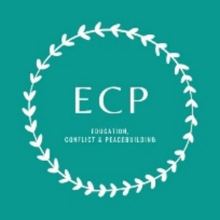

Education, Conflict, and Peacebuilding Interest Group

Education, Conflict & Peacebuilding (ECP), hosted the INEE Meet-up for Canada on April 26th. This was an opportunity to connect with those working, researching, or studying within the field of education in emergencies. Participants were asked about the key possibilities and challenges of EiE work in Canada, and how the pandemic had highlighted particular needs, priorities, or possibilities for EiE.

You can now follow us on Twitter @ecp_ig and on LinkedIn https://www.linkedin.com/company/ecpig. We’ll be glad to highlight your research, work, and accomplishments that are related to the field of ECP! Stay tuned for a release of our website, which is being built by developers from the Women in Tech program – an initiative that trains female programmers in conflict-affected areas.

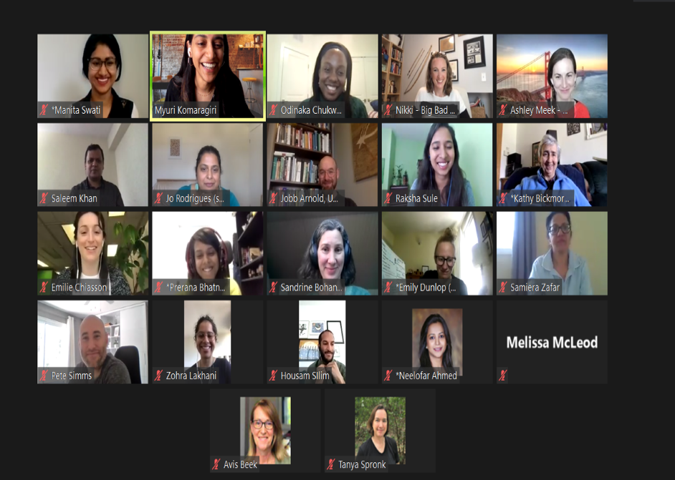

Immigrant and Refugee Education Interest Group (IRE)
Spring 2021 | Page No. 6
Emmanuelle Le Pichon, Dr. Sarfaroz Niyozov, Antoinette Gagné, Stephen Bahry , Max Antony­Newman, Dania Wattar and others, have created a research interest group on the topic of students with immigrant or refugee background. The group is entitled Immigrant and Refugee Education Interest Group (IRE). Everyone is welcome to join! Please feel free to contact Dr. Le Pichon at e.lepichon@utoronto.ca to join the group.

Meet CIDE Faculty - Dr. Kathy Bickmore

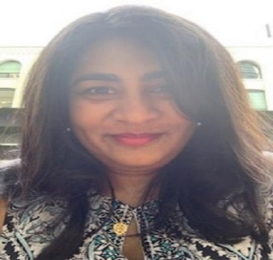

Interviewed by

Munira Tayabali `

Dr. Kathy Bickmore

My name is Munira Tayabali. I graduated from the CIDE program (MA) in June 2020, thanks to Professor Kathy Bickmore’s consistent, meticulous, and firm supervision. It was a long journey, laced with the usual vicissitudes of life, but I reached my destination with Mwalimu Kathy on my side along with many other contributors and well-wishers. This interview is a personal tribute to Professor Bickmore, my mentor and my teacher, and so much more.

I also wish to thank Prof. Carly Manion for the opportunity to include this interview content for CIDE’s Spring Newsletter. Life is indeed a circle, as Kathy says below. In 2015, Prof. Manion, with whom I had studied in the CIDE Program, had graciously agreed to be my very first, formal interviewee for Prof. Heather Sykes’ course in Research Methodology. Carly had barely known me then, but during my interview with her about her own research in Gambia, she had coached me on how to ask the W5 questions and guided me through the conversation. Carly’s interview laid the essential groundwork for the 27 interviews that I would conduct in rural, northern, Tanzania in 2016, for my own ethnographic research thesis that Kathy had supervised. Thank you Carly, for stepping in then, and again this year, and, for your continued dedication to CIDE and its students.

Finally, I also wish to thank Ms. Neelofar Ahmed for curating this content for CIDE’s newsletter.

“. . . a lucky person learns by doing, and by communicating, and by having relationships with people. I learn from people different from myself, . . . from different backgrounds. . . as from people far away.” Kathy Bickmore, March 17, 2021

I sat down with Kathy to learn about her background, her philosophy of work, and her future pursuits. As her student, I also wanted to briefly share with the readers why I had chosen Kathy as my supervisor, and how studying with her for six years has had a positive impact on my life, continued impact on my job at the University of Toronto, and on my state of being.

Q: How did you end up in Toronto from an Ivy League?
KB: Well, life is funny – it goes in circles sometimes. I grew up in the United States, across the lake from Toronto, in Rochester, so, this is my home region. I worked for several years during and after my undergraduate education, developing and teaching a mini-course, 20+ plus hours, in Alternatives to Violence. I already had that interest in using education to help people speak for themselves for justice, inclusion, and democracy. My course included non-violent action and conflict-resolution, on personal, local, and more global levels. It focused on what people can do about violence and injustice in social institutions and communities, large and small. It seemed strange to have someone without graduate education teaching teachers in graduate school, so I went to a master’s program at the University of Iowa and studied social studies and international development education. At U of Iowa, I discovered the depths of my ignorance about the rest of the world. It was pretty incredible that, in our little, well-intentioned, peace-building course - instead of assuming the United States was the light of the world making everything better, now we had framed the United States as the big problem - the assumed power and agency and thinking all stayed in the global North. So, instead of just completing my master’s degree so I could go back and continue teaching teachers (and youth), I needed to learn more. I applied to Stanford University’s School of Education, which had a very strong, critically-minded, program in Comparative International Education.

Spring 2021 | Page No. 7

Dr. Kathy Bickmore Interview, Continued

I spent four years there, learnt a ton. It was great having classmates from all over the world. At the time, I was most interested in how North Americans learned about the rest of the world, to help build justice. My wonderful international classmates in that small program also had critical perspectives on development, and so it worked out well.

Q: Why Canada?
KB: Some of it is just the way the job market works… I didn’t go directly to Toronto from Stanford. I was recruited back to Cleveland, Ohio where I had lived and taught before graduate school and led this Alternatives to Violence project as a ‘non­academic’ activist teacher. I had met my partner just as I was finishing at Stanford, who then went to Toronto, while I started in Cleveland. For the first four years, we commuted through the snow belt. This was not the age of cell phones: You would say, ‘Ok, I am leaving now’, and if there wasn’t too much of a blizzard, 5­6 hours later, you would arrive! In a way, I miss that, because the journey back and forth provided me with a lot of time to think, which I actually haven’t had much since. My first day of work at the University of Toronto, in 1995, was the day the UofT signed the merger agreement with OISE. The Dean that hired me was Michael Fullan. At UofT, I didn’t begin in comparative international education job, per se. I was hired by both sides of the street (the Faculty of Education for teacher education, and OISE for scholarly work in education for democratic conflict and peace building). I was a teacher education practitioner, but with a scholarly trajectory: in those days, the few faculty who did both were called ‘blended.’ My first comparative education task was to learn Canada.

Q: As an American citizen, how easily could you work and integrate within Canada?
KB: Since I study and teach citizenship, it was important that I become a ‘Canadian’ as soon as I could. I felt quite dehumanized by the immigration process, frankly, although not as much as many newcomers to Canada are. I spent hours on hold with machine voices talking to me, but English is my first language, and I came in with my American (now dual) citizenship, and a job (facilitated by NAFTA).

Q: From teacher education to Comparative International Education, it now makes sense to me how you knew so much about the classrooms and students and schools. Could you talk a little about how you have arrived at this juncture, where you are now doing peace and conflict studies, researching countries afflicted with conflict and collecting amazing data?
KB: Well, on one level, I have been working in related areas, one way or another, all along. My masters is in social studies education, plus international development education. My doctoral work is in international comparative education, but my research was in California. My dissertation is called, Practicing Conflict: Citizenship Education in High School Social Studies.’ The teachers participating in that research all did some form of transnational education. So, I have been studying education for democratization, peace­building and constructive conflict from the beginning, from multiple viewpoints to help us understand that kind of work. That hasn’t changed. The details have changed, in that I keep learning and expanding my horizons, and I am so grateful for that. I have always been most interested in school and classroom level work, kid­level work. Sometimes it’s not classroom, in the sense of a formal curriculum – for instance, I studied peer mediation conflict resolution leadership programs. That is one of the places where kids in schools get to speak for themselves; and handle problems that interest them, using their own voices; and can teach other kids and so forth. Incidentally, while I was doing my doctoral work, I was teaching grade 8in East Palo Alto, California, which is across the proverbial tracks (Highway 101) from Stanford/Palo Alto. East Palo Alto is a historically Black community with an interesting newcomer immigrant population, where Gloria Ladson­Billings did her field work for The Dreamkeepers, about culturally responsive and sustaining pedagogy. I went back and forth on my bicycle. My ghettoized, brilliant East Palo Alto kids, many of whom had never seen the Golden Gate Bridge, knew about their own diasporas where they came from, and about wealth and poverty entwined with gender, sexism, race, and racism. One of the things those young people did with

Spring 2021 | Page No. 8

Dr. Kathy Bickmore Interview, Continued

me that year in social studies was to develop a simulation ­ a kind of an alternative United Nations­type deliberation ­ around the then­brewing Gulf War. I just drew a geographic circle around the Middle East region, to include the countries most directly affected plus the influencers such as the Soviet Union, United States. The kids were so smart, in the insights they shared, each representing a nation­ state and its interests in that conflict, in this problem­solving negotiation (simulation). I was delighted because, when they were taken seriously, they took themselves more seriously. Even though they didn’t have the social status for much local mobility, either in the economic system or across the region ­ they had this global understanding about the roots of the Gulf War conflict.

From Stanford, I moved back to Cleveland, to re­encounter my old self now that I had become some kind of an academic ­ a very peculiar period of time, and as I said, also commuting back and forth to spend every few weekends in Toronto. So, the settings changed. I did research in the Cleveland area when I was in Cleveland. Later, I did research in big cities across Canada, in the Safe and Inclusive Schools project, which introduced me to Canadian educational cultures and policies. Collaborative projects attentive to gender dynamics included anti­bullying with Japan, democratic citizenship education with Tula Russia and the UofT Munk Centre, and peacebuilding education with a school in rural Jamaica. Another project in Toronto was about diverse students’ opportunities for open dialogue about conflicting viewpoints, infused in different subject areas, in different kinds of classrooms, in different grades. By then, I felt I sort of knew Canada. After that, I started really doing international comparative education research. But you see how the basic themes haven’t changed.

Q: Your research and courses begin at grassroot level field studies and you start with the kids and help shape them to become peace-builders of the future. Would you say that these nuggets of varied experiences helped frame your philosophy of work?
KB: Yes, I mean, a lucky person learns by doing, and by communicating, and by having relationships with people. I get to learn from and with people different from myself, from different backgrounds or whatever, nearby as well as far away. Of course, in local research, you can spend more time in the field, as you will remember [from your own thesis research]. This place in Tanzania [where you did your research] ­ presumably, you could learn more with even longer period of time, but you learned a lot in the small window of time you had. Before grad school, I had created a self­contained peace­building education course, that would be an add on (you could do it as a weekend workshop, or Tuesdays and Thursdays over a semester, wherever). Whereas, what I have been trying to do ever since is not to just add­on justice and peace education as more content. Teachers are just too busy (even before COVID19 and budget cuts)! Instead, my research and teaching try to inform some ways educators can actually transform what teachers and diverse students already do inside the regular, required parts of schooling ­ including the social conflict learning opportunities embedded in language, social studies, science and the rest, as well as in daily human relations.

Your [thesis] study also focused on the ways the teachers taught what they had to teach. That [classroom academic work] is where people actually spend most of their educational time, so there is space where potential transformation could take root. So, I certainly don’t have illusions that I know how to create democratic peace across the world. It’s complicated. You try to learn in ways that enable people to have conversations that could be useful to educators, and to use the differences among contexts to facilitate that sense of possibility. Which kinds of educational content, pedagogy, and conflict management make things worse ­ reinforcing social division and violence, or disconnecting from the conflicts the students are living and concerned about? On the other hand, which kinds of education can help to create critical, open­ended understanding, and to give young people a sense of protagonism – doing, not just having things done to them ­ in relation to the social systems where they live?

Spring 2021 | Page No. 9

Dr. Kathy Bickmore Interview, Continued

Q: So, what’s next for Kathy?
KB. Well, this year I am finally wrapping up this Peace-Building Citizenship research project, which has been extended year after year, adding grad students, adding more countries, and so on. There is plenty more to do. I have a smaller project with a colleague and an NGO doing student anti-bias leadership work in some First Nations communities, which we will finish around this year, too. My sabbatical was postponed for six months because of COVID19 – which is great actually, because my students weren’t done yet, and neither was I. So, July 1, 2021 to June 2022 is the sabbatical, and I hope to spend most of it in Latin America. In addition to Mexico, where I did some of the peace-building citizenship research, I have been developing some good relationships around democratic education in Chile, where I taught an intensive doctoral course (online) this January, all crammed into one week, and of course in Spanish, but lovely: can you imagine a grad course with only about 6 students? Everybody had time to participate fully. At OISE and in my undergraduate course in Victoria College (UofT), I usually have more than 20 per class, so I enjoyed that and learned a lot. Chile is creating a new Constitution: the one they have now is the same one they had during the dictatorship. So, it is a very interesting time for citizenship and peace building. I hope that Covid-19 will allow me to go there. I have been waiting for this for a long time, and I could not be more grateful. My sabbatical to Latin America was half-planned when they invited me to Harvard. So, I said, ‘how about the following year?” Can you imagine, if my visiting Professorship at Harvard had been only online? What a disappointment! But, fortunately, in 2022-2023 I will be going to Harvard. We’re hoping that Covid-19 will be behind us by then.

Q: This is a question to myself: Why did I choose you as an interviewee? I would like to share with the readers, the rationale for my choice, as well as the 5 lessons that I have learnt by studying with you, that continue to help me grow.
MT: In 2015, I learnt that my own thesis supervisor would be leaving the country. I approached a few OISE faculty in a desperate search for a new supervisor. They all turned me down because their fields of studies didn’t align with mine. I finally decided to approach you despite many students warning me not to do so. In 2013, during the CIDE orientation, the students I spoke to appeared terrified of your exceedingly high expectations. I told myself, ‘over two decades ago, I crossed the ocean on my own to Canada, and I began a new life in this country, what could be more challenging than that?” I had absolutely no idea what I was getting into being your student; a ton of hard work, intense attention to detail and high degree of accuracy, an expectation to always go an extra mile with each task, and those countless revisions! All of that paid off in so many ways. As soon as I had completed my thesis, my unit offered me a permanent job. Since 2015, I had been applying the strategies and skills that I was learning from you to both my professional and personal life. These tools continue to build my professional confidence and have helped me excel at work. I would like to share some of these with the readers:

Always have your ‘So What? up your sleeve: Whether it is for a thesis statement, a work project, or a life’s decision, have the W5 as your elevator pitch ready in your pocket.

Develop resiliency to criticism and countless revisions: It is exhausting to be at the receiving end of these, but they help you grow, and develop thick skin. The end product is even better than your first draft.

Work at becoming a pretty darn good editor – it is an excellent skill to have. I edit everything, text messages, WhatsApp messages, twitter feeds, emails, notes, verbal speech, and well, I drive people and organizations crazy in the process!

Do a thorough fact-check with reliable sources to support your statements and research: You will develop excellent and strong research skills.

Finally, to grow into a strong, confident individual, your mantra should be: ‘Bring it on, Kathy, I’ll deal with it’. You may pull hair in the process, but it will grow back!

I promise…….Good Luck!

Spring 2021 | Page No. 10

Notes from the Field

International Collaboration Supporting Student Social and Emotional

Needs During COVID-19

By: Nana Gulic, 1st year doctoral student, Social Justice Education

In 2019, I left my job at a Croatian elementary school to work on national education reform. However, when in November 2020, my former principal called me to return to the school to help out during COVID, I could not refuse. As I prepared to return, I had many ideas about how I can help, projects we can implement. Little did I know what was waiting for me: tired and frustrated teachers, disconnected and anxious students. They were trying their best to get through the difficulties and do their best in the given condition but were running out of fuel. In the eight months prior, they had done online and mixed­model learning; however, teachers and students alike longed to return to classrooms.

The most recent research done by Zagreb Child and Youth Protection Centre (2021) shows that 10% of students show depression and anxiety symptoms related to COVID-19. In my school context, the 10% would be around 80 students ­ an alarming number. Furthermore, we do not regularly see our students, which makes it more challenging to identify those struggling and provide them with the support they need. Seeing the pandemic's negative impact on student mental health, many teachers placed mental health at the center of their teaching. As a school­wide Child and Youth worker, my job was to help support them and share knowledge and materials they could use.

In our school, we take our responsibility to the community very seriously. This time, we were in need, so we turned to our global community for support. We reached out to an English professor at Mohawk Community College, Dr. Christine Boyko­Head. Seeing some of the similar issues with her students, she was excited about giving her students an assignment that would have a real impact. We came up with the idea that college students develop stories, videos and infographics on mental health topics. This was a graded assignment for them. More importantly, it was an opportunity for students to engage with a group of elementary students in Croatia to give them tips on how to stay safe and how to cope with feelings of uncertainty and anxiety. Mohawk students created videos on growth mindset, mindfulness, bullying, confidence, and being different. In Croatia, we used these resources as teaching tools, but most importantly, to let our students know that they are not alone. In turn, Croatian students will organize the 'Healthy Body, Health Minds' week, where they will share some of the tips learned and develop their materials that can help their peers.

This project will not resolve the severe consequences of COVID­19 that impacted our students and our teachers. However, it is a small reminder that across continents, age differences and language barriers, we can engage our students in acts of kindness that can help build resilience locally, nationally and internationally. See assignment description and examples of student work at: https://wke.lt/w/s/DmvP9L

Reference:
Zagreb Child and Youth Protection Centre (2021) Uslijed pandemije i potresa, više od polovice
djece obuhvaćene probirom barem ponekad ima poteškoće koncentracije. Accessed April 3rd, 2021 at https://www.poliklinika­djeca.hr/aktualno/novosti/hrt­uslijed­pandemije­i­potresa­vise­od­ polovice­djece­obuhvacene­probirom­barem­ponekad­ima­poteskoce­koncentracije/

Spring 2021 | Page No. 11

CIDEC Artists

At a time when so much of the world is feeling

Title: “Canvas of the Everyday. Bringing Colour to the Clutter”
the stress and uncertainty of the pandemic and repeated lockdowns, many of us are seeking sources of joy, healing and a nurturing of the human spirit.

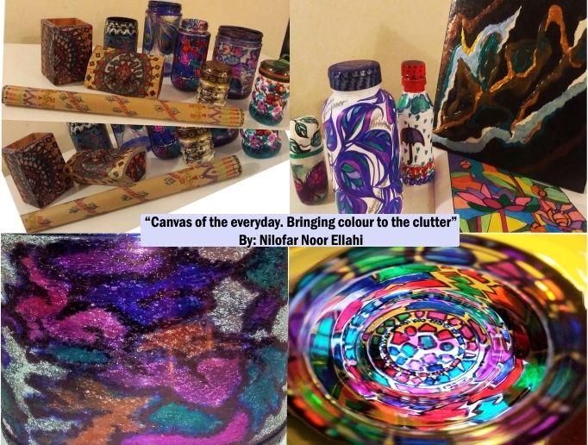
There is an urgent social need to find avenues to reduce stress and maintain mental health and well- being. In order to maintain a positive outlook in the face of dismal news reports, my family and I recently thought of reviving our long­neglected passion for arts and crafts. In the spirit of liberating spontaneity, we thought of simply using everyday household items that would have turned into garbage anyway as our canvas. We began "art­ing" on all the random empty bottles, jam jars, cardboards or boxes, chewing gum and medicine containers, old colouring scrapbooks, and even on kitchen towel rolls we could find in the house. We made sure to remind ourselves that no one was watching, and no one was judging our art skills. The intention was to nurture our creative freedom and help preserve our inner hope and peace to keep resilient during pandemic restrictions. The attached picture shows a glimpse of our creations to share and inspire the CIDEC community in stagnant

By: Nilofar Noor E. (PhD Student, OISE/SJE, CIDE)
times. It shows how we brought fun and colour to the clutter while adding vibrance to the canvas of our everyday. As William Martin says in The Parent's Tao Te Ching (1999), "And make the ordinary come alive...the extraordinary will take care of itself."

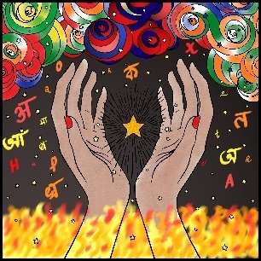
Every Picture Tells a Story – Here is…

My Transnational Life

By: Sudhashree Girmohanta
PhD Student, Language and Literacies Education

Spring 2021 | Page No. 12

CIDEC Research Grants & Development Projects

Dr. Stephen Anderson
- Professor Emeritus Stephen Anderson is currently collaborating with Dr. Santiago Rincón-Gallardo on the development of a professional development program for school district office leaders concerning their role and practices supporting system wide inclusive leadership for all students in all schools under contract with the University of Cincinnati Systems Development and Implementation Center for the State of Ohio.

Dr. Kathy Bickmore
- 2019 (Principal Investigator), “Sparks of Courage and Understanding: Manitoulin and North Shore Youth Building Bridges and Combating Racism.” Funded by Canadian Heritage – continuing, delayed by COVID-19
- 2019 (Co-Investigator with PI Christina Parker, University of Waterloo), “Constructive Classroom Dialogue and Peacemaking Circles in Diverse Classrooms.” Funded by SSHRC– continuing, delayed by COVID19
- 2013 (Principal Investigator), “Peace-building Citizenship Learning in Canada and Mexico [subsequently added Bangladesh and Colombia]: School Connections with Life Experience.” Funded by SSHRC – finishing in 2021

Dr. Danielle Freitas
- SRCA Growth Grant: Learning to teach English in the TESOL Plus graduate certificate program. Funding: $10,000
- 2018 – present:Learning to teach English in the TESOL Plus graduate certificate program; Role: Principal Investigator
- 2021 – present: Globalizing the Local, Localizing the Global: English Language Teaching in Monolingual and Multilingual Contexts. Role: Principal Investigator (in collaboration with Dr. Andrea Mattos, Dr. Leina Juca and Dr. Erika Amancio from the Universidade Federal de Minas Gerais, Brazil).

Dr. Emmanuelle Le Pichon
- Expanding Web-Based Educational Opportunities for Canadian Students in STEM - MITACS grant, Duration: 2021-2025
- Filling the learning gaps caused by the pandemic: Supporting teachers and their diverse students with digital technology - MITACS grant, Duration: 2020-2021
- Plurilingual pedagogies and digital technologies to support learning in Science, Technology, Engineering and Mathematics - Social Sciences and Humanities Research Council, Partnership Development Grant [Le Pichon, E.; Gagné, A.; Fleuret, C.; Auger, N., Sauvage, J. - Duration: 06.2020- 08.2022]
- Northern Oral Language and Writing through Play: A Partnership Supporting Indigenous Children's Language, Cultural Knowledge and Writing, https://now-play.org/ [Stagg-Peterson, S.; Co-investigators:
- Le Pichon, E., Brownell, C., Sandwell, R., Wood, J., Hedges, H., Jesson, R, Parr, J., Lindgren, E. - Duration: 2020-2027

Spring 2021 | Page No. 13

onours and Awards

Honours and Awards

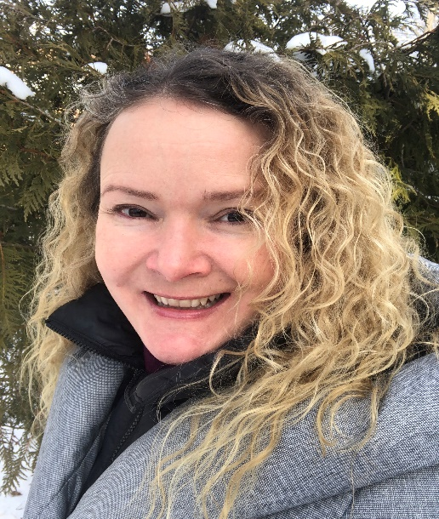

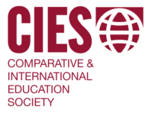
CIES Historian

Incoming CIDE/CIDEC Director, Carly Manion, has recently been elected to serve a 3-year term as Comparative & International Education Society (CIES) Historian. She is honoured to have the privilege of serving the society in this capacity.

Dr. Carly Manion

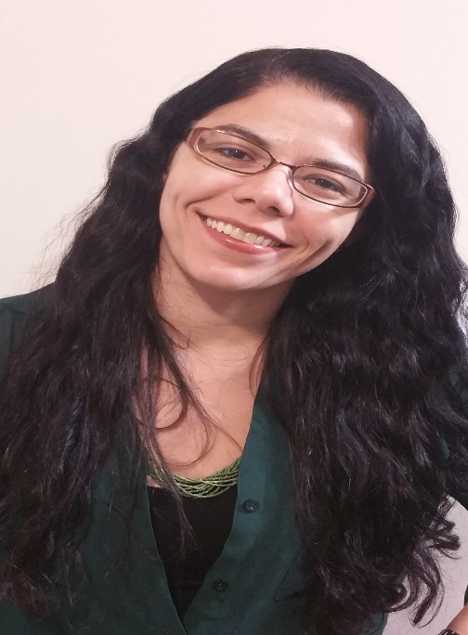

2021 Canadian Association for Teacher Education Recognition Award for Doctoral Thesis

Each year, the Canadian Association for Teacher Education (CATE) recognizes significant contributions to research in teacher education in Canada. Dr. Danielle Freitas’ doctoral thesis, entitled, “It Kind of Made Me Think: Is This the Real Me? Is This Really Who I Am?” A Mixed Methods Investigation of Teacher Learning and Teacher Development in CELTA Courses, has received this award for 2021. Her thesis promotes teacher education and scholarship in pre­service education, in-service education, and professional

Dr. Danielle Freitas
development, showing evidence of connecting and contributing to the body of literature.

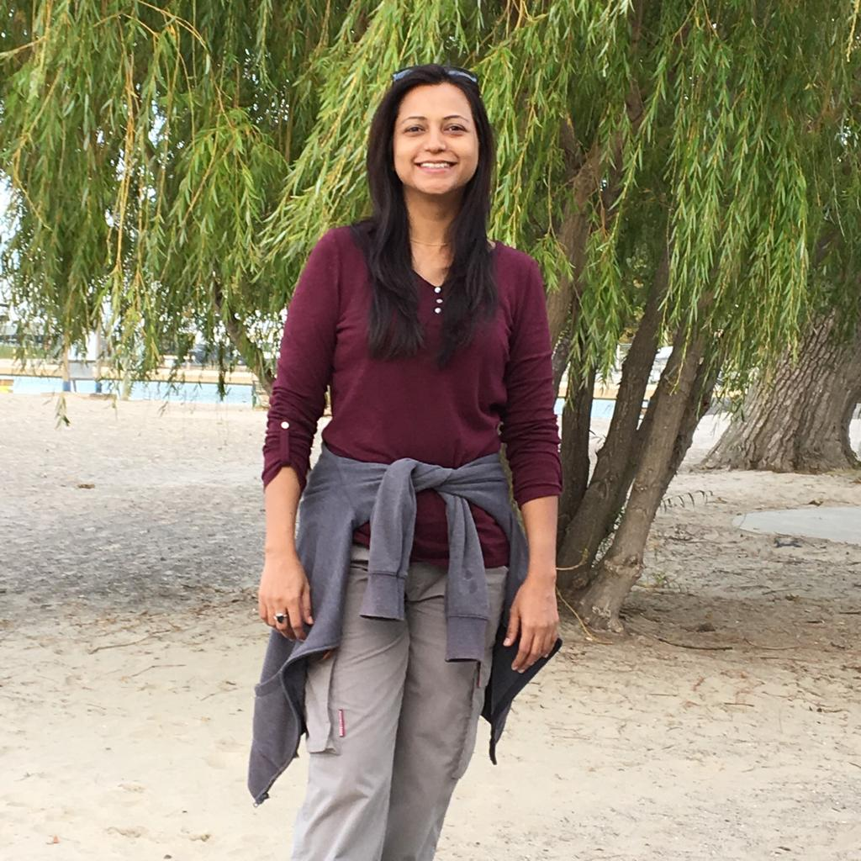

William G. Davis Golden Anniversary

Leadership Scholarship Award

Neelofar Ahmed is a third­year doctoral student in LHAE, ELP specializing in CIDE is a recipient of William G. Davis Golden Anniversary Leadership Scholarship Award 2020. Named after OISE’s founder, William G. Davis (at the time Minister of Education, later Premier of Ontario), this award honours the exceptional leadership of graduate student educational leaders who
will be the next generation's change­makers. Neelofar Ahmed

Spring 2021 | Page No. 14

HundrED award

CIDE Community News, Continued

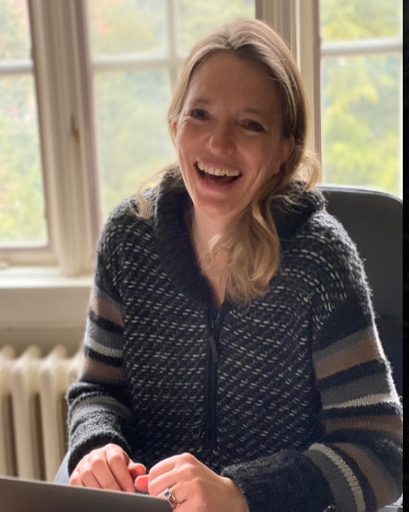
HundrED Award
Dr. Emmanuelle Le Pichon
In 2020, Emmanuelle Le Pichon in collaboration with Language Friendly school network got the HundrED award for creating one of the most innovative practices and approaches in multilingual education https://hundred.org/en/innovations/language-friendly-school#58ec2926.

This is a short paper published online and translated in 23 languages for the School Education Gateway, Europe's online platform for school education: Digital literacies and language-friendly pedagogies: where are we now? https://www.schooleducationgateway.eu/en/pub/viewpoints/experts/digital-literacies-pedagogies.htm

New Books Envisioned by WCCES President, N’Dri Assié-Lumumba | Dr. Ruth Hayhoe

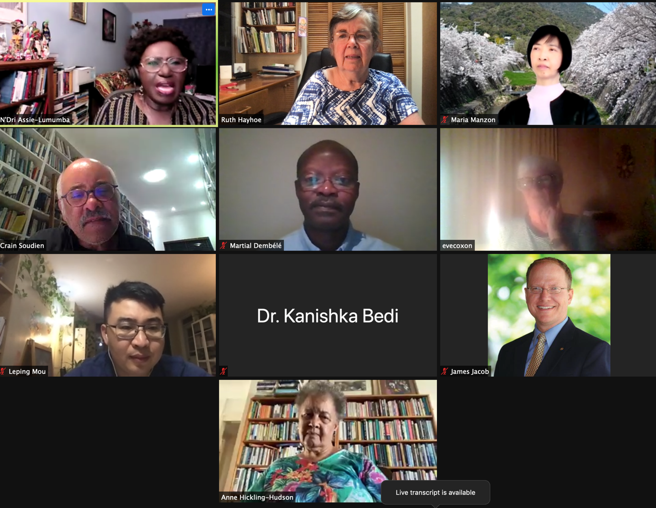
Members of the Standing Committee at our March 26, 2021, meeting

In October of 2020 I was appointed chair of the Standing Committee on History and Records Management for the World Council of Comparative Education Societies, with former WCCES President Anne Hickling Hudson as my co­chair. We are planning two new books, to update the 2007 book Common Interests Uncommon Goals: Histories of the World Council of Comparative Education Societies and Its Members edited by Mark Bray, Maria Manzon and Vandra Masemann. Book One will be an intellectual history with reflections from nine major world regions on new ideas and experiences that challenge and enrich the field of comparative education. Book Two will contain institutional histories of the World Council since 2007 and its regional and national member societies. The plan is for the two books to be published in time for the next World Congress of Comparative Education which is expected to be held in Bangalore, India, in 2023.

Spring 2021 | Page No. 15

CIDE Community News, Continued

Congratulations!

June 2021 CIDE Graduates

• Alicia Rios

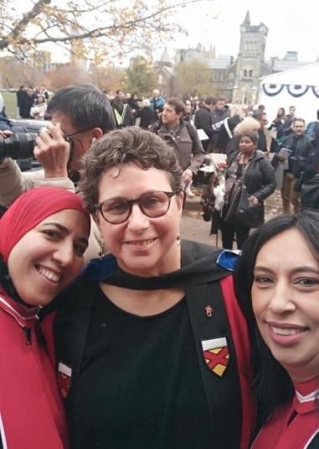
• Alon Eisenstein • Aya Elzoheery • Diane Barbaric • Diego Nieto
• Jasmine Pham
• Laurel Bingman • Luanfei Yin
• Luyue Liu
• Qiongli Zhu
• Rochelle D’Souza • Sarah Clapperton • Sarah Morales
• Tharsy Selvanantham • Alison Chan
• Diane Simpson
• Nooreen Rahemtullah


Alumni News

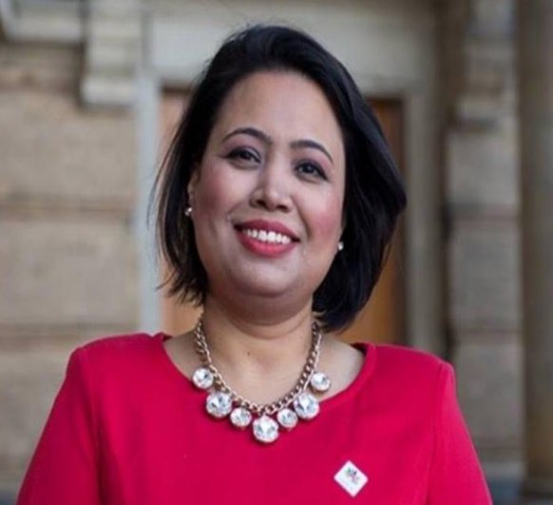
Payal Khazanchi an alumnus of OISE, was the co-recipient of the inaugural MacNaught-Taillon (M&T) Emerging Patient Leader Bursary award in 2020. This award established in 2008, presented every three years honours up-and-coming leaders in health informatics and/or health policy, and offers support for further training, research, or education.

Payal graduated with a Master’s in Education in Adult Education and Community Development in the summer of 2020 with two additional specializations in Workplace Learning and Social Change, and Comparative, International and Development Education. Payal is a family leader and currently the Vice-Chair of Family Advisory Committee at Holland Bloorview Kids Rehabilitation Hospital. Payal is a strong advocate of immigrants’ caregiver experience in Canada. She is deeply committed towards family-centred care and has dedicated her time advocating for clients and families’ needs in improving the quality of care through family engagement in the healthcare system. She has also been an integral part of the pandemic steering committee and the health equity steering committee at the hospital. Payal’s work is grounded in harnessing the strengths of children with special needs and helping parents, especially immigrants, navigate the Canadian healthcare system.
Spring 2021 | Page No. 16

CIDEC Faculty, Alumni, and Students’ Presentations and Publications

Presentations:

Ahmed, N., Alam, S., Bhatnagar, P., Islam, (April, 2021). The Global Pandemic and Educational Ramifications in South Asia. Panel organized at the Graduate Student Symposium, the Center for South Asian Studies, the University of Toronto.
Bahry, S. (2021). Language­in­education policy change towards stronger use of non­dominant languages. Invited Discussant, Language Issues SIG Highlighted Panel, Comparative & International Education Society.
Bickmore, Kathy (2021). “Teaching Social Difference: ‘Canadian’ Curricula in International Comparative Context.” Curriculum Studies in Canada Symposium Series. (Online, February 16). http://curriculumstudiesincanada.ca/services/ and https://www.youtube.com/watch?v=xXtv­ _emCTw.
Bickmore, Kathy (2020). “Las Pedagogías para Construir una Ciudadanía para la Paz Justa y Sostenible: Un Marco Teórico.” Presented at Universidad Iberoamericana – León, México (online, October 29).
Bickmore, Kathy (2020). “Global(ized) Citizenship Education: Economic Conflicts in Youths’ Lives and Lessons in Mexico and Canada.” In CIDEC Seminar with Najme Kishani Farahani and Ángela Guerra­Sua, “Generating Peacebuilding Agency?” Oct.15,
online. https://www.oise.utoronto.ca/cidec/2020­seminar­webcasts
Bickmore, Kathy (2020). “Safe and Inclusive Schools? Ontario Policy­in­Use under Budget Cut Regimes: 1990s (Harris) and Now (Ford).” Collaborative Specialization in Educational Policy Seminar Series. February 19, online.
Hancock Montgomery, J., Chuttoorgoon, D., Ahmed, N. & Pluchino, J. (2021, Apr 9). During Times of
COVID-19: Reporting and Representing Refugees in PISA and EQAO Assesments [Roundtable
Session]. AERA Annual. https://tinyurl.com/y4n7ob5q
Manion, C. (November 2020). “The Impacts of the COVID­19 Pandemic on Educational Equity Around the World: Mapping the Immediate and Longer­term Implications”. Invited speaker at the First Multidisciplinary International Virtual Conference on Diversity, Inclusion and Equity: Synergies and Challenges in the Wake of COVID­19. Faculty of Liberal Arts and Human Sciences, Ziauddin University, Karachi, Pakistan.
Niyozov, S., Bahry, S., Antony­Newman, M., & Ortega, Y. (2021, April 27). Immigrant and refugee students in Canadian secondary schools: The role of teachers, families, and community organizations. Migration Working Group: Inclusion and support of immigrant and refugee students. Canada Excellence Research Chair (CERC) on Migration & Integration. Ryerson University, Toronto.
Niyozov, S., Wattar, D., Antony­Newman, M., Ortega, Y. & S. Bahry (2021, February 26). Immigrant and Refugee Education:Persistent Problems, Flawed Solutions, and Possible Ways Forward? Comparative International & Development Education Centre (CIDEC, OISE, University of Toronto

Spring 2021 | Page No. 17

CIDEC Faculty, Alumni, and Students’ Publications, Continued

Publications

Anderson, S., Uribe, M. & Valenzuela, J.P. (2021). Reforming public education in Chile: The creation
of Local Education Services. Education Management, Administration and Leadership. DOI:
10.1177/1741143220983327
Attar, Z., Blom, E. & Le Pichon, E. (2020). Towards More Multilingual Practices in the Mathematics Assessment of Young Refugee Students: Effects of Testing Language and Validity of Parental Assessment. International Journal of Bilingual Education and bilingualism.
Auger, N. & Le Pichon, E. (accepted). Diversités langagières et Culturelles à l’école. Coll. "Pédagogies" to be published in 2021 by ESF Sciences Humaines.
Beerkens, R., Le Pichon, E., Supheerd, R., Ten Thije, J. eds. (2020). Enhancing Intercultural Communication in Organizations: Insights from Project Advisers, Routledge.
Bahry, S. (in press, 2021). Global mobility and linguistic hybridity. Chapter 8 in E. Piccardo & G. Lawrence (Eds.), The handbook of plurilingual education. Routledge.
Bahry, S. (forthcoming). English in Tajikistan. In K. Bolton (Ed.), Encyclopedia of World Englishes. Wiley Blackwell.
Bahry, S. (forthcoming). Language diversity in Amdo: The past, present and educational implications for the changing language ecology of Sunan Autonomous Yughur County, Gansu. In. G. Cabras (Ed.). Language Diversity in Amdo: Changes and Challenges. Mapping Amdo Series Amdo Research Network.
Bahry, S. & Wang, G. (forthcoming) Covid­19 and minority language revitalization: The case of minority communities in Yunnan and Gansu, China.
Bickmore, Kathy, & Kaderi, Ahmed Salehin. (2021). Teaching Values for Comprehensive Just Peace? Teachers’ Curricula for Social Cohesion in México, Bangladesh and Canada. Chapter 7 in Candice Carter (Ed.), Teaching and Learning for Comprehensive Citizenship: Global Perspectives on Peace Education (pp. 114­140). New York and Abingdon, UK: Routledge.
Bickmore, Kathy & Diana Barrero (2021 under revision). Global(ized) Citizenship Education: Environmental and Resource Conflicts in Youths’ Lives and Schooling in Mexico and Canada. Submitted to Kubow, P., Strong, K., Webster, N & Miranda, D. Contestations of
Citizenship: Children and Youth, Democracy, and Education in an Era of Global
Change. Presented at Citizenship and Democratic Education SIG Symposium, The Popular Turn in Global Citizenship Education: Youth Voices from Four Continents, in Comparative and International Education Society (virtual) annual conference, April 14, 2020.
Bickmore, Kathy (2021). (2021 under revision). Violence is Resourcelessness: Peace­building Learning Opportunities in Schools in Mexico, Bangladesh and Canada. In Abdi, Ali, Misiaszek, Greg (Editors) International Handbook on Critical Theories of Education. Palgrave.
Goebel, J., Manion, C., Millei, Z., Read, R., and Silova, I. (2020). Academic conferencing in the age of COVID­19 and climate crisis: The case of the Comparative and International Education Society (CIES). International Review of Education, 66, 797­816.
Hayhoe, R. (2021). Comparative education and the dialogue among civilizations. In B. Lindsay (ed.) Comparative and International Education: Leading perspectives in the field. Palgrave Macmillan. (The book has 13 chapters, all by Honorary Fellows of the CIES).
Hayhoe, R. “The Arts and Music in Chinese Learning Traditions: Towards Greater Reciprocity
through Cultural Understanding,” in Xavier Bouvier, Marc­Antoine Camp & Regula Steiner (ed.) Comparative Views on Musical Talent and its Promotion in Chinese and Western Worlds, Switzerland: Chronos­Verlag, 2021. 8minute version as presented at a Symposium in Lucerne, Switzerland, Dec. 7, 2020: https://play.library.utoronto.ca/play/691282c2964835437fa18ec55f65d810
Hayhoe, R. (forthcoming 2021). Preface for Yunyun Qi, Building Cross-Border Joint Universities in China: A
Case Study of an Organizational Dilemma, to be published by Taylor and Francis.

Spring 2021 | Page No. 18

CIDEC Faculty, Alumni, and Students’ Presentations and Publications

Hayhoe, R. (2021). “Potential benefits of reciprocity between Sinic and Anglo­American values
In Higher Education,” Globalisation, Education and Societies, 19 (3).
Hayhoe, R. (2020). “Reflections,” Special Issue of China Quarterly, No. 243, on “The State
and Higher Education in Greater China,” December 2020, pp.1160­1167.
Hayhoe, R. (2020) Review of Michael Connelly and Shijing Xu (eds.) Book Series: Intercultural Reciprocal
Learning in Chinese and Western Education, Cham, Switzerland: Palgrave MacMillan, in Frontiers of Education in China, Vol. 15, No. 3, 2020, pp. 526­529.
Hayhoe, R. (2020). Foreword for Xiaohong Chi, Cross-Cultural Experiences of Chinese Immigrant Mothers in Canada: Challenges and Opportunities for Schooling, New York: Palgrave MacMillan.
Hayhoe, R. (2020). Preface for Xiaoxin Du, Role Differentiation in Chinese Higher Education: Tensions between Political Socialization and Academic Autonomy, Springer.
Kambel, E.­R. & Le Pichon, E. (2020). Kieliystävällinen koulu [Language friendly school]. In J. Alisaari, E. Jäppinen, N. Kekki, R. Kivimäki, S. Kivipelto, K. Kuusento, E. Lehtinen, A. Raunio, E. Repo, S. Sissonen, M. Tyrer & H. Vigren Kielestä koppi – Oppimateriaali kielitietoiseen
perusopetukseen [Catch the language­ A studybook for language sensitive basic education], pp. 293 ­ 298. University of Turku, Finland.
Le Pichon, E.; Cole, D.; Baauw, S.; Steffens, M.; van den Brink, M.; Dekker, S. (2020). Transcultural itineraries and new literacies: how migration memories could reshape school systems, In. Passerini, Proglio and Trakilović, The Mobility of Memory across European Borders. Migrations and Diasporas in Europe and Beyond, Berghahn, New­York. Oxford.
Le Pichon, E. & Ammouche­ Kremers, M. (accepted). Reinventing education in the light of student mobility in higher education: the example of the peer­feedback program. In Gandolfo Cascio, Roselinde Supheert & Jan D. ten Thije The Riches of Intercultural Communication: Challenging Linguistic and Cultural Diversity to be published by Brill publishers.
Le Pichon, E.; Cummins, J. & Vorstman, J. (accepted). Using a web­based multilingual platform to support elementary refugee students in Mathematics, Journal of Multilingual and Multicultural Development.
Le Pichon, E. (2020). Intercultural communication, migration and mobility. In. Guido Rings & Sebastian Rasinger. The Cambridge Handbook of Intercultural Communication. Cambridge University Press handbook.
Le Pichon, E. (2020). Kieli ja identiteetti maahanmuuttajaoppilaiden näkökulmasta [Language and identity from the perspective of immigrant background students]. In J. Alisaari, N. Kekki, R. Kivimäki, S. Kivipelto, K. Kuusento, E. Lehtinen, A. Raunio, E. Repo, S. Sissonen, M. Tyrer & H. Vigren Minästä kiinni – Perusopetuksen oppimateriaali moninaisista identiteeteistä [Catch the self – A studybook about diverse identities for basic education], pp. 34 ­ 41. University of Turku,
Finland.
Le Pichon, E. (2020). Bildung für Asylsuchende und Geflüchtete [Multilingualism in Society: Refuge and Asylum]. In. Gogolin, Hansen, McMonagle and Rauch. Handbuch “Mehrsprachigkeit und Bildung” [Handbook “Multilingualism and Language Education.”] Springer. pp.245­250.
Le Pichon, E., Siarova, H. & Szonyi, E. (2020). The Future of language education in Europe: Case­ Studies of innovative practices. NESET II report, Luxembourg: Publications Office of the European Union. https://nesetweb.eu/en/resources/library/the­future­of­language­education­in­ europe­case­studies­of­innovative­practices/
Obradović­Ratković, S., Kovačević, D., Ahmed, N., & Ellis, C. (February, 2021). Educating refugee students in Canada:Towards a pedagogy of healing. Newcastle upon Tyne, UK: Cambridge Scholars Publishing.

Spring 2021 | Page No. 19

CIDEC Faculty, Alumni, and Students’ Presentations and Publications

Oleksiyenko A., Blanco, G., Hayhoe, R., Jackson, E., Lee, J., Metcalfe, A., Sivasubramaniam, M. & Q. Zha. (2021) “Comparative and international higher education in a new key? Thoughts on the post­ pandemic prospects of scholarship”. Forum in Compare: A Journal of Comparative and International Education, DOI: 10.1080/03057925.2020.1838121.
Ortega, Y. (2021). Working for social justice in a marginalized Colombian English teaching classroom. In D. Christian & K. M. Bailey (Eds.), Research on teaching and learning English in under-resourced areas. (pp.171­184). Routledge and TIRF. Link
Parker, Christina & Bickmore, Kathy (2020). Classroom peace circles: Teachers’ professional learning and implementation of restorative dialogue. Teaching and Teacher Education 95 (103129), 1­ 10. https://www.sciencedirect.com/science/article/pii/S0742051X19315148
Parker, Christina & Bickmore, Kathy. (2020). Complexity in restorative justice education circles: Power and privilege in voicing perspectives about sexual health, identities, and relationships. Journal of Moral Education, 1­23. doi:10.1080/03057240.2020.1832451
Prasad, G., Auger, N. & Le Pichon, E. eds. (accepted). Multilingualism and Education: Researchers’ Pathways and Perspectives to be published in 2021 by Cambridge University Press.
Silova, I., Millei, Z., Goebel, J., Manion, C., Read, R. (2020). Beyond the human: Rethinking education and academic conferencing during the times of climate crisis [Review Essay]. Comparative Education Review, 64(4), 749­752.
Wattar, D. & Le Pichon, E. (Accepted). Mobility of Syrian­ Canadian students and continuity of math education: A comparative curriculum mapping approach. In A. A. Abdi & G. W. Misiaszek (Eds.), Palgrave International Handbook on Critical Theories of Education. Palgrave.
Winters, K. L., Longboat, C., Ratković, S., Dénommé­Welch, S., Varghese, A., Ahmed, N., Miranda, H. & Yang, S. (October, 2020). Displacement and Belonging in Canada: Building Reconciliation Through Literature, Theatre, Poetry, and Film. In Colella, C,. El­Hoss, T, Parayre, C (Eds), Im/migrant Passages: Crossing Visual, Spatial and Textual Boundaries - Im/migrations passages visuels, spatiaux et textuels. Small Walker Press, Brock University, Canada

Spring 2021 | Page No. 20

