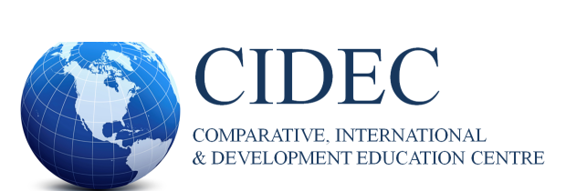

NEWSLETTER | **Spring** **2022**



**Inside this Issue**

* Director’s Message
* The Joseph P. Farrell Student Research Symposium
* Honors and Awards
* Interview with Dr. Grace Karram Stephenson
* CIDE Student Association
* CIDEC Interest Groups
* Spring 2022 Graduates
* CIDE Faculty, Alumni, and Students’ Publications

**Director’s Message**

Happy Spring, everyone! I hope that you will have a chance to enjoy the longer days and warmer temperatures and all the returning plants, trees, birds, and animals that accompany these changes. As risks associated with the COVID-19 pandemic appear to be easing, many will also be experiencing a happy return, of sorts, to social life. Yet, even amidst such happy and hopeful times, I know that hearts are heavy, and there are heightened concerns regarding new and escalating conflicts around the world, implications of the pandemic for education and learning, and the climate crisis, to name but a few pressing issues.

It has been my pleasure to work with the vibrant CIDE/C community, including members of our Steering Committee, all CIDE-affiliated faculty, and all CIDE students. Thank you for sharing your expertise, guidance, and input during my first year as CIDE/C Director.

I wish to also extend a warm welcome and thanks to our new (and returning)

CIDE-affiliated sessional faculty this year: Yomna Awad; Stephen

Bahry, Valerie Damasco, Mary Drinkwater, Patrick Finnessy, Soudeh Oladi Ghadikolaei, Mona Ghali, Dejan

Ivkovic, Rainos Moyo Mutamba, Yecid Ortega, Emma Sabzalieva, Grace Karram Stephenson, Elena Toukan, and

Stephanie Tuters.

Special thanks to CIDE-affiliated faculty, Miglena Todorova (Department of Social Justice Education) for

initiating and organizing a collaboration between CIDE/C and the Centre for Media, Culture, and Education

(CMCE) as part of the latter’s “Cultures and Differences in Education” series, with this year’s focus being on

addressing sexual violence and prevention in schools and on campuses. For more information and to access

recordings of the events, visit the following page: [https://www.oise.utoronto.ca/cmce/cultures-and- differences-in-education/](https://www.oise.utoronto.ca/cmce/cultures-and-%20differences-in-education/)

I’m pleased to announce that a new one-time (for now) stream of (modest) funding to support the activities of

CIDEC Interest Groups (IGs) is currently underway and accepting applications. The CIDESA, as the liaison between

IGs and CIDEC, is helping to coordinate this initiative, in addition to all their other efforts to build and nurture our

CIDE/C community. Thank you, CIDESA!

I want to thank all the contributors to this Spring 2022 edition of the CIDEC newsletter, and to CIDEC GA and

talented co-editor, Dareen Charafeddine, for assisting with its produce. As a brief teaser for what’s inside, the

newsletter features an interview with CIDE-affiliated faculty, Dr. Grace Karram-Stephenson (led by Yilun Jiang,

MEd student, LHAE/HE), news piece on the J. P. Farrell CIDE Student Research Symposium (JPFSRS), message

from CIDESA, news, and updates from some Interest Groups (Education, Conflict and Peacebuilding IG; Immigrant

and Refugee Education IG, and the Africa IG), and information regarding faculty and student grants/awards,

publications, and presentations. The newsletter also shares details concerning Dr. Diego Neito’s receipt of the Michel

Laferrière research award, as well the names of CIDE students graduating in June. Congratulations to everyone on

your incredible accomplishments and contributions!

I hope you will all have an enjoyable summer, resting, relaxing, exploring, and growing.

Warm wishes,



Carly Manion, CIDE/C Director

Inside this Issue

HoHownhflafafagag

**The Joseph P. Farrell CIDEC Student Research Symposium 2022**

For many years, on the third Friday in February, the CIDE/C community has gathered together to learn more about and engage with student research, and this February was no different. Traditionally, the symposium is held at OISE, but due to the pandemic, this year’s Joseph P. Farrell Symposium was held online on February 18, 2022, and it was as enriching as ever. The symposium was attended by more than 50 community members, and the variety of student presentations was quite significant. Together, we explored and analyzed topics on equity and justice in education, as well as comparative education and internationalization across K-12 schools and higher education. The opening comments by Dr. Carly Manion were both enlightening and moving for many of our attendees who knew Dr. Farrell (Joe) personally. We extend a hearty thanks to the presenters, chairs, CIDESA, and CIDE/C Administrator, Sazna Aliyar, as well as faculty and students in the audience – for their incredible contributions to the symposium this year, and we look forward to more.

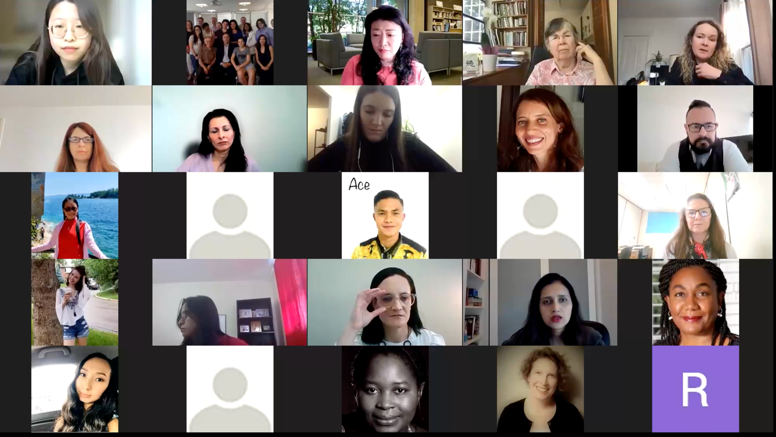

**Welcome Remarks**

**Session 1- IT ALL BEGINS WITH A TEACHER**

[Chair: Dareen Charafeddine]

*Initial insights into Teacher Professional Development in Rural Colombia and Honduras Using an Accompaniment Approach* [Bita Correa, PhD Candidate, CTL. Curriculum and Pedagogy]

*Teachers’ Perceptions of 21st Century Competencies in Different Cultures* [Christine Tewfik, PhD Student, CTL, Curriculum and Pedagogy]

*Quechua as a Second Language Teachers from the Peruvian Andes, a Narrative Inquiry Study* [Yesica Paola Ayme Bustamante, MA Student, CTL, Language and Literacies Education]

**Spring 2022 | Page No. 2**

**Session 2 – EQUITY, JUSTICE AND BUILDING INCLUSIVE RELATIONSHIPS**

[Chair: Vandra Masemann]

*South Africa and Cambodia: Grappling with the Educational Equality for Learners with Disabilities in Mainstream Schools* [Gerda-Marie Van Onselen, MEd Student, LHAE, Educational Leadership and Policy]

*Unsettling “Humanity” and “Land”: De-centering Anthropocentric Thought for Anti-Colonial Environmental Education Schools* [Lois Boody, MEd Student, SJE, Social Justice Education]

*Building Positive Principal-Student Relationships Under Chinese Educational Reform During the Past Two Decades: Experience from High-School Leaders in Beijing, China* [Yuan Chai, MA Student, LHAE, Educational Leadership and Policy]

**Session 3 – COMPARATIVE HIGHER EDUCATION AND INTERNATIONALIZATION**

[Chair: Carly Manion]

*Mexican Students’ Experiences in Study Abroad Programs: Analyzing the Link Between Experiences and Learning Outcomes* [Iván Ramírez Figueroa, PhD Candidate, LHAE, Educational Leadership and Policy*]*

*Contextualizing the Science, Technology, Engineering and Mathematics Gender Gap in European and Sub-Saharan African Universities* [Gabrielle Thibeault-Orsi, MEd Candidate, LHAE, Educational Leadership and Policy]

*Global Competencies: How MBA Schools Develop Interculturally Competent Leaders* [Freeda Bukhari Khan PhD Candidate, LHAE, Higher Education]

*Searching for Equity: A Holistic Analysis of East Asian International Student Experiences: A Case Study of a Canadian University Engineering Program*[Phoebe Kang, EdD Candidate, LHAE, Educational Leadership and Policy]

**Spring 2022 | Page No. 3**

**Honours and Awards**

Inside this Issue

HoHownhflafafagag

Inside this Issue

**Michel Laferrière Research Award 2022**

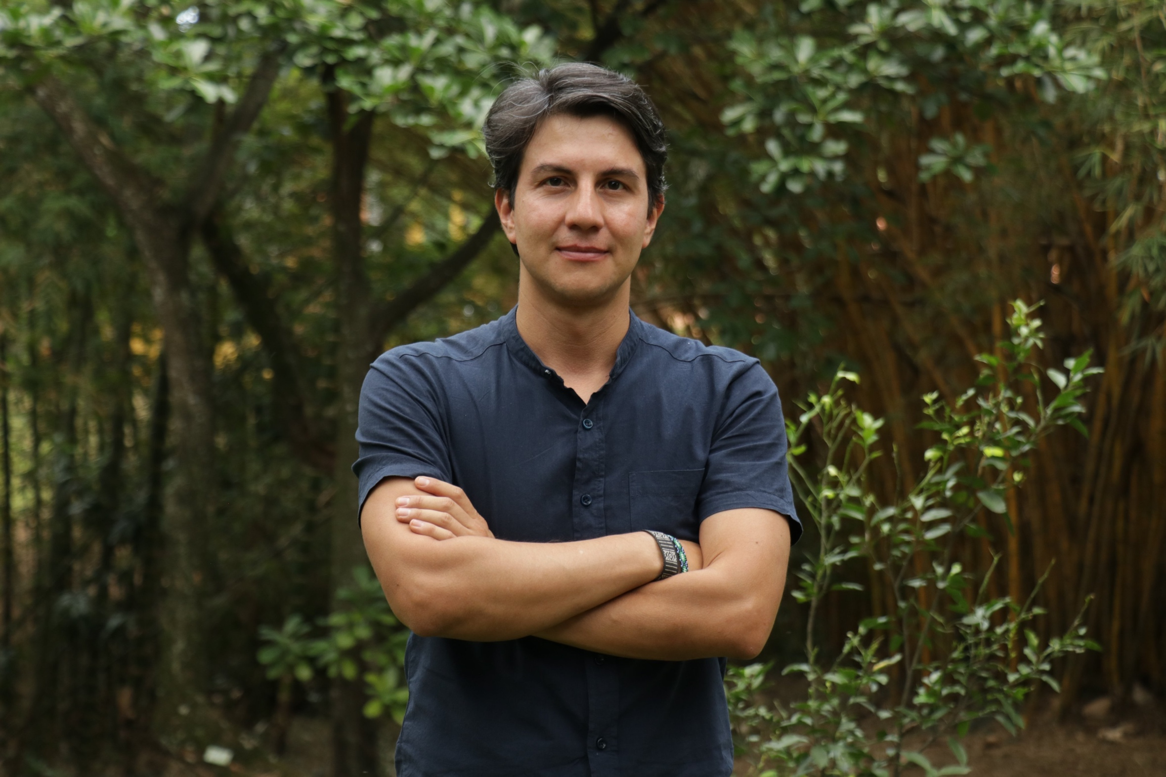

Dr. Diego Neito

Congratulations to Diego Neito who was awarded the Michel Laferrière Research Award 2022 for best doctoral thesis in the field of Comparative Studies in Education in Canada. This recognition is awarded by the Canadian Society for the Study of Education, and it was given to Diego Neito, scoring his thesis 5/5 in all evaluation criteria:

a. Significance of the problem addressed

b. The conceptualization and design of the research

c. The potential value of the research for theory development, improved practice and future

research in comparative and international education

d. Writing quality

The adjudicators remarked that Neito’s thesis, *Learning conflict in the midst of violence- Urban youth and school life in Colombia’s (post)conflict transition,* is one of the finest they have read. To quote one of them, “With more than 30 years working in the field, and in supervising and assessing doctoral dissertations, this is undoubtedly, one of the finest dissertations that I have read. The researcher deserves the CIESC M.F. Award”.

To learn more about Diego Neito’s research, read the abstract [here](https://docs.google.com/document/d/139mYMAQQIiIdSyE5jk7DN8KF2emw2N4V/edit).

**Spring 2022 | Page No. 4**

**Get to know the CIDEC Faculty**

Inside this Issue

HoHownhflafafagag

**An Interview with Dr. Grace Karram Stephenson**

By Yilun Jiang (MEd. Student, LHAE, Higher Education

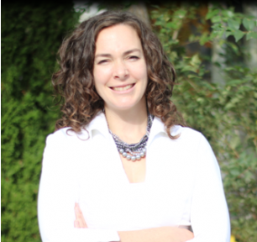

“I’m beginning to map out some of the global pathways of immigration, not just your traditional ones, where the student goes from one country to another. What are the three steps they might make on their way from the country of interest for them? And is that the last step? Or do we begin to see another sort of movement over that we have the ideas of the brain train instead of just brain drain and see how that works? And how do the different types of higher institutions contribute to that?”

**Yilun Jiang:**

Thank you so much for sharing your time and your experience with us for this interview. I would like to start by having you tell us a little bit about your academic background.

**Grace Karram Stephenson:**

I always loved studying other countries and learning about how life is different in other countries. When I went to my undergraduate degree, I went to Trent University, which is a small school outside of Toronto, about an hour and a half away. I studied international development and economics. We were so fortunate in that class to have professors who have worked all around the world teaching us about how different countries put in programs and policies to try to become more economically and socially strong- so really interesting conversations. And when I started my third year at university, I went on a study abroad program to West Africa, to Ghana. I was there for eight months, and we were very much learners. Our goal, when we were there, was to be learners and to learn from the country’s culture. We had to volunteer, and when I went there to volunteer, for the second half of my course, I worked in a small school in the north, very hot, dry terrain and wonderful communities, the villages that we lived in. I taught as a grade-four teacher and learned a lot about the different programs that the organization offered. It was run by people from Ghana, who had done their graduate work at U of T actually. So, they had returned to Ghana, and worked on environmental regeneration, working with sustainable agriculture, and they also ran a school. So, I worked at the school, and I loved education. And so that was the first experience with education and because I like that so much, I came to OISE when I did my teaching degree. I took one course by Sarfaroz Niyozov, our wonderful former director of CIDEC. It was the Global Education course. And I loved it. That was a really, really exciting experience for me, and that is what brought me back to do a master’s degree in OISE, years later. But after my teaching degree, there were no jobs. So, I did not become a teacher. I went to work in the US at an American university where my husband was doing grad school. And then (I) went to work in the Fiji Islands and run a study abroad program. And then when I came back to Ontario, home for me, I went back to my Master's in Higher Education. And my reason for being at OISE was

**Spring 2022 | Page No. 5**

CIDEC. That was the big draw. Sarfaroz was a wonderful mentor, I got to work with him later. I always loved his perspectives on culture and religion and how it impacts higher education.

**Yilun Jiang:**

Oh, that's a very rich academic experience! I'm so glad to hear that you've experienced lots of higher education systems all around the world, in Canada, West Africa (mainly Ghana), America, Fiji, Malaysia and the United Arab Emirates. Could you share your experience or feeling after studying and comparing so many higher education systems?

**Grace Karram Stephenson:**

This is a really good question. I mean, after you go to different places sometimes, what we see the most is a reflection on our own practice in our own culture, rather than being able to totally and completely understand another culture. And that's been one thing that the research has shown in study abroad programs for a long time. And I think that was my experience working with Fiji Islands. We had American students come over and we paired them with students and this sort of intercultural staff and intercultural student mix. Our goal with all the programs that I've been fortunate to be a part of is this idea of mutual education and mutual understanding to try to help neutralize or decrease some of the power imbalances between the global north and the global south. When the American students would come to Fiji, these big guys were so excited to go snorkeling. And they would meet these even bigger guys because Fijian tend to be quite strong, quite muscular, very good at that. The huge muscular guys, who would wear wrap skirts called Sulu, and it would just blow their mind that these big strong guys could either be wearing what we might call a skirt. Right? And they would begin to see how rigid their own gender norms were, how rigid their view of the world was. But there's also an incredible influence of religion, as Fiji has strong, Hindu, and Asian populations. And the students from the American context might be religious but when they got to Fiji, they realized how kind of secular culture is, how spirituality isn't the number one thing that informs our lives. So, there's a lot of reflection back on ourselves.

**Yilun Jiang:**

That's a very great answer. It just reminds me, as an international student, maybe after years of studying higher education, it will just make me gain more in-depth knowledge about the East Asian HE systems, and how they are different from the European or North American ones. Well, it just gives me the sense to say how different it could be in multiple higher education systems. And it is really a great opportunity to do this comparison.

**Grace Karram Stephenson:**

Well, you could feel that the UK and the US experience were very different, right? So, you’ve been able to study their own culture from very different lenses.

**Yilun Jiang:**

Yes. All these study-abroad experiences and language learning like German and English learning made me more familiar with their its higher education system. So, it just gave me a reason to study at CIDEC. Would you like to tell us about some research topics that you’ve been currently involved in?

**Grace Karram Stephenson:**

So, there are two areas of research that I have the most experience with. So, my own doctoral work, about six years ago, I looked at how branch campuses impact student populations in Muslim heritage countries. So (I was) looking at very diverse populations in the UAE and Malaysia, trying to understand how a student who is from a peripheral politically marginalized group. How do those students begin to understand themselves when they go to a Western branch campus, but in their home country? And so, I love this conversation about how linguistic shifts happen, how ethnic groups are positioned through Western education. Western education sometimes claims to be neutral, but we know that it's not. There are very specific values that come through values of, say, gender, economic values, business, problem-solving, leadership skills that we prioritize in our Western education. So that was a wonderful study. And so, since then, I've been able to write on the concept of student diversity, internationalization, international programming. That's been lovely to keep in touch with. And then for the last five years, my main job has been to work with Dr Glen Jones on the academic profession in the knowledge society study. And this is a collaboration of 31 countries. And we administered the same survey as all the other countries, to our professors across Canadian public universities. So, we have professors at 64 universities across Canada giving us data, and (this) led to quite a large sample, a large survey sample. And it helped us to understand where testers are trained, how they are trained, and where they get funding from, what types of activities they are mainly involved in, whether teaching or research or service, and it helps us understand how (they are) involved in governance, how they view their institutions, how professional different types of institutions experience their work. So that's really what we're working on- publishing those findings last year and a half or last two years. And it's been such a rewarding experience. Some of the work we do is just the Canadian publications, and some of

**Spring 2022 | Page No. 6**

that involved working with wonderful teams. I was recently working with a team from Portugal and Thailand and Argentina and Lithuania, five of us, (who) were able to compare how our how academic work is experienced in these five or six countries.

**Yilun Jiang:**

Wow, that's a very interesting experience. I think it’s really fascinating to study all kinds of factors that impact higher education governance, like professor training or funding for research activities and programs. I’m curious about one thing. Did you face any kind of challenges or difficulties while you're doing that research?

**Grace Karram Stephenson:**

Yes, so two different types of challenges. I think, one is the actual logistics of the work that we do. When we're trying to do research and there's a barrier, it can be really hard. And for our projects, with the professors and the survey, ethical permission was our big barrier. I think it took us 18 months to get permission from 64 universities to be able to conduct the survey because Canada does not have a well-harmonized ethics system. So, if I am conducting a survey with OISE students, I only need the University of Toronto ethics. But even if I have University of Toronto ethics, I can't just go to Brock University, and suddenly interview students or professors. So, we found it quite difficult to navigate all the different things across Canada. I was fortunate I had a team of three excellent research assistants, and they worked really diligently over those 18 months to be able to get the ethics application done so that we were able to have 64 universities participate. So yeah, that would be the logistical challenge. And then there are other challenges. We had some technical problems with our survey system, that, we don't know exactly, but perhaps every 20th or 40th participant couldn't get past questions 3, and we couldn't replicate it and we couldn't fix it. And so, we had these challenges that cut our response rate that should have been bigger if the technology had worked more smoothly. So strange things like that were barriers and you just worked your best. And sometimes you just have to let it go. You can't fix everything. And then in terms of my own experience during doctoral work, the personal challenges were big. I had two kids during my doctoral work, and they're such a gift to have, my children, they're so lovely and wonderful. But it makes you realize you're trying to do two things at once. And when you have children, you get very, very tired and your brain is tired. And when you're working on a PhD, you usually need your brain to not be tired, or very sharp. And so those were my challenges, but when I was in my program, there were other wonderful women who were also doing their PhDs and having their kids.

**Yilun Jiang:**

Oh, that's so great. I'm so proud of you like you're also taking family responsibilities while studying and I'm so glad that you have also found a great way to handle these problems like talking with peers who shared the same situation with you. I would like to know more about the survey work that you’ve done. Is it the main research methodology for that research you've worked on in the past five years? Or have you adopted any other research methodology?

**Grace Karram Stephenson:**

So, in the early first year of our project (so with every project), we had an extensive literature review, and this report is available on the CIHE website. And in this report is an extensive survey other than our literature review of all the writing on assessors that have taken place, about the Canadian context, specifically. So, we did that first year during the literature review, like we always have to do with any study. And then it was purely a survey methodology.

**Yilun Jiang:**

Wow, that's very great work. I really appreciate that. Is there any future research project you want to take? Or do you have any kind of goals for your future academic career?

**Grace Karram Stephenson:**

That's a great question. Right now, I switched from other research roles, almost exclusively research, to a teaching role for the next year or two. And I think that my goal in the next five years is to bring back a balance in that and currently, I'm just teaching, and I don't have the projects to bring my students into, but I love involving students in my research. And so, there are some really interesting studies that are on my mind, particularly about how students move through different educational hub locations, to then pursue higher education in their destination of choice. So, you might be an Indian citizen, may have studied in Dubai, but your end goal is to try and do a degree in Canada and immigrate to Canada. So, (I’m) beginning to map out some of these global pathways of immigration, not just your traditional ones, where the student goes from one country to another? What are the three steps they might make on their way from the country of interest for them? And is that the last step? Or do we begin to see more, another sort of other movement over that we have the ideas of the brain train instead of just brain drain and see how that works. And how do the different types of higher institutions contribute to that? Which ones are students predominantly using? Which ones have better pathways for students to be mobile throughout the world? And, of course, there are also really interesting questions about how

**Spring 2022 | Page No. 7**

internationalization works in different disciplines. So, we know that we saw the internationalization and we have

student movement, research collaboration, and we have curriculum change at home, you know, setting up different campuses. But actually, when we begin to look at where those activities are happening, different academic disciplines were actually engaged in internationalization very early. And we know that they are

studies and there are differences. We don't know the extent of that, and we haven't been able to begin to systematically assess what activities are connected to different academic disciplines, and then we begin to realize we're looking at very technical concepts, not just a general term of internationalization. It's buried in the study of different disciplines.

**Yilun Jiang:**

Wow, that's a very great plan. I think as an international student, I'm also very interested in the research topic. I wonder if you consider taking anybody in a program.

**Grace Karram Stephenson:**

Absolutely. But right now, because I'm just in the teaching stream, I don't get to do it right now. But give me a few years, and we'll have some fun. We'll have some more research fun.

**Yilun Jiang:**

Okay, great. Yeah. So, because of this process topics are so interesting about internationalization and how we can help international students just to move from different education systems. And yes, that’s a great topic that needs a lot of research. I would like to ask a question on behalf of other CIDEC new students. Could you give any suggestions for them, about how they can improve their academic study in the first year? Or how they can behave more actively in the Higher Education program?

**Grace Karram Stephenson:**

I think that's a great question. We are so fortunate that our CIDEC students are excellent, and they all come in with lots of experience. But sometimes when we come in and meet people who seem to have more experience than us, we begin to feel that ours isn't as important. So, my first piece of advice for our students is to value your own experience and to remember that or that your international experiences and the work that you've done, or what lead you to the great research questions. So, you don't need to look at everyone else's pathway, but look at your own and think about what research question my experience has highlighted. So, dive into that experience, begin to explore research questions, and brainstorm research questions that help you to understand what you've worked in more deeply. Of course, my second piece would be, make the effort to go to the small group activities. So, if there's a special interest group, if there's a breakout social time, make some effort to get a smaller group activity or meeting to get to know people who have similar research interests to yours. You have this peer group that can support you. And then even though this is a bit different than the other advice, go to some talks that are totally outside of what you know. We have wonderful seminars, and sometimes you look at them, like oh, that's not interesting. Go to a few that look like their different topics because the best research makes two different areas of scholars talk to each other and bring them together. So, you may end up going to a seminar that's on peace and conflict building, and you realize that theories they’ve shown you actually may contribute to the way that you see governance to internationalization that we actually have to have a robust understanding of how different cultures and peoples interact and reconcile, whatever it is. But I would say try to go to something that's a bit different as well.

**Yilun Jiang:**

Thank you so much! That’s great advice. I think I totally agree with your first advice in that I've also got the same feeling when I moved into the higher education program, I've seen lots of professionals also joining this program. They have perhaps more work experience than me, and it pressed me a little bit at the very beginning. But then I just think that what I need to do is to still make full use of my experience and dig in-depth about the research interest, research method, and related theories.

**Grace Karram Stephenson:**

Absolutely, it's easy to forget or not value our own experience. Just forget that. Your experience is important when you meet other people.

**Yilun Jiang:**

Yes, I think it is a very natural step that you've gained your vision and perspective of Canadian higher education systems when you arrive in the country and accumulate experience in the context. It is also fascinating that some speakers have done the interdisciplinary work between Economics, International Relations, and Education. This

leads to another curious question: Could you give any suggestion to people who want to do interdisciplinary study in the field of higher education? How can they create a balance? And how can they figure out a solution when faced with puzzling knowledge points that haven’t been learned before?

**Spring 2022 | Page No. 8**

**Grace Karram Stephenson:**

Well, you know, it's an interesting question. Higher education has to be interdisciplinary because no one's doing higher education for their undergraduate. So, everyone is bringing some other topic in. And I think it's hardest for students in the sciences. Because when we talk about the social science, theoretical understanding that you can transfer between disciplines, whereas it's harder to transfer a biology knowledge to social sciences, but it's still where they come from, it's still something they bring in, and the way that they analyze, the way they approach knowledge and research methods, will always reflect your undergraduate leanings often, unless you've made a huge change. But when you get into graduate work in higher education, you'll find yourself actually having to relearn some fundamental fields, some foundational fields. So, you might find yourself having to read for two or three classes, or really try and understand deeply the theoretical framework. You are getting them in LHA3810, and you may take some time to begin to read all about Neo-Marxism or dependency theory, you might find yourself drawn to institutional theories, look at new institutionalism, and you have to read it. So almost everyone, at some point in their degree, feels like they're learning theory, or a new field from scratch, from zero. And that is a hard thing to do. But it's a pretty normal part of graduate work. Even though I had international development and economics, I used a lot of social psychology in my own doctoral thesis. So, I have to learn social psychology suddenly, and since then, I've taught it, I've actually been able to teach wonderful learners in a course that draws on foundational psychology theories, but it was a new thing I had to almost learn from zero. And that's part of graduate students’ normal. Part of graduate school is to get the tools to be able to take in new fields in the enterprise.

**Yilun Jiang:**

That's very, very important and great advice. It is at the time that we just pick up these materials from zero and we have the opportunity to take more into this field and perhaps make better preparation for the doctoral studies. I think that brings us to quite the end of the interview. So, I have a final question. Do you have any general advice for CIDEC students, either master or doctoral students, who are studying in or outside Canada at such a special time?

**Grace Karram Stephenson:**

Do you mean specific times, like now in Covid or what do you mean?

**Yilun Jiang:**

Yes, with Covid- that is a quite difficult time with having the online courses.

**Grace Karram Stephenson:**

Yes, I see. It is such a different world for online courses. I think it takes more work to make friends. You have to be very, very, what we call, intentional. You make the effort, set updates and get to know that as well. I think for you, you've done a wonderful job saying, can I meet with you, or can I get to know you? Because there are fewer informal casual meetings in hallways and lounges. So, I think that people can find small groups to get together with to be brave and say to someone “Hi! Can we meet/talk?” For two or three people let's get together for an online coffee break. Even if it's just a half an hour coffee break. There are different groups around OISE that will do this for you. But it's nice when you can do it with your own students in class. So that's my advice. And of course, as always, during this time, find some time in nature, go for some walks, after you've been reading for too long, sitting too long. Go for a walk, find time to- make sure call your parents. Make sure people are okay. Because we all need each other.

**Yilun Jiang:**

Yes, this is a very great suggestion for us to just keep a balance between the study and extracurricular activities. Is there anything you want to add?

**Grace Karram Stephenson:**

No, that's really nice. Thank you so much.

**Yilun Jiang:**

Thank you so much.

**Spring 2022 | Page No. 9**

Student Association (CIDESA)!afbakg

**A Message from CIDE**

**Student Association (CIDESA)**

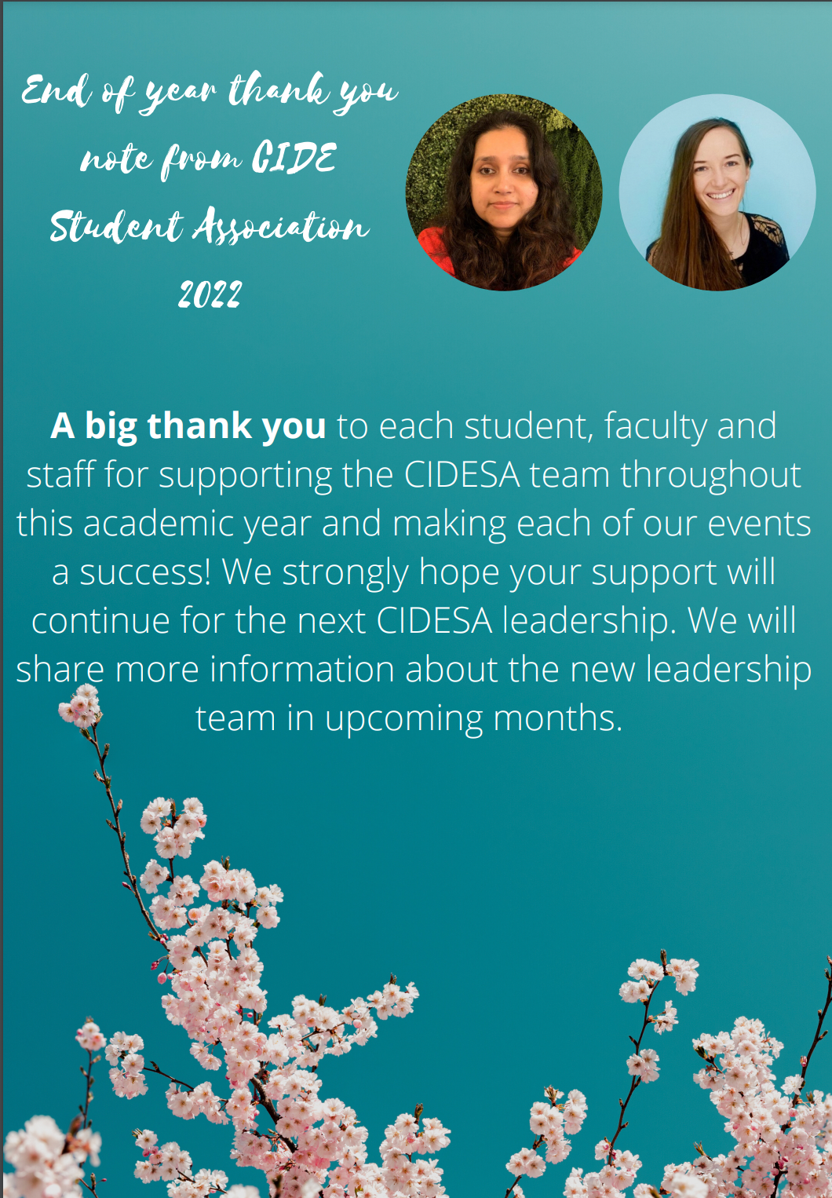

**Lois Boody**

CIDESA Co-Chair

**Sudhashree Girmohanta**

CIDESA Co-Chair

**Spring 2022 | Page No. 10**

**CIDEC Interest Groups (IGs)**

Student Association (CIDESA)!afbakg

Education, Conflict and Peacebuilding Group

Education, Conflict & Peacebuilding (ECP) and the Immigrant and Refugee Education (IRE) groups under CIDEC have collaborated to organize a 90-minute session **on May 4th 5:30pm with Sarah Dryden-Peterson,**Associate Professor at the Harvard Graduate School of Education and Director of [Refugee REACH](https://can01.safelinks.protection.outlook.com/?url=http%3A%2F%2Fwww.reach.gse.harvard.edu%2F&data=04%7C01%7Cdareen.charafeddine%40mail.utoronto.ca%7C90754d072a744aff712808da1d779e1a%7C78aac2262f034b4d9037b46d56c55210%7C0%7C0%7C637854696830479693%7CUnknown%7CTWFpbGZsb3d8eyJWIjoiMC4wLjAwMDAiLCJQIjoiV2luMzIiLCJBTiI6Ik1haWwiLCJXVCI6Mn0%3D%7C3000&sdata=gLYIEzTjAEI3kiyhSuc2%2F0dEMHpLgS9KSY3YIFDsd6A%3D&reserved=0)**.** With her considerable experience conducting qualitative research in scenarios of forced displacement and uncertainty, Dr. Dryden-Peterson will guide us through this workshop geared to those of us working on research in contexts of crisis, violence, disruption, and conflict, considering both substantive and methodological aspects of our research.  To attend, please register here:  <https://utoronto.zoom.us/meeting/register/tZItduytqzwtGdUoWvfVWN0oqZwqbhKe4ti7>

***What can we learn methodologically and substantively through comparison across these contexts?*** When registering, please indicate if you wish to share your own research dilemmas within a small group. Regardless of where you are in the research journey, you are still encouraged to participate as an opportunity for collective dialogue.

Immigrant and Refugee Education Research IG

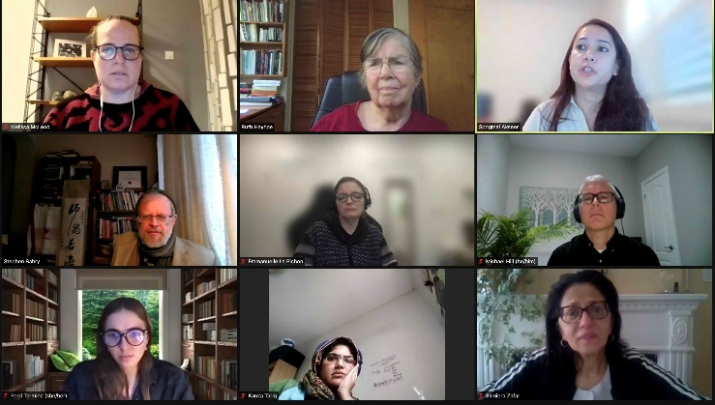

**IRE Research Activities since January 2022**

**Jan 27, 2022. Guest Speaker:** CIDE Alum, Dr. Spogmai Akseer, Research consultant, UNESCO; previously, Research Associate- UNICEF Office of Research Innocenti. **OISE,** **Doctoral thesis, 2015:** [Learning in a Militarized Context: Exploring Afghan Women’s Experiences of Higher Education in ‘Post-Conflict’ Afghanistan](https://tspace.library.utoronto.ca/handle/1807/70849). **OISE.** Dr. Akseer spoke to us about her experience living, working and researching in Afghanistan and her experience as a research associate at a research-focused NGO “Innocenti”, the research arm of UNICEF, especially their work on children, migration and education, and her current work at UNESCO.

**FEB 24, 2022.** **Guest Speaker:** Dr. Jaswant Kaur Bajwa, George Brown College & [Canadian Centre for Victims of Torture](https://ccvt.org/) ( see an article by Jaswant Kaur and coauthors in *Refuge: Canada's Journal on Refugees / Revue canadienne sur les réfugiés,* “[Higher education and informational barriers](https://www.erudit.org/en/journals/refuge/1900-v1-n1-refuge03391/1043063ar.pdf)”. Dr. Kaur Bajwa spoke with us about her work and research as professor, researcher, and counsellor and as board member of the Canadian Centre for Victims of Torture. We discussed students of refugee background and (post-secondary) education, including informational barriers faced by refugees seeking to access higher education, the effects of trauma on refugee learners, and trauma-informed education support for refugees.

**Spring 2022 | Page No. 11**

Immigrant and Refugee Education Research IG- Cont’d

**MAR 24, 2022. CIDEC Seminar:** “Experience and Perspectives of Children and Parents of PostSoviet Immigrant and Refugee Families: Educational Research on Stakeholders from a Seldom-noticed Group” Sarfaroz Niyozov, Stephen Bahry, Max Antony-Newman, Zahra Jafarova, Kateryna Pashchenko.

**MAR 31, 2022.** **Guest Speaker:** CIDE-affiliated Prof. Claudia Diaz-Rios talked to us about some of her work and the Colombian government’s educational responses to Venezuelan migrant children, which has committed to provide migrants with access to the country’s regular education system. Nevertheless, Venezuelan migrants are segregated in low-quality schools, and often perceived as subjects with deficit and in need of adaptation or assimilation. Integration in local education systems is not enough to secure the right to education and creates additional dilemmas for the educational inclusion of migrant children. Some discussion followed.

**APR. 7, 2022. SSHRC Insight Grant Awarded.** *Educational Experiences of Post-Soviet High School Students in Canada*. PI Dr. Sarfaroz Niyozov; CIs, Dr. Stephen Bahry; Dr. Max Antony-Newman; Zahra Jaffarova & Kateryna Paschenko, RAs.

### **APR 28, 2022. Guest Speaker:** Dr. Melissa Hauber-Özer, Adjunct Faculty, George Mason University. Dr. Hauber-Özer has been working with Syrian refugees in Turkey in various capacities and she spoke to us on her work and research in this area. Her doctoral dissertation focused on access of Arabic-speaking refugees to higher education in Turkey, which requires them first to achieve certification in Turkish language proficiency and to receive a Turkish high school equivalency. She used a combination of critical ethnography and narrative inquiry to explore the experiences of Turkish refugees with entry to and experience within Turkish higher education.

**April 19, 2022. CIES Language Issues SIG, Highlighted Session: Understanding language education from a diverse curricular perspective (CIES 2022).** Chair: Dr. Stephen Bahry.*The potential of reciprocal knowledge in STEM education: inviting our students' languages and curricula into the classroom:* Dr. Emmanuelle Le Pichon, Mai Naji, Dr. Dania Wattar.This paper looked at incorporation of funds of knowledge and home languages of immigrant/refugee students (speakers of Arabic, Mandarin or Urdu) in Toronto, comparing grade 4-8 home and host curricula in terms of content, language, and approach to teaching mathematics and science and developing a comprehensive resource for teachers and parents. The team also created resources (guides, activities, online resources to authentic documents, lesson plans) that reflect students' languages and the curricula of their home countries.

**MAY 4, 2022.** IRE, together with Conflict & Peacebuilding (ECP) research interest group, a co-sponsored a CIDEC Seminar with Dr. Sarah Dryden-Peterson, Harvard University, entitled, *“Studying Education Amidst Uncertainty & Crisis: A Dialogue on Research Dilemmas”*

**MAY 15-19, 2022.** CIESC, CSSE. Educational experiences of Canadian school students from post-Soviet backgrounds A systematic review of the literature. Prof. S. Niyozov, Dr. S. Bahry, Dr. M. Antony-Newman, Z. Jafarova, K. Pashchenko.

**Spring 2022 | Page No. 12**

The Africa Interest Group

We are a group of graduate students in the CIDE collaborative specialization from different programs across OISE who share an interest in research on the Africa Region. We aim to bring together students who are conducting research on Africa or have a general interest in discussing educational issues in the region. We also aim to support and provide a safe space for early-career scholars focused on Africa to share their research struggles and academic experiences.

Please email [yara.abdelaziz@mail.utoronto.ca](mailto:yara.abdelaziz@mail.utoronto.ca)  if you're interested in joining our group.

**Winter Semester Activities:**

**Collaboration with AMEWS: Online co-working sessions**

The Africa Interest Group collaborated with the [**Association for Middle East Women's Studies**](https://amews.org/)  (AMEWS) in hosting online co-working sessions in March 2022, which were attended by many graduate students from OISE and other Universities in Canada and around the world. The idea behind the online co-working session is to make working from home less isolating by providing a community space where members can come together and work on their academic or other related tasks. It is also a great space to expand your network and meet new students and faculty members worldwide. Sessions follow the Pomodoro technique that includes a group check-in at the start, focused working blocks (50 mins), and short optional breaks (10 mins). The Africa Interest Group will continue to co-host with AMEWS the online co-working sessions in April 2022. We welcome graduate students and faculty members from all disciplines to join us. Please use the link below to register for our April online co-working sessions.

<https://docs.google.com/forms/d/1cFda442a5IuDsS-DSBL0C_aQJ-mkVWE-WYg_6EzydgM/edit?ts=6215bff2>

Please see the CIDE/C website for further information on Interest Groups: <https://www.oise.utoronto.ca/cidec/cidec-interest-groups/>

**Spring 2022 | Page No. 13**

Inside this Issue

HoHownhflafafagagCCo

Spring 2022 CIDE GRADUATES

CONGRATULATIONS!

Inside this Issue

HoHownhflafafagagCCo

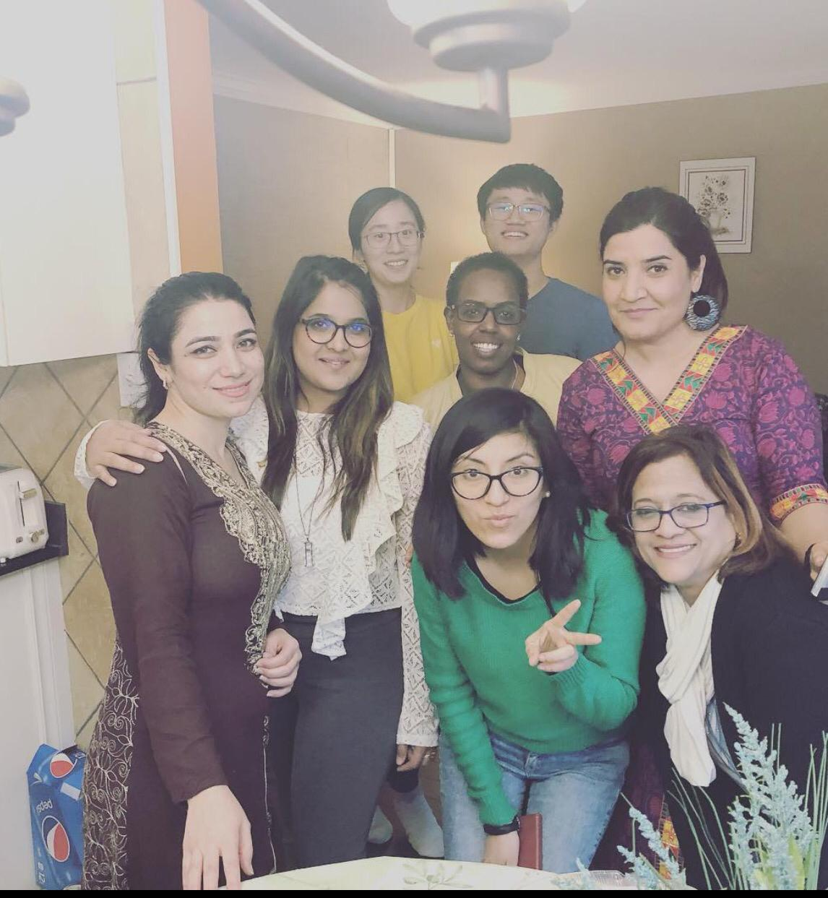

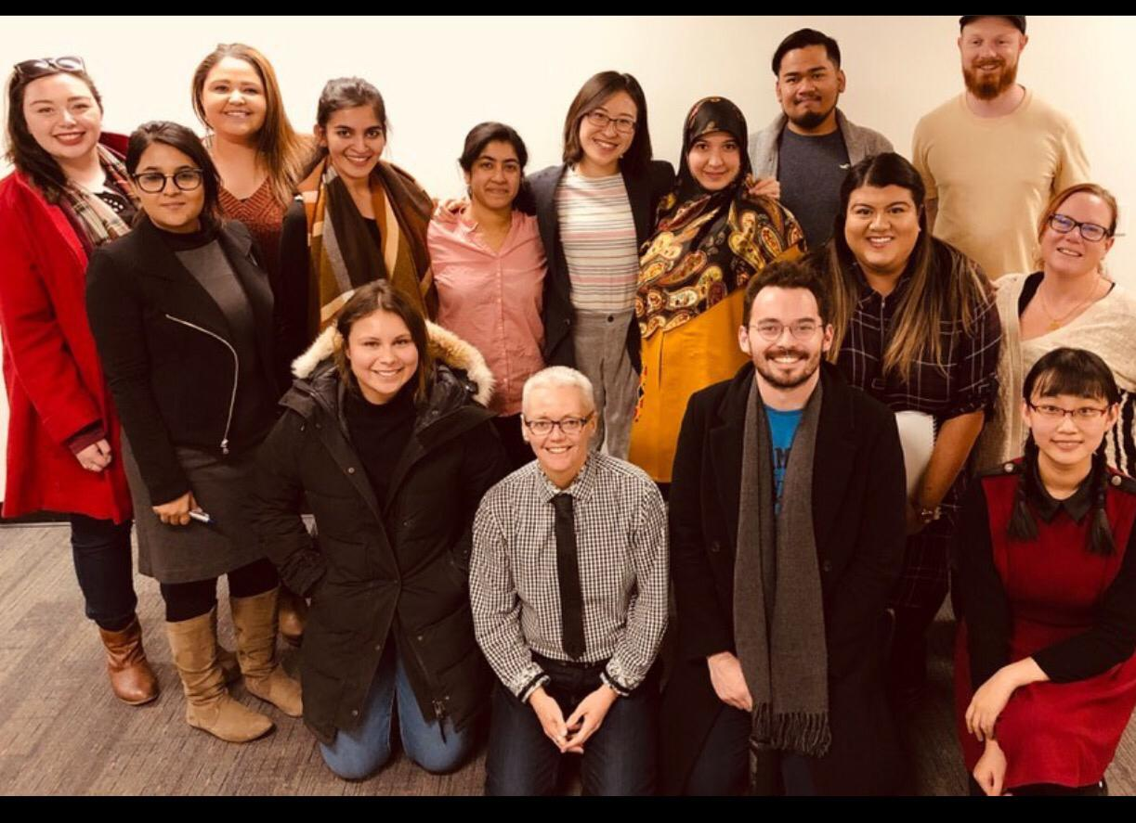

**Spring 2022 | Page No. 14**

**Fall 2021 | Page No. 18**

Inside this Issue

HoHownhflafafagagCCo

**CIDEC Faculty, Alumni and Students’ Publications**

Research Grants and Projects

Bale, J. (Principal Investigator), Gagné, A. (Co-investigator), and Kerekes, J (Co-investigator). (2016-2021 More Than “Just Good Teaching”: Mainstream Teacher Education for Supporting English Learners and Teacher Education Policy in Ontario.

Bickmore, K. 2019 (Principal Investigator), “Sparks of Courage and Understanding: Manitoulin and North Shore Youth Building Bridges and Combating Racism.” Canadian Heritage.

Bickmore, K. 2013 (Principal Investigator), “Peace-building Citizenship Learning in Canada and Mexico *[subsequently added Bangladesh and Colombia]:* School Connections with Life Experience.” Insight Grant, Social Sciences and Humanities Research Council of Canada.

Diaz Rios, C.M. in partnership with Nathalia Urbano-Canal (Co-PI), Universidad del Rosario UR-Colombia. “Educational responses to Venezuelan Migrants in Three Subnational Governments.” Small Grant for Partnerships UR.

Diaz Rios, C.M. (Principal Investigator), Manion, C. (co-applicant), Menashy, F. (co-applicant), Mundy, K. (co-applicant) (2021). SSHRC Insight Grant (2021-2025), “In the wake of a pandemic: International organizations and educational change in four countries, post-COVID-19”.

Gagné, A. (Principal Investigator) and Le Pichon-Vorstman, E. (Co-Principal Investigator). 2016-2021 The Academic and Social Integration of Student of Refugee background in Canadian Schools and Beyond.

Le Pichon-Vorstman, Gagné , A., Fleuret, C. (UOttawa), and Auger, N. and Sauvage, J. (Université Paul-Valéry MontPellier) (2020+). Plurilingual pedagogies and digital technologies to support learning in Science, Technology, Engineering and Mathematics.

Gagné, A. (2021-2022). Mobilizing the key findings of the FSL – Labour Market Partnership Project Promising practices for the development of FSL teacher identity and language proficiency among multilingual teacher candidates.

Publications

Aarrevaara, Timo, Finkelstein, Martin J., Jones, Glen A. & Jung, Jisun. (Eds.). (2021). *Universities and the Knowledge Society: The Nexus of National Systems of Innovation and Higher Education*. Cham, Switzerland: Springer.

Aarrevaara., Timo, Finkelstein, Martin, J., Jones, Glen A. & Jung, Jisun (2021). Universities and the Knowledge Society: An Introduction. In T. Aarrevaara, M. J. Finkelstein, G.A Jones. & J. Jung (eds.), *Universities and the Knowledge Society: The Nexus of National Systems of Innovation and Higher Education* (pp. 3-14). Cham: Springer.

Aarrevaara., Timo, Finkelstein, Martin, J., Jones, Glen A. & Jung, Jisun (2021). The Academic Profession in the Knowledge-based Society (APIKS): Evolution of a Major Comparative Research Project. In T. Aarrevaara, M. J. Finkelstein, G.A Jones. & J. Jung (eds.), *Universities and the Knowledge Society: The Nexus of National Systems of Innovation and Higher Education*(pp. 49-64). Cham: Springer.

**Spring 2022 | Page No. 15**

Bégin-Caouette, Olivier, Jones, Glen A., Karram Stephenson, Grace & Metcalfe, Amy Scott (2021). Canada: The Role of the University Sector in National Research and Development. In T. Aarrevaara, M. J. Finkelstein, G.A Jones. & J. Jung (eds.), *Universities and the Knowledge Society: The Nexus of National Systems of Innovation and Higher Education* (pp. 375-392). Cham: Springer.

Hayhoe, Ruth. (2021). Preface. In Betty Eng, *Crossing Cultures, Crossing Identities: Personal Narratives of Teacher Knowledge.* Switzerland: Palgrave MacMillan

Bickmore, Kathy (forthcoming 2022). “¿Cómo se maneja el conflicto, para permitir la construcción de una paz sostenible, en la educación ciudadana cotidiana?  Perspectivas de jóvenes y profesores mexicanos afectados por la violencia.”  In ^Paula Ascorra (Ed.), *Educación Para la Ciudadanía en Tiempos Constituyentes.* Santiago de Chile: FONDECYT.

Bickmore, Kathy (forthcoming 2022). Schooling for building just peace: Comparative perspectives on facing difference, conflict, and violence in education.In William Pinar & Anne Phelan (Eds.),*Curriculum Studies in Canada: Present Preoccupations.*University of Toronto Press.

Bickmore, Kathy (in press 2022).  Foreword. In Catherine Vanner, Spogmai Akseer, and Thursica Kovinthan Levi (Eds.), *Teaching Peace and Conflict: The Multiple Roles of School Textbooks in Peacebuilding.* Springer.

Bickmore, Kathy & Fathallah, Rim. (in press 2022). Teaching Social Justice amidst Violence: Youth and Enacted Curricula in Canada, Bangladesh, and México.  In Abdi, Ali, Misiaszek, Greg (Editors)*International Handbook on Critical Theories of Education.* Palgrave.

Bickmore, Kathy & Barrero, Diana (in press 2022). Globalized Local Environmental and Resource Conflicts in Mexican and Canadian Youths’ Lives and Schooling: Silenced Citizenship Questions.   In Kubow, P, Strong, K, Webster, N & Miranda, D. *Contestations of Citizenship: Children and Youth, Democracy, and Education in an Era of Global Change* (Routledge).

Bickmore, Kathy, & Kaderi, Ahmed Salehin. (2021). Teaching Values for Comprehensive Just Peace? Teachers’ Curricula for Social Cohesion in México, Bangladesh and Canada. Chapter 7 in Candice Carter (Ed.), *Teaching and Learning for Comprehensive Citizenship: Global Perspectives on Peace Education* (pp. 114-140). New York and Abingdon, UK: Routledge.

Celeste Yuen, *Multiculturalism, Educational Inclusion and Connectedness in Hong Kong: Wellbeing, Ethnicity and Identity among Chinese, South and Southeast Asian Students* (Milton Park, Oxfordshire: Routledge, 2022)

Díaz-Ríos, C., & Urbano-Canal, N. (2021). The World Bank and Education Policy in Colombia: A Comparative Analysis of the Effects of International Organizations’ Learning on Domestic Policy. *Journal of Comparative Policy Analysis: Research and Practice*, *0*(0), 1–17. <https://doi.org/10.1080/13876988.2021.1991796>

Díaz-Ríos, C., Urbano-Canal, N., & Ortegón-Penagos, N. (2021). How do national regulations for publicly subsidized private schools work in a decentralized context? *International Journal of Educational Development*, *84*, 102437. <https://doi.org/10.1016/j.ijedudev.2021.102437>

Díaz-Ríos, C. (2021). The politics of education reforms in post-conflict societies: A cautionary tale for the Colombian case. In J. L. Fabra-Zamora, A. Molina-Ochoa, & N. C. Doubleday (Eds.), *The Colombian Peace Agreement: A Multidisciplinary Assessment* (1st edition). Routledge.

Díaz-Ríos, C., Poirier, M., & Dion, M. L. (2021). Unequal citizenship and unequal outcomes: The Limits of Education and Health Policy Innovations in Latin America. In *Handbook of Development Policy*. Edward Elgar Publishing. <https://www.e-elgar.com/shop/usd/handbook-of-development-policy-9781839100864.html>

**Spring 2022 | Page No. 16**

Edward Howe, *Teacher Acculturation: Stories of Pathways to Teaching,* (Leiden, the Netherlands, Brill, 2022)

Gagné, A., Bale, J., Kerekes, J., Rajendram, S. Adjetey–Nii Owoo, M., Brubacher, K. Burton, J., Larson, E., Wong, W., Zhang, Y. (In press) *Centering Multilingual Learners and Countering Racism in Canadian Teacher Education.* Official Languages and Bilingualism Institute - OLBI Journal.

Gagné, A., Kalan, A., Herath, S. (Eds.) (In press). *Critical Action Research Challenging the Neoliberal Constrictions of Language and Literacies Education Globally - Auto and Duoethnographies of Global Experiences.* Peter Lang Publishing.

Gagné, A.& Wattar, D. (In press). A Duoethnographic Perspective on Supporting Muslim Children, Youth and Their Families in Canadian Schools*.* In *Equity and Justice Perspectives on Education in Canada* edited Ali A. Abdi. Canadian Scholars Press.

Gagné, A., Jaramillo, C., Ortega, Y. (In press). NCARE - A Network of Critical Action Researchers in Education: Processes & Realizations. In *Critical Action Research Challenging the Neoliberal Constrictions of Language and Literacies Education: Auto and Duoethnographies of Global Experiences* edited by Antoinette Gagné, Amir Kalan and Sreemali Herath. Peter Lang Publishing.

Gagné, A., Herath, S. & Kalan, A. (In press). Pathways to Challenge the Neoliberal Constriction of Education: An Introductory Multi-ethnography. In *Critical Action Research Challenging the Neoliberal Constrictions of Language and Literacies Education Globally* edited by Antoinette Gagné, Amir Kalan and Sreemali Herath. Peter Lang Publishing.

Gagné, A., Herath, S. & Kalan, A. (In press). Widening the Path to Challenge the Neoliberal Constriction of Education: Our Concluding Multi-ethnography. In *Critical Action Research Challenging the Neoliberal Constrictions of Language and Literacies Education Globally* edited by Antoinette Gagné, Amir Kalan and Sreemali Herath. Peter Lang Publishing.

Gagné, A., Rajendram, S. & Wattar, D. (2022). Working Toward Equity and Engagement in an Online Course for Future K-12 Teachers. In *Teaching in the Post COVID-19 Era: World Education Dilemmas, Teaching Innovations and Solutions in the Age of Crisis edited by I.* Fayed, I., & J. Cummings, J. Springer Publishing. New York.

Gagné, A. (2021). Teacher Education for Diversity Through an Autoethnographic Lens. In *Superdiversity and Teacher Education: Supporting Teachers in Working with Culturally, Linguistically, and Racially Diverse Students, Families, and Communities* edited byGuofang Li, Jim Anderson, Jan Hare, and Marianne McTavish. Routledge Publishers.

Garcia, J., Kenfield, Y., Moreyra Portilla, R., Ortega, Y., Solis, M-J., Straits, K., Straits, S., Xucanx Lazo, M. (2021). Centering translanguaging in critical teacher education: Cultivando nuevos conocimientos de translenguaje en la educación de futuros docentes. *Association of Mexican American Educators Journal,15*(3)*, 125-150.*[Link](https://amaejournal.utsa.edu/index.php/AMAE/issue/view/41)

Hantian Wu, *China’s Outward Oriented Higher Education Internationalization: A New Typology and Reflections from International Students,* Singapore: Springer, 2021.

Jones, Glen A. & Jefferson, Alison Elizabeth (2021). Reconceptualizing the Phenomenon of Inbreeding: Labour Markets, Stratification and Capital. *Higher Education Quarterly,*76(1), 8-19*.* <http://doi.org/10.1111/hequ.12329>

Jung, Jisun, Jones, Glen A., Finkelstein, Martin J. & Aarrevaara, T. (2021). Comparing Systems of Research and Innovation: Shifting Contexts for Higher Education and the Academic Profession. In T. Aarrevaara, M. J. Finkelstein, G.A Jones. & J. Jung (eds.), *Universities and the Knowledge Society: The Nexus of National Systems of Innovation and Higher Education*(pp. 415-428). Cham: Springer.

**Spring 2022 | Page No. 17**

Lili Yang, *Higher Education, State and Society: Comparing Chinese and Anglo-American Approaches*. London:Bloomsbury, 2022).

Manion, C. and Njie, H. (2021). *Gender, disability and inclusive education in development and humanitarian*

*contexts: Evidence synthesis*. New York, NY: Inter-agency Network for Education in

Emergencies (INEE).

Manion, C., and Njie, H. (2021). *Gender, disability, and inclusive education: Thematic review of the INEE Minimum Standards.* New York, NY: Inter-agency Network for Education in Emergencies (INEE).

Menashy, F., and Manion, C., (2022). The Political Economy of Global Education Policy.

In K. J. Saltman and N. Nguyen (Eds.), *Handbook of Critical Approaches to Politics and Policy*

*of Education*. Routledge.

Mundy, K. and Manion, C. (2021). The education for all initiative: History and prospects. In E. Unterhalter and T. McCowan (eds), *Education and international development:* *Practice,*

*policy and research* (2nd edition).London: Bloomsbury.

Ortega, Y. (2021). Transformative pedagogies for English teaching: Teachers and students building social justice together. *Applied Linguistics Journal.* [Link](https://doi.org/10.1093/applin/amab033)

Ortega, Y. (2021). ‘I wanted to be white’: Understanding power asymmetries of whiteness and racialisation. *Whiteness and Education*. [Link](https://www.tandfonline.com/eprint/TDI2JWVXRQFUXCUDSPKG/full?target=10.1080/23793406.2021.1920046)

Pham, J. (2021). "Chapter 14 The Fallacy of Native-Speakerism in English Language Education". In *Outside and In-Between*. Leiden, The Netherlands: Brill. doi: <https://doi.org/10.1163/9789004466357_016>

Schneijderberg, C., Götze, N. Jones, G. A., Bilyalov, D., Panova, A., Karram Stephenson, G.  & Yudkevich, M. (2021). Does Vertical University Stratification Foster or Hinder Academics’ Societal Engagement? Findings from Canada, Germany, Kazakhstan, and Russia. *Higher Education Policy*, 34(1), 66-87. <https://doi.org/10.1057/s41307-020-00219-5>.

Sztainbok, V. (2021). The Great Pandemic Confinement: Long-term Care, Migrants, and OrganizedAbandonment. Intersectionalities: A Global Journal of Social Work Analysis, Research, Polity, and Practice, 9(1), pp. 7-27.

Sztainbok, V. and Lorena Gajardo. Latina knowledge production and the ethics of ambiguity. In Teresa Macías (Ed.) Unravelling Research: The Ethics and Politics of Knowledge Production in the Social Sciences. Fernwood Press.

Wang, Siyi, & Jones, Glen A. (2021). Competing Institutional Logics of Academic Personnel System Reforms in Leading Chinese Universities. *Journal of Higher Education Policy and Management*, 43(1), 49-66.  <https://doi.org/10.1080/1360080X.2020.1747958>

**Spring 2022 | Page No. 18**

Presentations (including talks/keynotes)

Bale, J., Gagné, A., Kerekes, J., Rajendram, S., Brubacher, K., Burton, J., Larson, J., Nii Owoo, M.A, Wong, W., Zhang, Y. (2021). *Mainstream Teacher Education and Linguistically Responsive Teaching: Critical Perspectives on Teacher-Candidate Learning about Supporting English Learners,* CSSE.

Bickmore, K. (2022). “Educación para la Paz y Abordaje del Conflicto.” Invited Lecture, Departamento de Educación de la Facultad de Ciencias Sociales, Universidad de Chile (18 April).

Bickmore, K. (2022). “Educación Democrática, Conflicto y Escuela.” Invited Lecture, Grupo de Estudio Democracia, Ciudadania y Conocimiento Social en la Escuela y la Formación Docente, Proyectos Fondecyt, Universidad de Chile (21 April).

Bickmore, K. (2021). “Teaching Social Difference: ‘Canadian’ Curricula in International Comparative Context.” Invited Lecture, Curriculum Studies in Canada Symposium. (Delivered online, February 16). Posted June: [http://curriculumstudiesincanada.ca/services/](https://can01.safelinks.protection.outlook.com/?url=http%3A%2F%2Fcurriculumstudiesincanada.ca%2Fservices%2F&data=05%7C01%7Cdareen.charafeddine%40mail.utoronto.ca%7C72c6d746cfda4b047f8308da243ec65c%7C78aac2262f034b4d9037b46d56c55210%7C0%7C0%7C637862149273173243%7CUnknown%7CTWFpbGZsb3d8eyJWIjoiMC4wLjAwMDAiLCJQIjoiV2luMzIiLCJBTiI6Ik1haWwiLCJXVCI6Mn0%3D%7C3000%7C%7C%7C&sdata=9%2BBq6Sd3WAf9pXcsxAlElhSyw45ZAyW2Y0rflfd7sGM%3D&reserved=0) and [https://www.youtube.com/watch?v=xXtv-_emCTw](https://can01.safelinks.protection.outlook.com/?url=https%3A%2F%2Fwww.youtube.com%2Fwatch%3Fv%3DxXtv-_emCTw&data=05%7C01%7Cdareen.charafeddine%40mail.utoronto.ca%7C72c6d746cfda4b047f8308da243ec65c%7C78aac2262f034b4d9037b46d56c55210%7C0%7C0%7C637862149273173243%7CUnknown%7CTWFpbGZsb3d8eyJWIjoiMC4wLjAwMDAiLCJQIjoiV2luMzIiLCJBTiI6Ik1haWwiLCJXVCI6Mn0%3D%7C3000%7C%7C%7C&sdata=OhoGfOVWwEznQAP8%2BsTrrsXOr4gTTYM%2FcEMRpoJIueM%3D&reserved=0)

Bickmore, Kathy (2022). “Globalized Local Environmental Confl­­icts in Mexican and Canadian Youths’ Lives and Schooling: Silenced Citizenship Questions.” Presented at virtual Comparative International Education Society (April 20).

Bickmore, Kathy (2021) . “Promoting a Culture of Peace, amidst Oppression? Globalized Discourses and Teachers’ Lessons in México, Bangladesh, and Canada.” Presented in virtual panel – ^World Congress of Comparative Education Societies Symposium (November 19).

Bickmore, Kathy (2021). “Re-imagining Pedagogy (for) Social Conflict in a Globalized World.” Presented in Marianne Larsen’s Western University course, Globalization and Education (October 20)

Cavalcante, A. Gagné, A., Le Pichon-Vorstman, E. (2022). *What are the Mathematical Benefits of a Language-Friendly Pedagogy?* In the STEM Education in a Globalized World International Perspectives on Critical Teacher Education for Diversity Symposium. AERA Conference.

Gagné, A., (2022). *My journey from being ‘othered’ & ‘othering’ to listening & creating spaces for change with newcomers to Canada* in the Autoethnographies of Critical Action Researchers: Trajectories to Equitable Learning Communities that Challenge Neoliberalism Symposium. WERA Conference.

Gagné, A. (2022). *La cartographie de soi: Une pédagogie innovante*. OPSBA FSL Pilot Project Seminar.

Gagné, A., (2021). *Supporting K-12 English Learners through Digital ‘Me Mapping’ in Can*ada. University of Cuenca, Ecuador.

### Gagné, A., (2021). *Education of Children & Youth of Refugee Backgrounds*. ESL Resource Group of Ontario.

Gagné, A., (2021). *Me Mapping & Oral Language Development.* ESL Resource Group of Ontario

Gagné, A. (2021). *La cartographie de soi: Une pédagogie innovante*. Conférence du CRÉFO.

Gagné, A. (2021). *Literacy Development through Digital Me Mapping in Literacy Enrichment Academic Programs - LEAP.* The Education of Students of Refugee Background in Canada and Beyond Seminar. University of Toronto.

**Spring 2022 | Page No. 19**

Gagné, A. (2021). *Supporting K-12 English Learners through Digital ‘Me Mapping’ in Canada.* Public Lecture sponsored by the Canadian Studies and Education Programs. Bridgetown University, Massachusetts.

Gagné, A. (2021). *The Canadian School System and Embedded Measures for Newly arrived students and their parents in Ontario*. Schools and Teacher Education in Societies Shaped by Migration Seminar, University of Bremen, Germany.

Gagné, A. (2021). *Teacher education at the Ontario Institute for the Studies in Education/University of Toronto – ´me maps´ as an innovative tool to teach how to approach the needs of diverse students,* Schools and Teacher Education in Societies Shaped by Migration Seminar. University of Bremen, Germany.

Gagné, A., Kerekes, J. and Bale, J. (2021). *Learning to Support English Learners in Ontario: A Comparative Analysis of Teacher-Education Programs* in the Multilingual education or how to learn to teach multilingual learning Symposium. AILA.

Gagné, A., (2021). *Digital ‘Me Mapping’ with Newcomer Youth and Their Future Teachers*

in the new dynamics for new cultural, linguistic and digital realities: Adapting mainstream learning environments to and for migrant learners Symposium. AILA.

Gagné, A., Le Pichon-Vorstman, Rajendram, S. Wattar, D. (2021). At the Intersection of Research & Pedagogy:  Digital ‘Me Mapping’ with Newcomer Youth and Their Future Teachers, CSSE.

Gagné, A., Ortega, Y. Herath, S. Kalan, A., Jamarillo, C. (2021). *NCARE - A Network of Critical Action Researchers in Education: Processes & Realizations Symposium,* CSSE/CAARE, London, ON.

Hayhoe, R. (2021). “Cultural Heritage and Educational Evolution,” Keynote Lecture for the *Seventh World Wide Forum of Comparative Education* at Beijing Normal University. Beijing, September 18, 2021.

Hayhoe, R. (2021). “What Kind of Quality is Vital for the Future of Higher Education,” Keynote Lecture in Chinese for *The Third Shanghai International Conference on Higher Education Inspection and Evaluation*, Shanghai, November 13, 2021.

Hayhoe, R. (2021). “Reflections on a Life between Confucian China and the Christian West,” Keynote lecture for *China and Higher Education: Responding to a Changing World – Does Internationalization of Higher Education Still Matter?”* Manchester University, December 7, 2021.

Hayhoe, R. (2021). “Women, Faith and Sustainability: A Dialogue Among Asian Civilizations,” Keynote Opening Presentation for the annual conference of the *Hong Kong Educational Research Association*, Hong Kong, in dialogue with Professor Maria Manzon of Sophia University, December 9, 2021.

Le Pichon Vorstman, E., Wattar, D., Gagné, A. Cavalcante, A. (2021). *Filling the learning gaps caused by the pandemic: Supporting teachers and their diverse students with digital technology*. CTL Research Matters: A CTL Virtual Event

Manion, C. (2022). *Globalizing Discussions on Gender, Violence and Education in K-12 Contexts*. The Centre for Media, Culture and Education (CMCE) and The Comparative, International, and Development Education Research Centre (CIDEC) co-sponsored seminar. OISE, University of Toronto.

**Spring 2022 | Page No. 20**

**Spring 2022 | Page No. 18**