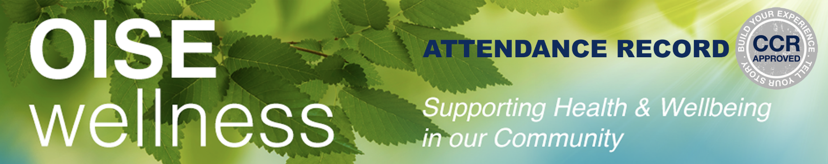

**Cultivating Personal Health & Wellness through Mindfulness**

***A Co-Curricular Credit Opportunity for Students***

The Cultivating Personal Health & Wellness through Mindfulness program is an opportunity for students to become aware of, develop knowledge about, and practice mindfulness for their overall health and well-being. The program is intended to improve one's general well-being to impact both their academic and personal lives. Successful students will have attended 10 or more of the available OISE Wellness sessions throughout the year. Attendance will be verified using attendance reports. Sessions can include Balance Break sessions, Lunch & Learn sessions, Community of Practice sessions, or any other program listed on the OISE Wellness website. ***This opportunity is available to all OISE students.***

For more information about the program and how to register, visit: [**https://www.oise.utoronto.ca/wellness/Co-Curricular_Credit_Opportunity_for_Students**](https://www.oise.utoronto.ca/wellness/Co-Curricular_Credit_Opportunity_for_Students)

|  |  |
| --- | --- |
| ***Student Name:*** | ***UTORid:*** |
| ***Zoom Name:*** | ***Email Address used to register:*** |

|  |  |  |  |  |
| --- | --- | --- | --- | --- |
|  | **Session Type**  **(Lunch & Learn, Weekly Practice, CoP)** | **Session Title** | **Facilitator/Speaker name** | **Date/Time** |
| 1 |  |  |  |  |
| 2 |  |  |  |  |
| 3 |  |  |  |  |
| 4 |  |  |  |  |
| 5 |  |  |  |  |
| 6 |  |  |  |  |
| 7 |  |  |  |  |
| 8 |  |  |  |  |
| 9 |  |  |  |  |
| 10 |  |  |  |  |

**CONGRATS! You did it!**

Submit your completed Attendance Record and Reflection to [**oise.wellness@utoronto.ca**](mailto:oise.wellness@utoronto.ca)

**Cultivating Personal Health & Wellness through Mindfulness**

***A Co-Curricular Credit Opportunity for Students***

***Goals and Reflection***

After 10 sessions, submit the completed Attendance Record along with a ***Reflection*** (about a paragraph or two) that responds to the following prompts:

* Describe key learning from your participation within the wellness program (i.e. knowledge, skills, practices etc.)
* How will what you learned and practiced impact your personal and professional lives in the future?

You are encouraged to set two or three goals at the beginning of the year and reflect on whether the program helped them meet your goals in your reflection document.

**My Goals:**

***Reflection:***