Name_________________________________________________________________________

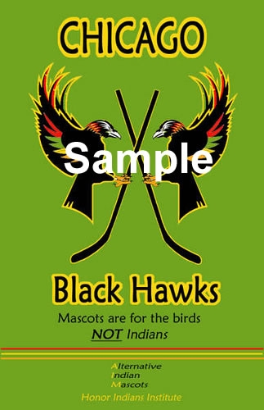
Racism in Sports Team Trademarks

ISU#2 – Create a new logo/poster to make social change!

Part A:
Create a new logo and poster for the Cleveland Indians, Atlanta Braves, Washington Redskins or other sports team that has a controversial logo caricaturizing indigenous peoples in racist ways. See http://honorindians.com/category/mascots-that-honor/ for ideas.

Part B: write a persuasive letter to the team in question (research the name of the owner or general manager) giving them at least 3 REASONS why they should make a change and how the image negatively affects indigenous peoples.

Part C: send the new logo and letter to the team, Ms. Athia and Honor Indians Institute by email.
Ms. Athia mohini.athia@tdsb.on.ca and Honor Indians Institute HonorIndians@gmail.com
DUE DATE:________________________ Communication /16 Thinking/Application /28

Logo Creation & Poster Design Rubric
 | 4 | 3 | 2 | 1
Logo Design Attractiveness and Relevance | Logo is very well designed, relevant to the sport, attracts and retains attention to the poster. | Logo is well designed, relevant to the sport and attracts attention. | Logo is somewhat attractive, relevant to the sport and draws some attention to the poster. | Logo is not attractive, relevant to the sport and does not draw the viewer to the poster.
Logo Originality/  Creativity | Logo is clearly an original design that has extensive creativity. | Logo is an original design and is creative. | Logo has some original design elements but lacks creativity. | Logo has no original design elements and lacks any creativity.
Poster Design | Poster is very well designed, attracts and retains attention. | Poster is well designed and attracts attention. | Poster is somewhat attractive and draws some attention. | Poster is not attractive and does not draw the viewer to the poster at all.
Spelling and  Grammar | Contains few, if any punctuation, spelling or grammatical errors. | Contains several errors in punctuation, spelling or grammar that do not interfere with meaning. | Contains many punctuation, spelling and/or grammatical errors that interfere with meaning | Contains many punctuation, spelling and/or grammatical errors that make the piece illegible.

Name_________________________________________________________________________

Persuasive Email Letter Rubric
 | 4 | 3 | 2 | 1
Opening  Statement | Strongly and clearly states a personal opinion. Clearly identifies the issue. | Clearly states a personal opinion. Some references to the issue. | Personal opinion is not clearly stated. Little or no references to the issue. | Personal opinion is not easily understood with no reference to the issue.
Supporting  Details | Provides 3 or more strong details, reasons and/or examples in support of the opinion | Provides 3 details, reasons and/or examples in support of the opinion. | Provides at least 1 detail, reason and/or example in support of the opinion. | Provides little or no support of the opinion.
Tone/  Language | Chooses words that are clear, descriptive and accurate. Maintains consistent persuasive tone throughout letter. | Adequately chooses words that are clear and descriptive. Demonstrates a persuasive tone in parts of the letter. | Chooses some words that are clear and descriptive. Lacks consistent persuasive tone. | Language and tone of letter is unclear and lacks description.
Format/  Organization | Sentences and paragraphs are complete, well written and varied. | Sentence and paragraph structure is generally correct. | Sentence and paragraph structure is inconsistent | Little or no evidence of sentence or paragraph structure.
Concluding  Statement | Summarizes personal opinion in a strong concluding statement. | Summarizes personal opinion in a concluding statement. | Concluding statement is a weak summary of personal opinion. | Concluding statement makes no reference to personal opinion.
Mechanics and  Grammar | Contains few, if any punctuation, spelling or grammatical errors. | Contains several errors in punctuation, spelling or grammar that do not interfere with meaning. | Contains many punctuation, spelling and/or grammatical errors that interfere with meaning | Contains many punctuation, spelling and/or grammatical errors that make the piece illegible.
Distribution of Email Letter | Email and poster design have been sent successfully by email to the relevant team, Ms. Athia and Honour Indians Institute. | Email and poster design have been sent successfully by email to 2 of the following: the relevant team, Ms. Athia and Honour Indians Institute. | Email and poster design have been sent successfully by email to 1 of the following: the relevant team, Ms. Athia and Honour Indians Institute. | Email and poster design have not been sent by email to any of the concerned parties.

