
NEWSLETTER Spring 2024

Inside this Issue
- Director’s Message
- Honors and Awards
- New Book (Diaz Rios)
- Upcoming Event 30/4: Handbook Series Launch
- Service and Appointments Beyond OISE
- CIDE Student Research
- Community Activities
- J. P. Farrell Student Research Symposium
- CIDEC Professional Development Series
- CIDEC Interest Groups’ Activities
- CIDESA News
- Spring 2024 Graduates
- CIDE Faculty, Alumni, and Students’ Publications
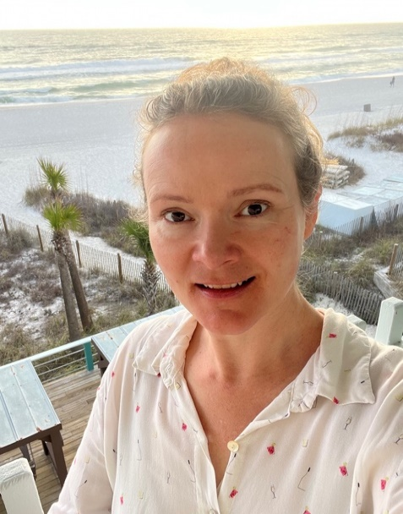
Director’s Message

Happy Spring, everyone! I want to thank all the contributors to the Spring 2024 edition of the CIDEC newsletter, and special thanks to CIDEC GA and co-editor, Mariya Hassan, for leading its production.

In this edition of the newsletter, readers will learn about CIDE student research (Jessica Denenberg, Aniza Fawad); the honors and awards received by CIDE students (Diana Barrero, JesusMiracle Chiadika, Nana Gulic, Nancy Hsiung, Adriana Marroquin Rodriguez) and CIDE-affiliated faculty (Mary Drinkwater, Ann Lopez, Francine Menashy); other scholarly and professional development activities of CIDE students (Emily Dobrich, Iffat Razzaque, Marie Sherman); OISE-CIDE social events at CIES 2024 (OISE had over 80 students and faculty participating!); activities of CIDEC Interest Groups (IGs); service and appointments beyond OISE (Karen Mundy); and a new book by Claudia Diaz Rios as well as other CIDE faculty, alumni and student publications. Additionally, we share highlights from the annual J. P. Farrell Student Research Symposium (JPFSRS) held on February 16, 2024, showcasing again the inspiring and important work of CIDE students. We also include an overview of the inaugural CIDEC Professional Development Series, 2023-2024, facilitated by CIDE alumnae, Zohra Lakhani.
Carly Manion (CIDE/C Director)

Congratulations to everyone on your incredible accomplishments and contributions!

It has been an absolute pleasure working with the CIDE/C community, including CIDE/C Steering Committee, all CIDE-affiliated faculty, and students, the CIDE Student Association (CIDESA), and CIDEC IGs this year. We are working hard to further strengthen and make the collaborative specialization (CIDE) and centre (CIDEC) even more inclusive and accessible. My gratitude to CIDE students, staff, and faculty across all participating departments for coming together to create and nurture such a vibrant, intellectually stimulating, and justice-centred community.

One important change to note: we are piloting some changes to the CIDEC ListServ and it is now moderated. We encourage subscribers (we now have around 1000) to continue to exchange information and share opportunities via the ListServ; however, we ask that you please send any messages you wish to post, to oise.cidec@utoronto.ca first and from there they will be sent out. We aim to offer a quick turnaround time of 24 hours, except on the weekends. Let us know if you have any questions or concerns.

Lastly, I am delighted to share that following a successful review, CIDEC has been renewed for 5 years. Reviewer comments were replete with praise and encouragement for CIDEC to continue its important work. Thanks to all those students, alumni, and faculty who contributed to the CIDEC self-study and centre review process.

I hope you will all have an enjoyable summer and look forward to connecting again in the Fall.

Warmly,

Carly Manion (she/her)
CIDE/C Director

Spring 2024 | Page No. 1

Honours and Awards

Students

Adriana Marroquin Rodriguez

Congratulations to Adriana Marroquin Rodriguez for being awarded a Dr. David Chu Scholarship in Asia Pacific Studies. The scholarship contributed to funding essential research travel required to conduct fieldwork in Taiwan and Panama for Adriana’s doctoral thesis, titled "Learning from Non-traditional International Student Mobilities: Narratives of the Life Stories of Latin American and Caribbean Graduates from Taiwanese Universities." More information about the award can be found at: Arts & Science Awards & Scholarships page.


Diana Barrero

Congratulations to Diana Barrero (Ph.D. candidate, Department of Curriculum, Teaching and Learning for being awarded the Feminist Theory Workshop International Travel Award. The international travel award enables emerging scholars from institutions all over the globe to actively participate in the Feminist Theory Workshop (FTW) at Duke University. This year FTW took place March 22-23 and offered unique opportunity for participants to engage in sustained dialogue about feminist theory across both disciplinary and national boundaries.

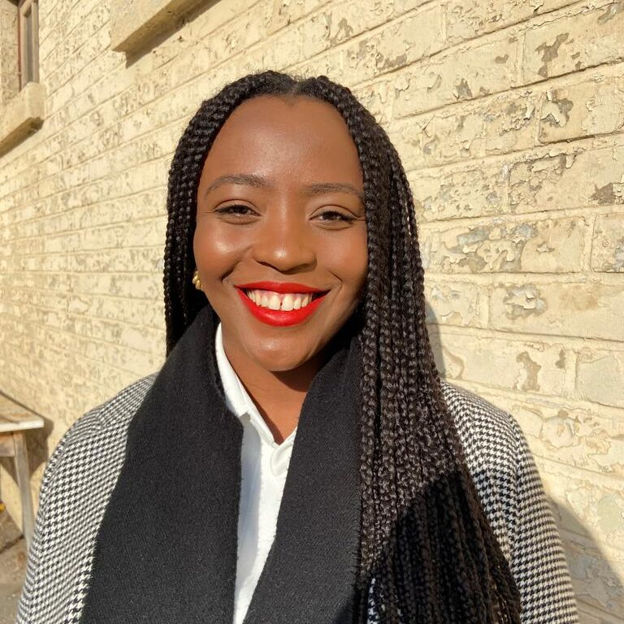
JesusMiracle Chiadika

Congratulations to JesusMiracle Chiadika who has recently been awarded the 2023-2024 Inlight Research Fellowship Award. JesusMiracle is a PhD student in Higher Education and Comparative, International & Development Education at OISE. Her research will aim to understand the mental health experiences of racialized undergraduate students. Using a qualitative approach, Chiadika will explore the surge in demands on services and resources for mental health, and the lack of culturally sensitive support systems tailored to meet the diverse needs of students. Chiadika is supervised by Associate Professor Elizabeth Buckner and Assistant Professor Linda Iwenofu.


Nana Gulic

In March 2024, Nana Gulic (Ph.D. candidate, Social Justice Education) received the Comparative International Education Society (CIES) Citizenship and Democratic Education SIG's* 2024 Outstanding Paper Award for her paper titled “Examining the Potential of Citizenship Education in Fostering Active Citizenship in Postsocialist Croatia: Teacher Perspectives". Congratulations Nana!

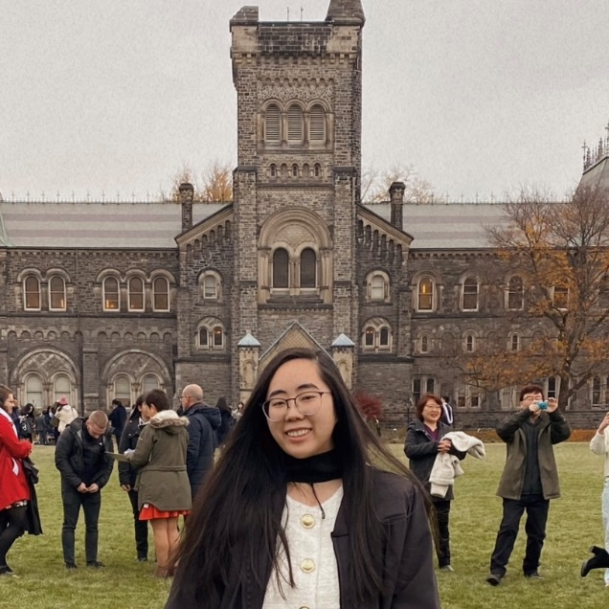

Congratulations to Nancy Hsiung, who has been awarded the Canada Graduate Scholarships — Master’s (CGS-M) by the Social Sciences and Humanities Research Council (SSHRC) on April 1, 2024. Currently, Nancy is in the final stages of her first year of full-time studies in the Master of Arts program in Educational Leadership and Policy, specializing in Comparative, International, and Development Education. Nancy’s thesis research investigates the intersection between secondary school leaders in Ontario and educational technology.

Nancy Hsiung

Faculty
Ann Lopez


Next month, Dr. Katherine Entigar will be traveling with three OISE graduate students, MA student Mengyuan Guo (AECD/LHAE), PhD student Jasmine Bégin Marchand (LLE/CTL), and PhD student Emily Dobrich (AECD/LHAE), to represent University of Toronto at the 2024 U7+ Student Challenge Summit in Ivory Coast. The UofT team will be joining faculty-student teams from University of Ottawa as well as France, Nigeria, India, Japan and Senegal as guests of the Institut National Polytechnique Félix Houphouët Boigny in Yamoussoukro from May 13-19. The call for proposals invited teams to identify a local issue and develop an interdisciplinary project highlighting the central theme for this year’s summit—inclusive education for inclusive societies—that illustrates the United Nations Sustainable Development Goals. The team’s proposed project, which aligns closely with Dr. Entigar’s work on inclusion in adult education with transnational learners, aims to democratize access to higher education for international students through peer mentoring and network-building.
Katherine Entigar

Spring 2024 | Page No. 2

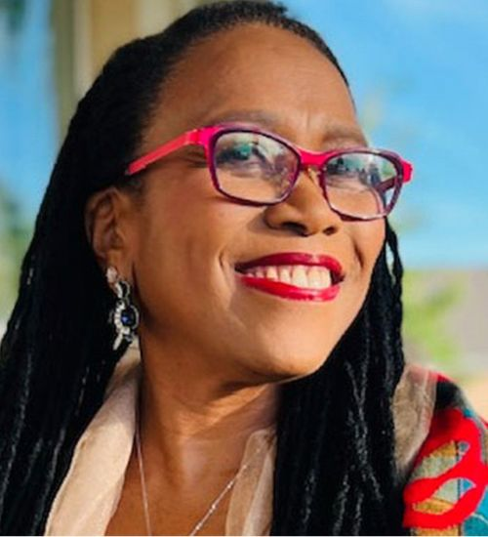

Congratulations to Dr. Ann Lopez (Professor, Department of Leadership, Higher and Adult Education) on recently being awarded an OISE Teaching Excellence Award: Award for Excellence in Educational Leadership. Since 2004-2005, OISE’s Teaching Excellence Awards recognize faculty and instructors who have made significant contributions to teaching and learning in our institute.


Francine Menashy

Dr. Francine Menashy's project Racial Equity for Education in Emergencies: Tracing Humanitarian Aid Policy-Making and Priorities was awarded a Spencer Foundation Racial Equity Grant. Through a mixed-methods study involving social network analysis and process-tracing, this project will track humanitarian aid allocation and examine the role that race plays in policy-making on education in emergencies. Congratulations Dr. Menashy!

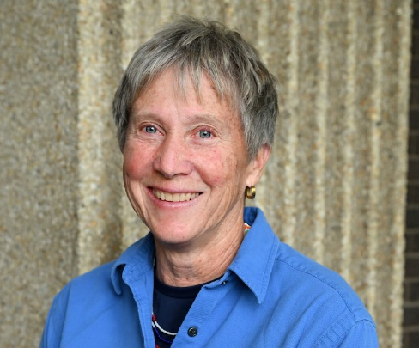
Mary Drinkwater

Congratulations to Dr. Mary Drinkwater (Sessional Lecturer, Department Leadership, Higher and Adult Education) on recently being awarded an OISE Teaching Award for Distinguished Contribution to Teaching. Since 2004-2005, OISE’s Teaching Excellence Awards recognize faculty and instructors who have made significant contributions to teaching and learning in our institute.

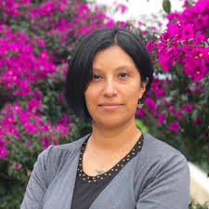
New Book (Diaz Rios)

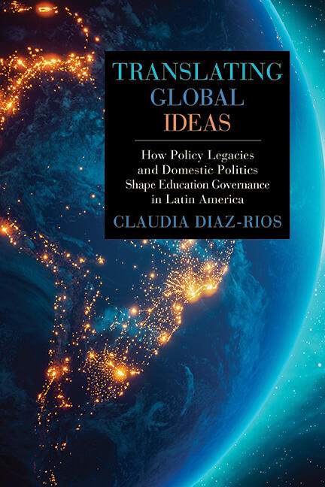
Congratulations to Dr. Claudia Diaz-Rios (Assistant Professor, LHAE/ELP) on the publication of her new book, Translating Global Ideas: How Policy Legacies and Domestic Politics Shape Education Governance in Latin America.
Claudia Diaz Rios

Book Description: International organizations have consistently influenced education reforms in Latin America, but not all countries have adopted the same policy recommendations. This book offers a unique comparative analysis of secondary education reforms in Chile, Argentina, and Colombia, from the 1960s to the 2010s, with a focus on three key milestones in the global history of education governance ideas: manpower planning, state-retrenchment, (market-based versus active-state), and ideas about having a right to a quality education in an era of government accountability. While responding to similar policy recommendations, these countries have differed in how they have implemented decentralization, incorporated private actors, allocated authority over curriculum, and established instruments of accountability. Claudia Diaz-Rios traces the legacies of previous education policies and local struggles among stakeholders in reshaping—and sometimes rejecting—foreign recommendations. Translating Global Ideas will be an invaluable resource for scholars of comparative politics and the globalization of education, particularly those interested in policy development in middle- and low-income countries, as well as practitioners invested in promoting education policy changes in Latin America.

To purchase the book, please click here.

Spring 2024 | Page No. 3

Upcoming Event: CGHE Webinar Series (University of Oxford)
Tuesday, April 30, 2024 (2-3 pm GMT UK)

Title of webinar – Handbook Series Launch – The Bloomsbury Handbooks of Crises and Transformative Leadership in Higher Education

Presenters: Dr. Mary Drinkwater (OISE-University of Toronto; Yorkville University); Professor Yusef Waghid (Stellenbosch University); Patrick Deane (Queen’s University)

Content: This webinar will kick-off the launching of a new 4-volume international handbook series, entitled The Bloomsbury Handbooks of Crises and Transformative Leadership in Higher Education, to be published in Spring 2024. The volume titles in the series include:

- The Bloomsbury Handbook of Values and Ethical Change in Transformative Leadership in Higher Education
- The Bloomsbury Handbook on Context and Transformative Leadership in Higher Education
- The Bloomsbury Handbook on Diversity, Crises and Transformative Leadership in Higher Education
- The Bloomsbury Handbook of Ethics of Care in Transformative Leadership in Higher Education

Global crises, unrelenting change, and disruptions (such as pandemics, financial crises, environmental crises, technological innovations, geopolitical events, and others) have induced both challenges and opportunities for institutions of higher education globally, while threatening the sustainability of many. In its intersections with the rise of protectionism, cultural chauvinism, authoritarianism and demagoguery, the COVID-19 pandemic exacerbated–or at least rendered more visible–a global climate in which culture wars infiltrated campuses, as well as the very discourse of higher learning. Proliferating scepticism about the value of science and expertise more broadly appears to signal a weakening of trust in the role of universities as transformative agents of positive social and human development. As a result of the complex contextual situatedness of these institutions, responses to these crises, disruptions, and uncertainties have often taken quite different approaches.

It is the lessons and reflections on the why and how to lead HEIs through these multiple, intersecting and ongoing crises and change that informs the development of the chapters within this handbook series. With over 120-chapter authors from six continents, these volumes will deepen the readers understanding of the multiple and intersecting crises and change issues, within diverse local and global geopolitical, social, economic and cultural contexts that leaders in higher education institutions (HEIs) needed to handle. In creating new policies, programs and pedagogical approaches, leaders in higher education have had to work critically, creatively and collaboratively to identify opportunities and overcome obstacles related to values, ethics, learning, engagement, inclusion, diversity, research, technology, accountability, partnership development, and sustainability, amongst others. Through their leadership and transformative change initiatives, many leaders and senior administrative teams have found or created new opportunities and are now looking at the valuable lessons learned from their experiences under extreme conditions, and how these might inform the post-pandemic, post-change or post-crisis directions for their university.

Handbook Series Launch | The Bloomsbury Handbooks of Crises and Transformative Leadership in Higher Education
- Tuesday, 30 April 2024 14:00 - 15:00 (UK Time)
- Zoom webinar, registration required
- Mary Drinkwater, OISE-University of Toronto; Yorkville University, Canada
- Yusef Waghid, Stellenbosch University, South Africa
- Patrick Deane, Queen’s University, Canada
Register Here (https://zoom.us/meeting/register/tJAsdOqvrDwqGtxr_8Z1fWnE7HilUBI59TKs#/registration)

Short Bios:
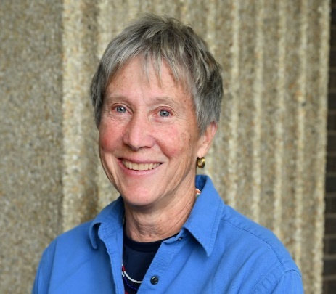

Mary Drinkwater is a Lecturer in Leadership, Higher and Adult Education, and Comparative International & Development Education at the Ontario Institute for Studies in Education, University of Toronto. She is also a faculty lead (curriculum; research) at Yorkville University. Mary’s research interests include critical and decolonial theory and praxis in education, transformative education, critical leadership, educational policy development. She was lead editor and chapter author in Transnational Perspectives on Democracy, Citizenship, Human Rights and Peace Education (Bloomsbury, 2019).

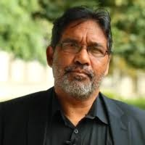

Yusef Waghid is a leading African philosopher of higher education intent on advancing democratic citizenship education, cosmopolitan education, and global citizenship education in the context of equitable redress and change, equality, non-discrimination, non-sexism, and justice for all. Epistemologically, he draws on multiple traditions of thought, most notably combining dominant aspects of Western and non-Western theories of knowledge to rethink philosophy of education in Africa as is evident in his latest book: Philosophical, Educational and Moral Openings in Doctoral Pursuits and Supervision: Promoting the Values of Wonder, Wander, and Whisper in African Higher Education (Routledge, 2024).

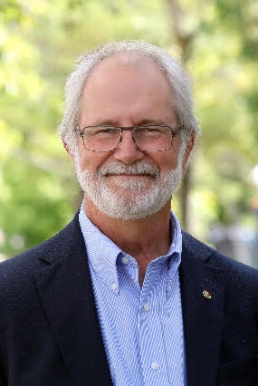

Patrick Deane is the Principal, Vice-Chancellor and Professor of English Language and Literature at Queen's University, Canada. He previously served nine years as President of McMaster University and has held senior leadership roles in the Canadian academy for over twenty years. His scholarly focus is on British culture and politics in the Twentieth Century.

Spring 2024 | Page No. 4

Service and Appointments Beyond OISE

- Karen Mundy has been appointed a non-resident fellow at the Center for Global Development in Washington, DC.
Karen is a Professor of Educational Leadership and Policy at the University of Toronto (cross-appointed to the Munk School of Global and Public Affairs) and a leading expert on education in the developing world. As Chief Technical Officer at the Global Partnership for Education, the world’s largest global fund providing more than $500 million per year to 67 developing countries, she led the development of GPE’s Strategic Plan 2015-2020, its Gender Equality Strategy, its Results Framework, Monitoring and Evaluation Strategy (2015-2020), and the publication of GPE’s first two Results Reports. At the University of Toronto, Dr. Mundy has been a Canada Research Chair (2002-2012) and the Associate Dean of Research and Innovation (2012-2014). She was the President of the Comparative and International Education Society (2014-2015). Her research has covered the global politics of “education for all”; educational policy and reform in Sub-Saharan Africa; and the role of civil society organisations in educational change. She has published six books and more than five dozen articles and book chapters and is a contributor to dozens of policy papers and reports. She is a two-time winner of the Bereday award for best article in the Comparative Education Review (1998, 2015). Source: https://www.cgdev.org/expert/karen-mundy
- Karen Mundy is also currently serving as a member of the Yidan Prize Foundation’s international advisory board (https://www.yidanprize.org/about-us/our-structure/full-bio/karen-mundy?anchor=our-advisory-committee). The Yidan Prize, established in 2017, is awarded to changemakers in education (research and development).

- Carly Manion concluded a 3-year term serving as CIES Historian in March 2024. Responsibilities included writing a book chapter on the intellectual journey(s) of CIES since its establishment, the production of several articles published in CIES Perspectives, assisting in the management of historical records (digital and print), participating in regular CIES Executive Committee and Board of Directors’ meetings, service on ad hoc committees, among other activities.

CIDE Student Research Summaries

- Sense of Belonging of Young Pakistani Immigrants in Ontario; School Factors and Experiences as Drivers and Barriers*
By: Aniza Fawad (MEd, LHAE/ELP; Supervisor: Prof. Carly Manion)
A sense of belonging in schools is “the extent to which students feel personally accepted, respected, included, and supported by others in the school environment” (Goodenow, 1993, p. 80). As Pakistan is the 10th largest source country in terms of immigration and as Pakistani youth have their own cultural, religious, and moral values, there is a need to explore the factors that affect their sense of belonging in schools. As an immigrant mother of three, I feel that the schooling experiences of my children played an important role in their peer relationships and academic pathways.
This study aimed to understand the meaning of a sense of belonging in schools for immigrant youth, with a focus on the perspective of K-12 Pakistani immigrant students in Ontario and explored the factors that can act as drivers and barriers affecting their school performance and physical and mental well-being.
The research involved a sample of seven Pakistani immigrant youth between the ages of 18 and 25 from different locations in Canada. A simple qualitative inquiry was conducted, and the data was collected by conducting semi-structured one-on-one interviews via Zoom and was transcribed by using ‘Live Transcribe’ by Google. For data analysis, the Thematic Analysis approach was taken and NVivo 12 was used to organize, visualize and code the data for analysis.
Findings and Discussion
In the initial phase of building a sense of belonging the young immigrant students start to get familiarized with the new school environment and start identifying the enabling factors and constraints to their sense of belonging. They develop the understanding and knowledge about the opportunities that can benefit them to settle in the new environment and develop the skills to tackle the challenges that hinder their belonging.
The findings of the study showed that the teachers’ behaviour, language support like ELL and ESL, mental health support and a positive parent-school relationship were enabling factors for the sense of belonging of the young Pakistani immigrants. On the other hand, language and accents, lack of cultural representation and the cultural and religious differences proved to be the constraining factors towards the sense of belonging in schools. The research showed that building a sense of belonging is not only the responsibility of the school, rather it is a two-way process, and students should also play their part.
The participants requested to arrange for modest athletic wear for Muslim students, a room for Friday Prayers and a cultural day to display their culture, dress and food. Participants stressed that counsellors themselves should be culturally aware of different cultures and religions, so they can better help students from various backgrounds. Participants suggested that even adding one piece of literature or articles from different parts of the world would make everyone in the class feel belonged and represented. Sports, trips and courses should not be very specific to the white Canadian culture and more inclusive to all sorts of backgrounds. Another challenge which participants highlighted was the Pakistani and Indian identity misconception which could lead to an identity crisis and overshadowing of Pakistani entity.
The Pakistani immigrant students who now have passed their struggling phase and have developed their belonging in Canadian schools gave valuable suggestions such as developing a buddy system, cultural awareness by the teachers and a mindset to accept the transition from Pakistan to the Canadian school system.
Spring 2024 | Page No. 5

Benefits of the Study
This study's findings help inform and develop research on young Pakistani immigrants’ sense of belonging in Ontario schools and participant’s perspectives help provide an in-depth view of the factors that act as drivers and barriers to belonging in schools. The study contributes important insights into the existing literature and potential policy and practice for immigrant students in schools. In addition, it may help increase awareness of the subject and encourage educators to reflect critically on the gaps between policy and practice.
Reference
Goodenow, C. (1993). The psychological sense of school membership among adolescents: Scale development and educational correlates. Psychology in the Schools, 30 (1), 79–90. https://doi.org/10.1002/1520-6807(199301) 30:1<79::AID-PITS2310300113>3.0.CO;2-X
*A video presentation of this research can be viewed here (or cut and paste onto browser: https://drive.google.com/file/d/17z2iSmR6uU-Rruw_9MpilRxeELzIISZk/view?pli=1).

- Approaches to Fostering International Partnerships in Higher Education: Canada and Germany in a Comparative Perspective

By: Jessica Denenberg, PhD (LHAE/HE; Supervisor: Prof. Elizabeth Buckner)

Over the past decade, strategic international partnerships (SIPs) have been repositioned as a fundamental pillar and a defining characteristic in the internationalization of higher education (Mwangi, 2017, p. 34; Knight, 2015, p. 110; Sutton, Egginton, & Favela, 2012, p. 147; Sutton, 2010, p. 60). The growing significance of international partnerships in higher education at national and institutional levels signals an important shift in the way that global collaboration is prioritized as a core mechanism for advancing strategic internationalization goals. Despite the widespread nature of this shift, university approaches to international partnerships vary across institutional contexts, thereby constituting a notable gap in our understanding of factors influencing strategic international partnership development. This gap is
especially significant since international partnerships have become a central element of university internationalization plans to foster research and innovation, to recruit international students and scholars, to engage in multilateral funding opportunities, and to find collaborative solutions to shared global challenges.

The first major consequence of this shift is that contemporary international academic partnerships have become progressively complex (Olson, 2013, pp. 230-231) and prone to uneven power dynamics and inequality (Buckner et al., 2022, p. 9; Mwangi, 2017, p. 36). Historically, institutional international partnerships have been characterized by patterns of a more of a “transactional” nature (Mwangi, 2017, p. 35), typically focusing on bilateral student mobility and exchange, and reflecting a process of “inward” internationalization that essentially seeks to gain something for the home institution (Sutton, 2010, p. 60; Enos & Morton, 2003, p. 21). In recent years, however, this trend has shifted towards a pattern of “transformational” partnerships (Mwangi, 2017, p. 35; Sutton, 2010, p. 60), thereby reflecting a process of “outward” internationalization that demonstrates genuine reciprocity and authentic mutual interest.

The second major consequence that emerges from this shift is an increasing focus on “strategic” approaches to internationalization (Buckner et al., 2020, p. 20), a trend that has fundamentally changed how international partnerships are approached, negotiated, and rationalized. Consequently, strategic international partnerships have taken on an increasingly central role in university internationalization plans, particularly as they relate to an institution’s mission to increase both inbound and outbound mobility, to increase numbers of international students and faculty members, and to increase research publication numbers and funding opportunities. Exploring the factors influencing the growth, development, and stability of international partnerships is thus an essential aspect of effectively advancing university strategic goals and addressing shared challenges.

As the internationalization of higher education becomes increasingly professionalized, strategic international partnerships play a central role in the globalized context of international higher education. Despite the varied challenges of fostering reciprocal and sustainable collaboration between nations and cultures, “the number of bilateral or network-based collaborative initiatives has soared in the last few years” (Knight, 2015, p. 110), a point that reinforces the ongoing relevance and importance of this practice for the field of higher education. The outcomes of this study have wider implications for theory and practice in the field of international higher education, affirming the critical role of international partnerships as a core mechanism for advancing strategic international goals, highlighting key challenges that limit partnership development, and offering recommendations for improving cross-cultural collaboration in higher education and research.

To learn more about my doctoral research — including my proposed framework to integrate a mutuality approach into partnership development — please view this short video presentation.

References

Buckner, E., Denenberg, J., Gelashvili, M. et al. (2022). The Internationalization of Higher Education in the Wake of COVID-19: A Rigorous Review of the Literature on Short-Term Impacts, in: CIHE Perspectives, Vol. 20, Boston College Center for International Higher Education (CIHE).
Buckner, E., Clerk, S., Marroquin, A., & Zhang, Y. (2020). Strategic benefits, symbolic commitments: How Canadian colleges and universities frame internationalization. Canadian Journal of Higher Education/Revue canadienne d’enseignement supérieur, 50(4), pp. 20–36.
Enos, S. & Morton, K. (2003). Developing a Theory and Practice of Campus-Community Partnerships, in: B. Jacoby (Ed.). Building Partnerships for Service-Learning. San Francisco, CA: Jossey-Bass, pp. 20–41.
Knight, J. (2015). International Universities: Misunderstandings and Emerging Models. Journal for Studies in International Education, 19(2), pp. 107–121.
Mwangi, C. G. (2017). Partner Positioning: Examining International Higher Education Partnerships through a Mutuality Lens, in: The Review of Higher Education, 41(1), pp. 33–60.
Olson, C. L. (2013). A Canadian Lens on Facilitating Factors for North American Partnerships. Journal of Studies in International Education, 17(3), pp. 228–243. https://doi.org/10.1177/1028315312453741
Sutton, S. B. (2010). Transforming Internationalization Through Partnerships. International Educator XIX, No. 1, pp. 60–63.
Sutton, S. B., Egginton, E., & Favela, R. (2012). Collaborating on the Future: Strategic Partnerships and Linkages, in: Deardorff, D., De Wit, H., Heyl, J. & Adams, T. (Eds). The SAGE Handbook of International Higher Education. Sage Publications, pp. 147–165.

Spring 2024 | Page No. 6

Community Activities
U7+ Alliance of World Universities
By Marie Sherman

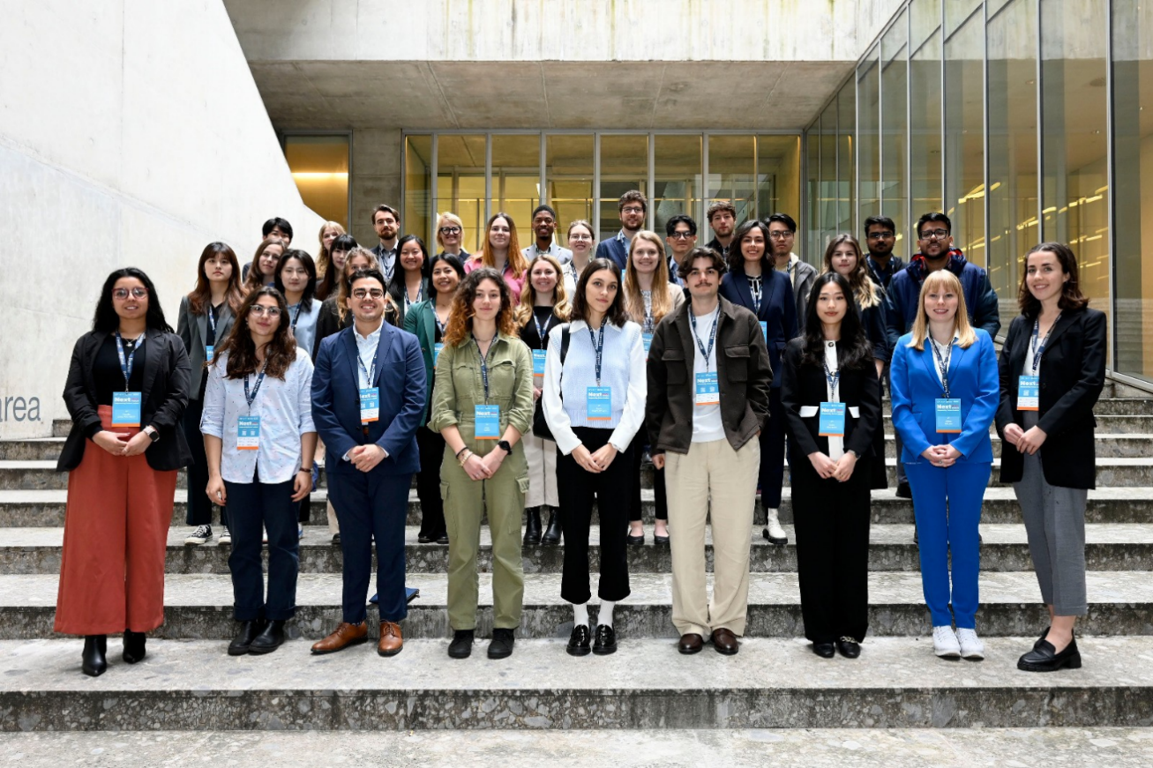
On March 18th and 19th 2024, Marie Sherman represented University of Toronto as part of the U7+ student delegation at the NEXT Milan Forum at Bocconi University. The U7+ Alliance is the first international alliance of university presidents who work towards “addressing global challenges in a multilateral context” (ABOUT - U7 Alliance). The delegation, made up of undergraduate and graduate students from across the world was tasked with discussing and tackling these issues themselves, as well as preparing videos to directly share policy recommendations for the university presidents when they meet in April.

In addition to this student-led collaboration, Marie also attended plenary sessions as part of the larger forum, where professors, scientists, researchers, CEOs, economists, authors, and government officials came together to discuss their work around some of the most complex challenges our world is facing, including: climate change, access to education, peace and security, AI and digital media, and gender equity. Marie is grateful for the knowledge and experience gained from the CIDE collaborative specialization serving as the foundation for these important discussions and collaborations. She is also deeply appreciative of the CIDEC and University of Toronto staff who made this opportunity possible.

Reflections on a Practicum in Comparative, International and Development Education with Midaynta Community Services

By Emily Dobrich & Ifat Razzaque


During the Fall 2023 semester, we had the opportunity to collaborate through a practicum placement with Midaynta Community Services. Located in Toronto, Midaynta Community Services is an organization that provides settlement services and other educational programs to refugees, immigrants, and youths in the community. Following the guidance of our Midaynta supervisor Muna Ali, the primary focus of our practicum was to produce a report based on the recordings of the Midaynta 2023 Youth Resiliency Conference. The two-day conference featured two keynotes and four panels, with some additional youth presentations. Each of us were assigned a designated day and responsible for creating a comprehensive and cohesive narrative of what was discussed from notes taken at the conference and video recordings of the sessions. Since we finished our work on the report within the time allocated to our practicum, and had some additional hours to spare, we helped Midaynta with drafting some community grant proposals and creating other education resources to support other Midaynta initiatives. As a culmination of our involvement in the project, we were invited to present at the round-table discussion Midaynta hosted to share a formal update on the report and what we learned.
Ifat Razzaque
Through this practicum placement, we came to appreciate the importance and dynamics of international education, research, and community development to support newcomers in Canada. Muna’s kind and accommodating leadership style ensured effective communication and collaboration were fostered. We had regular team meetings, which allowed us to set goals, share progress updates, and support one another. The experience truly demonstrated the potential that emerges when researchers, practitioners, and community members collaborate and combine their knowledge and skills towards a common aim. Effective communication and collaboration were fostered through regular team meetings and check-ins, allowing us to set goals and support one another. We want to express our deep gratitude to Dr. Manion, our OISE supervisor, for giving us this opportunity and for the unwavering support and care she gave us throughout the practicum, making it an incredibly positive and enriching learning experience. We highly encourage other CIDE students to seriously consider the opportunity for completing a practicum placement!
Emily Dobrich
OISE Alumni and Graduate Students at CIES Miami, March 11-14

It was truly a pleasure to see many past and current OISE graduate students contributing to the stimulating and engaging CIES Annual Meeting in Miami. Special appreciation goes to Cassidy Gong for organizing lunches on March 12 and March 14, where we could all meet and connect.
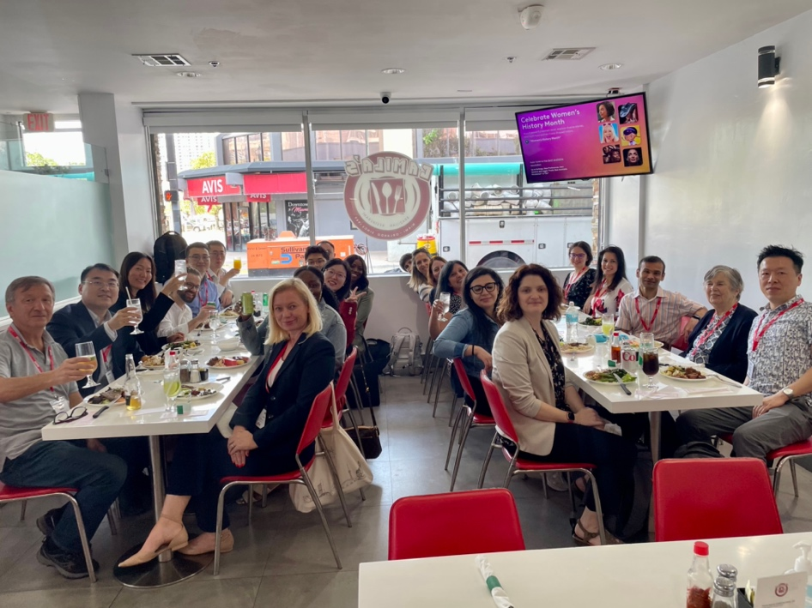
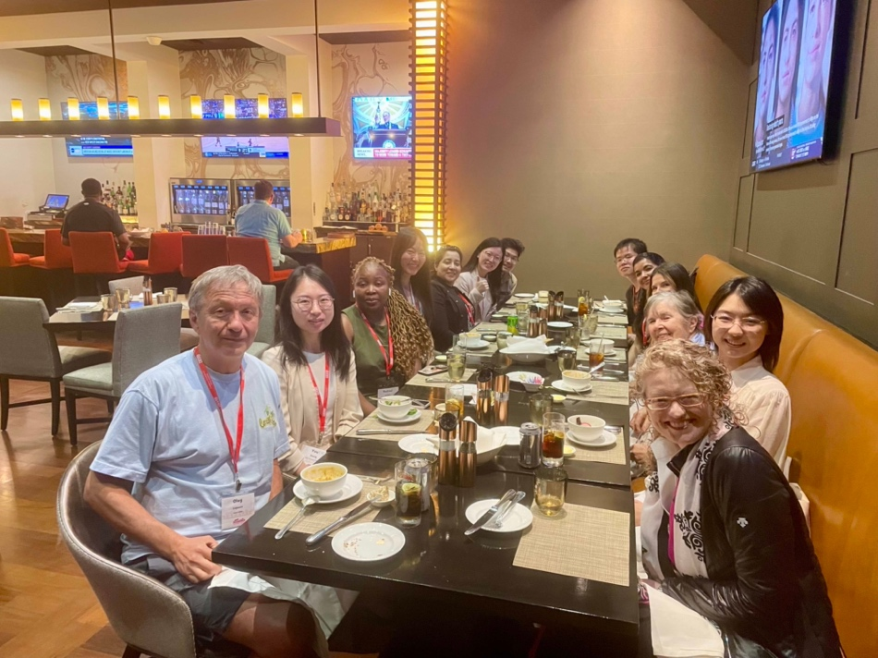
Photo Credit: Cassidy Gong

Photo Credit: Cassidy Gong
Spring 2024 | Page No. 7
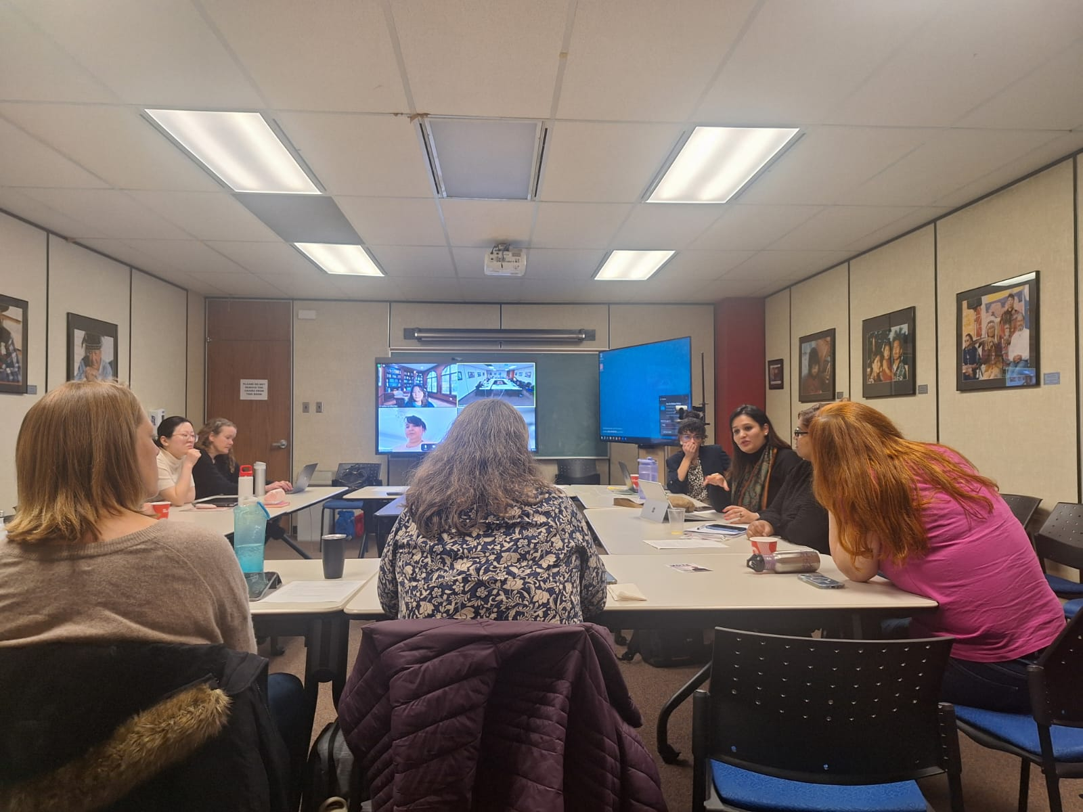
J.P. Farrell Student Research Symposium

On Friday February 16th 2024 students and faculty gathered for the annual J.P. Farell Student Research Symposium (see below for the complete program). Thought-provoking discussion followed students’ presentations of their research: topics included issues in higher education in Canada and Europe, social justice barriers and ESL policy in the Ontario public school system, decolonial approaches to women’s and BIPOC’s experiences in (STEM) education, riveting discussion of educational policies in Ghana and Vietnam, and a comparison between colonial education in India and Canada. Attendance peaked at around 40 attendees per session, online and in-person.

Thank you to all those who attended and participated. We look forward to seeing you at next year’s JPFSRS!

Session 1- Issues in Higher Education: Language, Community Building and Making Space for Alternative Approaches [Chair: Tavila Haque, PhD Student/LHAE/ELP & CIDESA Co-Chair]

A Plurilingual and Pluricultural Perspective on Internationalization of Higher Education in the Canadian Context [Rui Dong Chen, MA/CTL/LLE]

Transformative Learning Experiences of Internationally educated racialized women English instructors in the Canadian workplace: Implications for Teacher Learning and Support in Ontario Colleges and Universities through an Arts-Informed Narrative Multiple Case Study [Justine Jun, PhD Candidate/CTL/LLE]

Decolonizing Diasporic Discourses and Learning Experiences in Canada: An Evaluation of the Impact of an Embodied Learning Community-Building Workshop Project [Emily Dobrich, PhD Candidate/LHAE/AECD]

Issues Confronting International Asian Students in European Universities: A Review of the Literature [Minzi Zhang, PhD Student/LHAE/HE]

Session 2 – Barriers in the Ontario Public School System [Chair: Stephanie Fowler, EdD Student/LHAE/ELP & CIDESA Co-Chair]
Transcending the Classroom: Re-imagining “Social Justice Education” for TDSB Teachers [Sara Pagliaro, MA/SJE]
Understanding the system: a language policy ethnography of ESL policy in Ontario [Lisa Lackner, PhD Candidate/CTL/LLE
Session 3 – Decolonial Approaches to Women’s and BIPOC’S Experiences in Education [Chair: Carly Manion, CIDE/C Director]
Examining the Coloniality of Gender in Educational Policies: A Comparative Case Study on Teachers' Work in Egypt [Yara Abdelaziz, PhD Student/LHAE/ELP]
Gender (in)equity in STEM in the Global North and the Global South [Warda Mashhood, PhD Student/LHAE/ELP]
Session 4 - Comparative Educational Policies: Curricula, Practice and Ideology [Chair: Mariya Hassan, PhD Candidate/CTL/LLE & CIDEC GA]
Exploring the Dark History of Colonial Education on Indigenous Communities in Canada and India [Elwin Varughese, MEd Student/LHAE/ELP]
Language Policy as Personal Experience: A Southern Perspective of Language Policy via Ghana’s Practice of Medium of Instruction Policies [Mama Adobea Nii Owoo, PhD Candidate/CTL/LLE]
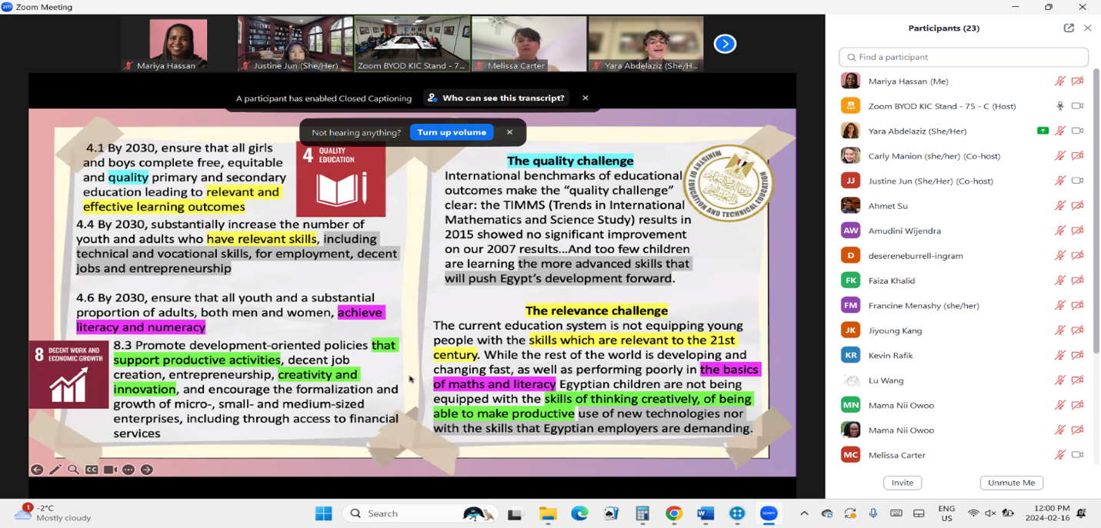
Environmental Education Policy in Vietnam: A Critical Discourse Analysis [Tien Pham, PhD Student /LHAE/ELP]

From Yara Abdelaziz’s [PhD Student/LHAE/ELP] presentation, “Examining the Coloniality of Gender in Educational Policies: A Comparative Case Study on Teachers' Work in Egypt”

Program Co-Chairs: Dr. Carly Manion (CIDE/C Director) & Mariya Hassan (CIDEC Graduate Assistant)
Spring 2024 | Page No. 8

CIDEC Professional Development Series, 2023-2024

*Facilitated by Zohra Lakhani, CIDE alumni, education and development professional*

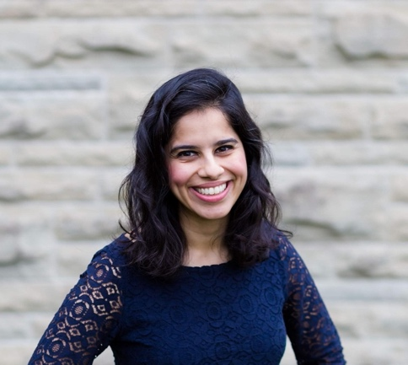
Session 1 (synchronous online): Telling Your Story
- Personal branding, LinkedIn, and one's social media/ digital footprint.
- Friday, November 10, 2023, 3:30pm-4:30pm

Session 2 (synchronous online): Applying for Jobs
Zohra Lakhani
- Where/how to search; resume/CV development; cover letters; preparing for an interview.
- Friday, December 1, 2023, 3:30pm-4:30pm

Session 3 (synchronous online): Building Your Professional Network
- How to network and reach out to folks via LinkedIn, cold emailing, making connections in virtual and physical spaces
- Friday, January 19, 2024, 3:30pm-4:30pm

Session 4 (synchronous online): The Elevator Pitch
- Workshop session in breakout groups where participants are practicing, providing feedback and editing their "elevator pitch".
- Friday, February 9, 2024, 3:30pm-4:30pm

Session 5 (in-person, Nexus Lounge): Happy Hour Live Networking Session [postponed, rescheduled for 2024-2025]
- CIDE students will have the chance to meet and network with invited representatives of organizations working in the field of educational development.
- Friday, March 8, 2024, 5:00pm-7:00pm

Session 6 (synchronous online): Happy Hour/Networking Debrief and Discussion
- Feedback, follow-up, reflections, connecting with connections made at happy hour.
- What's next? How do you continue to work on connections made and build relationships? How to pursue potential opportunities?
- Friday, March 22, 2024, 3:30pm-4:30pm

Spring 2024 | Page No. 9

CIDEC Interest Groups (IGs)

CIDEC East Asia Special Interest Group (EASIG) Updates
About: CIDEC East Asia Special Interest Group (EASIG) is organized by graduate students, focusing on promoting knowledge sharing and knowledge production in Asian studies related to education and supporting the academic and professional development of the Asian communities in North America. Please email us at oiseeastasiaig@gmail.com if you are interested in joining our executive team or would like to be included in our email list.
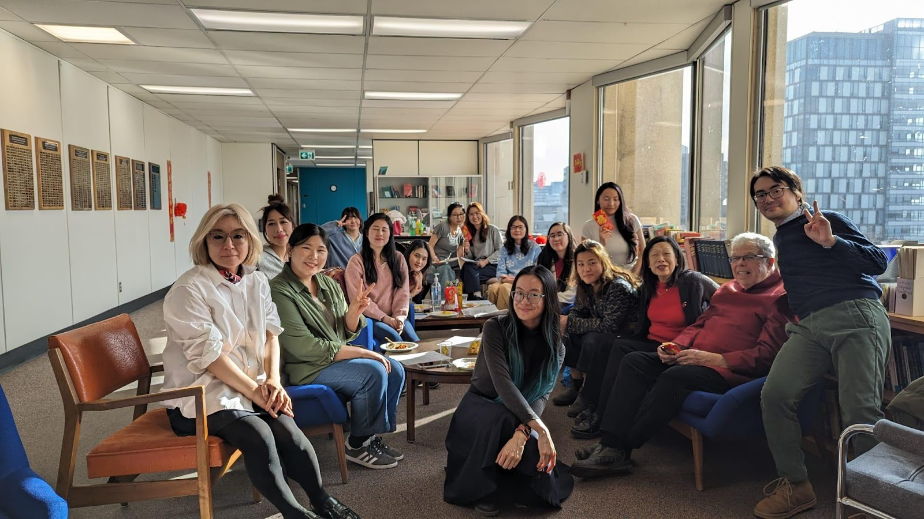
1. Lunar New Year Event
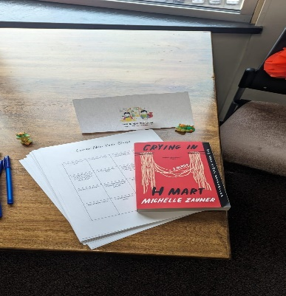
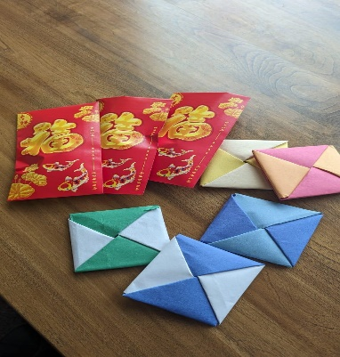
CIDEC's EASIG hosted a Lunar New Year Celebration on February 8th at the LHAE 6th floor lobby. Students, staff, and faculty from various backgrounds came together to celebrate this holiday. From guessing lantern riddles, to playing Lunar New Year bingo, and throwing ddakji (딱지) among other cultural activities, the day was filled with great fun to ring in the year of the dragon. CIDEC's EASIG also made sure to include traditional food and snacks stemming from Chinese, Vietnamese, and Korean cultures to ensure that we could include the diverse folks who celebrate of Lunar New Year. Thank you to everyone who attended!

2. 2024 CIDEC East Asia Special Interest Group (EASIG) Asian Heritage Month Symposium
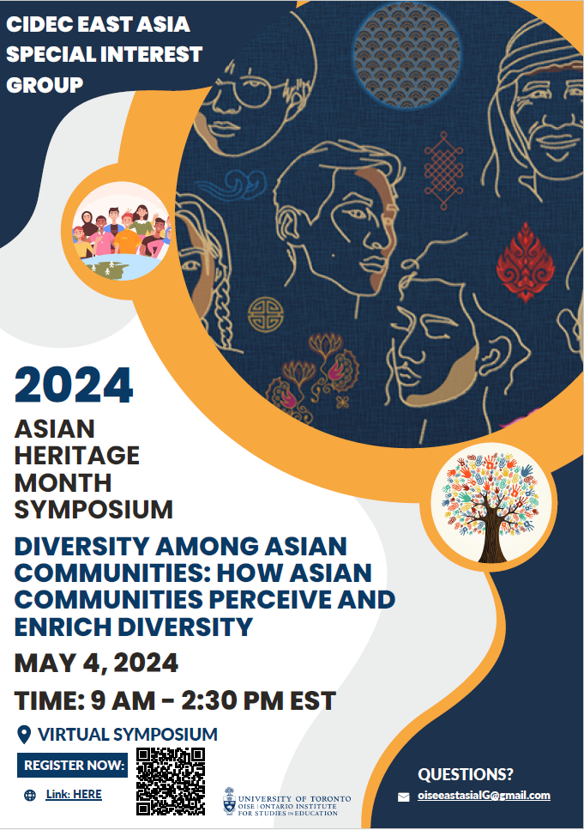
CIDEC East Asia Special Interest Group (EASIG) started planning for our annual virtual Asian Heritage Month Symposium on May 4th, 2024. This is our 4th annual symposium, and this year’s symposium theme is, “Diversity among Asian Communities: How Asian Communities Perceive and Enrich Diversity”.
Symposium Theme Details:
The term, diversity, is used commonly and frequently in various contexts. For this year’s Asian Heritage Month Symposium, we would like to invite participants to go beyond the tokenistic approach of diversity and think about what diversity means for Asian communities, and how they perceive and uniquely enrich diversity. In particular, Asian communities are not a homogenous group, and Asian cultures are not monolithic, although they are often portrayed as so. This symposium invites participants to engage in discussing the nuanced narrative around diversity within Asian communities and how diverse cultures within Asian communities variously contribute to the broader diversity narratives in North America.
This year’s symposium will include a keynote speaker, an academic panel, a practitioner panel, and a graduate student panel to share various perspectives that relate to this year’s symposium theme. Please register for the symposium here: https://utoronto.zoom.us/meeting/register/tZErde-orzwvGNTNTpgltBcSdDPckYbc9IyM. We will be sharing our symposium program with a detailed list of speakers in late April. Please reach us at oiseeastasiaig@gmail.com for any questions.

Spring 2024 | Page No. 10

CIDEC Gender and Education IG
by Dr. Norin Taj, Postdoctoral Fellow and Lecturer
Founder of Gender and Education Interest Group

The CIDEC Gender and Education Interest Group (G&E IG) hosted a panel session, "Students and Faculty in Conversation: 'Slow Spaces' and Community Building in Academia," at the Graduate Students' Research Conference 2024 on March 23, 2024, at the Ontario Institute for Studies in Education, University of Toronto. The aim of the session was to foster community through participatory research methods, support mentoring for graduate students, and advance gender equity initiatives. Student, alumni and faculty participants included, Yara Abdelaziz (PhD Candidate, ELP/CIDE); Emikay Al-Hassan Mohammed (MEd, ELP/CIDE); Ebru Bag (CIDE Alumnus); Nana Gulic (PhD Candidate, SJE/CIDE); Justine June (PhD Candidate, LLE/CIDE); Carly Manion (Associate Professor, Teaching Stream/CIDE Director); Norin Taj (Lecturer, ELP/CIDE).

The inaugural session explored the concept of "slow spaces" within graduate institutions, integrating reflective practices with conversations on community-building in academia. Panellists and conference participants engaged in discussions centred on the "slow space" philosophy as a tool to challenge power dynamics within academia and research. The conversation began by defining "slow spaces" in
terms of time and structure—the spatiotemporal quality of experiences in academia—and highlighted disparities in spatial relations, temporal structures, and labour hierarchies. Panellists addressed two pivotal questions during the session: 1) Reflecting on their personal experiences, how have they considered or experienced the concept of "slow spaces" in shaping their research practices? and 2) How can the academic community collaborate with the “slow space” philosophy, especially in the context of the dominant neoliberal trends of competitiveness in academia, to establish or foster more inclusive and reflective academic environments? The panellists acknowledged being constrained by traditional academic norms sometimes and discussed the challenge of balancing authenticity within academic settings, particularly when confined to specific roles or conforming to rigid academic expectations. The discussion encouraged an open dialogue, prompting conference participants to share their perspectives as well. Many highlighted the tension between meeting deadlines and maintaining the quality of research and thoughtful inquiry. To navigate these challenges, the panellists emphasized the significance of mindfulness in academic work, the importance of pacing in graduate studies, and the potential benefits of incorporating art-based research methods as innovative approaches to foster inclusive and reflective academic environments. One of the key takeaways from the panellists was the importance of “finding the right community,” listening “to your internal clock,” and the overarching idea that “slow doesn't imply a lack of quality.” Interestingly, the concept of "slow spaces" resonated with many participants as it described familiar but yet unnamed experiences. The discussion allowed them to recognize and articulate those experiences, highlighting the often-overlooked structural and temporal challenges faced in graduate education.
One of the key takeaways from the panellists was the importance of “finding the right community,” listening “to your internal clock,” and the overarching idea that “slow doesn't imply a lack of quality”.

The key recommendations emphasized the need for academic institutions to foster a culture that values reflective and participatory approaches to education. Promoting a more reflexive curriculum delivery could deepen engagement and balance the pressures of modern academia. Additionally, initiatives that prioritize community-building, mentorship, and recognizing each individual's contributions were highlighted as promising ways to move forward.

The G&E IG plans to create resources and host workshops to further explore the session's themes, offering guidance on ethical practices within academic demands and promoting research methods that prioritize thoughtful inquiry. For more information or to stay connected, please contact the G&E IG at cidec.gender.ig@gmail.com

A Note from the CIDE Student Association (CIDESA) Co- Chairs

Greetings from your CIDESA Co-Chairs!

As the year comes to an end, we would like to send good wishes and cheers to all CIDE students. As co-chairs, we had a great time being able to host the first in-person social gathering called, “Holiday Mingle” in the Fall of 2023. The event was very successful, and the CIDESA is now looking forward to presenting an end-of-year hybrid workshop, focusing on learning Zotero. The workshop will detail the ins and outs of Zotero, as well as teach students new skills to be able to utilize the platform in their research journey. It will be hosted by OISE Student and PhD Candidate, Yara Abdelaziz and Jade Halawani, a PhD student from George Mason University. The workshop will be held via Zoom as well as in-person, and there will be an opportunity for a social gathering afterwards. Please lookout for the flyers coming soon!

The 2023-2024 year has taught us what it means to have a community. The support and the positive energy students have shared throughout the year has truly been appreciated. As CIDESA Co-Chairs, we also had the opportunity to chair sessions as part of the annual J.P. Farrell Symposium conference held on 16th February 2024. Many CIDE students were able to present their research, and the co-chairs learned a lot from these researchers.
Tavila Haque (CIDESA Co-Chair)

We would also like to take a moment to thank Dr. Carly Manion for her constant mentorship, support and engagement throughout the events and their processes. Also, a special shoutout to Mariya Hassan, the CIDE Graduate Assistant for being so wonderful and a great point-of-contact for any and all updates.
Stephanie Fowler (CIDESA Co-Chair)
Thank you!

Sincerely,
Stephanie & Tavila

Please see the CIDE/C website for more information on the CIDESA and different Interest Groups and how to join them: https://www.oise.utoronto.ca/cidec/cidec-interest-groups/

Spring 2024 | Page No. 11
SPRING 2024 CIDE GRADUATES




Melissa Carter, MEd, SJE

Dongzhao Chen, MEd, LHAE/ELP

Kelvin Chen, MEd, LHAE/ELP

Jessica Deneberg, PhD, LHAE/HE: Approaches to Fostering International Partnerships in Higher Education: Canada and Germany in a Comparative Perspective

Rim Fathallah, PhD, CTL/C&P: Online Pedagogy for Creative Transnational Peacebuilding Learning in Design Education

Aniza Fawad, MEd, LHAE/ELP: Sense of Belonging of Young Pakistani Immigrants in Ontario

Nuo Huan, MEd, CTL/LLE

Anastasia Jakub, MEd, LHAE/HE

Wonny Kang, MEd, LHAE/ELP

Faiza Khalid, MEd, LHAE/ELP

Aining Kuang, MEd, LHAE/ELP

Diwen Lin, MEd, SJE

Akriti Mahajan, MEd, CTL/C&P

Shreeja Mukherjee, MEd, LHAE/ELP

Marie Sherman, MEd, LHAE/ELP

Izhar Ullah, MEd, LHAE/ELP

Elwin Varaghese, MEd, LHAE/ELP: Exploring the Dark History of Colonial Education on Indigenous Communities in Canada and India

Lu Wang, MEd, LHAE/ELP

Amudini Wijendra, MEd, LHAE/ELP

Shiying Zhou, MEd, LHAE/AECD

We wish you all the best in your future endeavors!

Spring 2024 | Page No. 12

CIDEC Faculty, Alumni and Students’ Publications
Inside this Issue
HoHowafagagCCo
Adam, E., &Adam, N. (2024). Education hubs in Qatar and The United Arab Emirates: Analysis of discursive construction
using Latent Dirichlet Allocation. International Journal of Educational Development, 107. https://doi.org/10.1016/j.ijedudev.2024.103034
Adam, E. (2024). A reappraisal of global university rankings’ influence in Canada: a senior university leaders’ perspective, Journal of Further and Higher Education, 48(1), 56-69. DOI: 10.1080/0309877X.2023.2253430
Adam, E. (2023). Reviving the sociology of organizations in higher education: The case of how global university rankings influence the strategic management of Canadian universities. International Review of Sociology. https://10.1080/03906701.2022.2156436
Adam, E. (2023). Mastering Fortuna: Higher education as an international relations strategy for diplomacy, development and sustainability: Jane Knight, Knowledge Diplomacy in International Relations and Higher Education. Higher Education, 87(2), 509-513. https://doi.org/10.1007/s10734-023-01020-0
Asim, M., Bell, S., Boakye-Yiadom, M., Nudzor, H. P., & Mundy, K. (2024). Management Practices and Implementation Challenges in District Education Directorates in Ghana. Educational Administration Quarterly, 0(0). https://doi.org/10.1177/0013161X241230527
Barrero Jaramillo, D. M. (2024). In Defense of Solidarity and Pleasure: Feminist Technopolitics from the Global South. Sociology of Race and Ethnicity, 0(0). https://doi.org/10.1177/23326492241238946
Bickmore, Kathy (in press 2024). Schooling for building just peace: Comparative perspectives on facing difference, conflict, and violence in education. In William Pinar & Anne Phelan (Eds.), Curriculum Studies in Canada: Present Preoccupations. University of Toronto Press.
Bickmore, Kathy (2023). Afterword. In Parker-Shandal, Crystena, The Doctoral Journey: First-Generation Perspectives Brill.
Bell, S., C. Leaver, Z. Mansoor, K. Mundy, Dana Qarout, and Martin J. Williams. (2023). The Role of Delivery Approaches in Education Systems Reform: Evidence from a Multi-Country Study. DeliverEd. Washington, D.C: Education Commission. (2023). https://educationcommission.org/wp-content/uploads/2023/06/The-Role-of-Delivery-Approaches-in-Education-Systems-Reform-Evidence-from-a-Multi-Country-Study.pdf
Diaz-Rios, C. (2024). Translating Global Ideas: How Policy Legacies and Domestic Politics Shape Education Governance in Latin America. State University of New York Press.
Dobrich, E. (2024). [Review of the book Graceful Resistance: How Capoeiristas Use Their Art for Activism and Community Engagement by L.M.Griffith (2023)] Comparative and International Education/ Éducation comparée et internationale, 53(1), 65-67. https://doi.org/10.5206/cie-eci.v53i1.17277
Fontdevila, C., F. Menashy, & A. Verger (2024). Just another brick in the wall? The changing legitimacy and relevance of the World Bank in global education. In A, Vetterlein & T. Schmidtke (Eds.). The Elgar Companion to the World Bank. Edward Elgar.
H. Wu and Hayhoe, R. (2023). China’s normal universities and their ethical engagement in social transformation: Philosophical traditions, historical evolution and social influence. In G. Gregorutti and E. Bosio (Eds.), The Emergence of the Ethically Engaged University (pp. 161-184). Switzerland: Palgrave Macmillan.
Hayhoe, R. (2024). Review of Jane Knight, Knowledge Diplomacy in International Relations and Higher Education. Comparative Education Review, 68(1),193-195.
Kester, K., Masemann, V.,Takayama, K. and Hayhoe, R. (2023). Learning from Asia: an APER Collective Response to the special issue of “Asia as Method”. Asia Pacific Education Review, 24(2), 282-289.
Kishani F. N. (2024). Hope amid violence: youths’ agency and learning experiences to transform social conflicts in non-democratic settings. International Journal of Social Pedagogy, 13(1). https://doi.org/10.14324/111.444.ijsp.2024.v13.x.003.
Mou, L., Q. Zha and Hayhoe, R. (2023). Liberal Arts Education in the Universities of Greater China: Historical Legacy, Current Models, and Future Prospects. Working paper 94, Global Centre for Higher Education. Oxford University.
Manion, C. (forthcoming 2024). International gender and education policy and practice: Where are we now? In E. Gottlieb, R. Iyengar, and M. Witenstein (eds). Comparative and International Education: An Introduction. Bloomsbury.

Manion, C. (forthcoming 2024). A review of teaching, learning, and community building in the Comparative and International Education Society (CIES). In N. Assié-Lumumba, E. Coxon, R. Hayhoe and C. Soudien (Eds.), WCCES and the Development of Comparative Education. Brill | Sense.
Menashy, F. & Z. Zakharia. (2023). Partnerships for education in emergencies: The intersecting promises and challenges of SDG 4 and SDG 17. International Journal of Educational Development. 103.
Mundy, K. (2023). Living and learning in the field of international development education. International Journal of Educational Development, 102919.
Spring 2024 | Page No. 13
Mundy, K. (2023). SDG4 and state capacity: The missing link. International Journal of Educational Development, 103, 102937.
Ng, P., Mou, L. and Hayhoe R. (Eds.) (2023). Liberal Arts and the Legacy of China’s Christian Universities. Springer.
Post, D. & Bickmore, K. (forthcoming 2024). Using the Past to Reconsider the Future: Perspectives from North America in Comparative and International Education. In N. T. Assié-Lumumba, E. Coxon, R. Hayhoe and C. Soudien (Eds.), World Congress of Comparative Education Societies book: WCCES and the Development of Comparative Education. Brill | Sense.
Zakharia, Z. & F. Menashy (2024) Decolonizing humanitarian assistance and education for refugees. In Y. Cheng, R. Sihdu, J. Waters (Eds.) Elgar International Encyclopaedia of Sociology of Education. Edward Elgar.
Zakharia, Z. & F. Menashy (2024). Partnerships and power in education in emergencies. In M. Shuayb & C. Brun (Eds) Education for Refugees: Theorising the Field. British Academy.

Spring 2024 | Page No. 14

